- Situation Report

The Situation Reports (SitReps) are short reports submitted on a periodic basis (monthly or quarterly depending on communication needs). The SitReps are prepared on an Excel document. The document is comprised of the following 5 tabs:
- Project Description
- Visibility
- Performance progress
- Change in context
- Humanitarian advocacy

The information regularly gathered in the SitReps is the information that will be used to complete the interim and final reports. Please note, that the SitReps are to be filled out even on months where the interim and final reports are due, as they are in excel form and generate the information needed to fill out these other reports.

- Project Description
This section is essentially an executive summary that is filled out once at the beginning of the project and will not require updating during the implementation of the project. It serves as the baseline for the subsequent tabs.

- Visibility
The information gathered in the “visibility tab” will be used by the ACT secretariat’s communication department to produce infographics which will be posted on the website and other social media outlets.

For example:
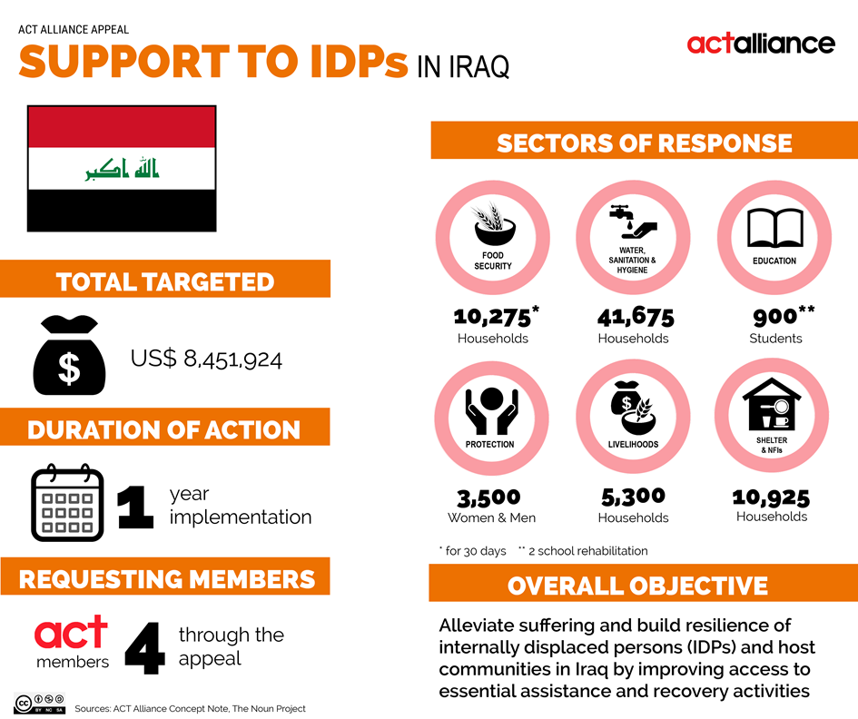

- Performance progress
This section collect data and reports the progress made on achieving targets according to the set schedule (variances on targets) and allows for a visualization of the progress over the project’s entire lifespan.

- Change in context
This section describes any changes in the context which influence member(s)’ ability to implement the project as planned. Member(s) should also describe what measure have been taken to mitigate any negative impacts and risks associated with the change in context.

- Humanitarian Advocacy
Humanitarian advocacy is now integrated within the humanitarian response and the humanitarian advocacy tool describes what actions will be taken throughout the project lifespan. This section allows the member(s) to report on the progress or any challenges faced in carrying out the advocacy activities described in the humanitarian advocacy tool.

- Interim/Final Reports

The interim and final reports use the same template. These reports are subdivided into the following 4 sections:
- Change and amendments
- Progress and deviations
- Appeal impact
- Visibility

The information necessary to fill out the interim/final reports is derived primarily from the SitReps and are complimented by assessments, M&E, etc.

- Change and amendments
This section is basically a copy & paste from the “change in context” tab of the SitReps. It reports any changes in context that have an impact on project implementation and request information on what measure were taken to mitigate any negative impact or risk cause by these changes. It also asks information regarding any changes/amendments made to the project as result of beneficiary consultations and feedback.

- Progress and deviations
The information requested in this section can be found in the “performance progress” tab of the SitReps, along with any major changes/variances in the financial report and implementation timeframe. There is space to explain and/or justify the deviation and also a space to record any lessons learned from the action, that may be of institutional use in the future.

- Appeal impact
The impact of the actions carried out in the project are usually determined by undertaking assessments and evaluations. This section provides space for member(s) to describe any impact on cross-cutting issues (such as: gender, environment, resilience, etc.) as well as on the durability/sustainability of the project’s impacts.

- Visibility
The visibility section puts forth the components of the project that helped build the Alliance’s reputation vis-à-vis various stakeholders. This includes reporting on the overall footprint of the Alliance in a country/response, as well as coordination mechanisms used to bolster reputation.

