PLEASE COMPLETE AND RETURN TO THE ACT SECRETARIAT BY 15th FEBRUARY 2020 **This annual report will be posted in ACT website.**

|  |  |  |  |  |  |  |  |
| --- | --- | --- | --- | --- | --- | --- | --- |
| **ACT FORUM ANNUAL REPORT 2019** | |  | | | | | |
| Name of the Forum |  | | | | | | |
| Membership of the Forum & Non-act guests | **ACT National Members**  1. Church of Uganda (COU)  2. Rural Action Community Based Organisation (RACOBAO)  3. Uganda Joint Christian Council (UJCC) | | **ACT International Members**   1. Diakonia Sweden 2. Finn Church Aid 3. Lutheran World Relief 4. Church of Sweden 5. ICCO Cooperation 6. World Renew 7. Bread for the World 8. Swiss Church Aid 9. Dan Church Aid | | **ACT Global Members[1]**   1. Lutheran World Federation | **ACT Observers[2]**  N/A | **Guests non-ACT members[3]**  **N/A** |
| FORUM convener | Name & Organisation:   1. Wyclife Nsheka, FinnChurchAid 2. Anabel Ogwang, Diakonia Sweden | | | | | Email address:  [Wycliffe.Nsheka@kirkonulkomaanapu.fi](mailto:Wycliffe.Nsheka@kirkonulkomaanapu.fi)  [annabel.ogwang@diakonia.se](mailto:annabel.ogwang@diakonia.se) | |
| FORUM Coordinator | Name & Organisation:  Patriciah Roy Akullo (Ms) Hosted by Dan Church Aid | | | | | Email address:  [prak@dca.dk](mailto:prak@dca.dk) | |
| Key focal points | Communications Focal Point (name and email): Forum Conveners as above  Security Focal Point (name and email): N/A  Advocacy Focal Point (name and email): Patriciah Roy Akullo, [prak@dca.dk](mailto:prak@dca.dk) | | | | | Contacts for any working groups (if the forum has):  Gender Working group,  Patriciah Roy Akullo, [prak@dca.dk](mailto:prak@dca.dk) | |
| Memorandum of Understanding aligned with new forums policy | Memorandum of Understanding (MoU) needs to be revised, finalized, approved by ACT secretariat and signed by membership of the Forum. Yes  YES/NO | | | | | Comments (e.g when do you plan to finalize this process in 2020?):April | |
| WHEN FORUM MEETINGS/frequency | Frequency/Dates (if known) Once every 2 months – on the last Thursday of the month | | | | |  | |
| Annual Forum Workplan | Did you have a Forum Workplan for 2019 aligned with the ACT Global Strategy?  YES/NO | | | | | Comments (eg when do you plan to develop one for 2020?):  March | |
| Date of Annual Meeting 2019 | 11th November 2019 | | | Key comments: Uganda forum to continue working together, focus on only 2 advocacy themes that is climate justice and gender justice | | | |
| Date of Annual Meeting 2020 (if known) | Not determined. Usually in November and meeting date to be determined in a forum meeting midyear | | | | | | |
| Forum Emergency Preparedness and Response Plan (EPRP) | Do you have a Forum EPRP that has been updated in last 12 months? YES/NO  Still working on it, hope members complete soon as we consolidate | | | | | When do you plan to elaborate one in 2020, or update it?:  Hopefully by May 2020 | |
| Capacity Development | List any training or capacity development initiatives undertaken at the forum level in 2019:   * Joint learning on gender justice * EPRP training for forum members * Training World Renew partners in Advocacy * Facilitating Climate change and DRR webinar with a case study of Uganda | | | | | | |
| Working Together on implementation of act strategic aims | Has your forum worked together on a joint initiative related to:  1. Gender Justice YES/NO  2. Climate Justice YES/NO  3. Emergency Preparedness and Humanitarian response YES/NO  4. Migration and Displacement YES/NO  5. Peace and Human Security YES/NO | | | | | | |
| If yes, please briefly describe the initiative(s) in light of the 5 programme themes, Also let us know that you filled in the Forum capacity mapping sheet:  We engaged in the 3 areas , its described below in the section of the summary of the achievement and yes we filled more details in the forum capacity mapping sheet. | | | | | | |
| Has your forum worked together on any joint humanitarian, sustainable development or advocacy initiatives specifically linked to gender justice or gender-related issues (if yes, please briefly describe the initiative, or let us know that you filled in the Forum capacity mapping sheet)?   * Yes , advocacy initiative on gender justice and its described below * Yes, we filled in the forum capacity mapping sheet and would wish to have an update in that regard. | | | | | | |
| Summary of Key achievements working together as a forum (and how they contribute to the ACT Global Strategy) | 1. **Gender Justice**  * **Sexual Offences Bill:** The forum continued to engage in influencing policy at national level and this was still with the sexual offences bill process. The gender working group of the forum organised and participated in several lobby meeting with Uganda members of parliament with other national actors, this was aimed at ensuring that the bill gets passed before the current house of Parliament closes for next general election. Several faith leaders were selected to be engaged in this process, this not only built capacity of faith leaders but amplified our faith voice in the process, a factor that was missing in the past and caused the delayed passing of the bill. ACT Alliance engagement in this process was appreciated by the Speaker of Parliament of Uganda and the Uganda women’s Parliamentary Association that commended the deep involvement of the church and henceforth continued to invite ACT Alliance /faith in all other gender related discussion at national level. Like before, we are aware that gender-based inequality and violence is perpetuated and has roots in sexuality vice and therefore this bill is critical to our work around gender justice. * **Gender justice campaigns:** In 2019, the forum engaged in the annual commemoration of 16 days of activism, with support from DanChurchAid and mobilisation through Church of Uganda. The campaign included a march across the city with messages against gender-based violence and the role of the church being displayed, this was a media hyped event and several talk shows and spot messages were run across several media stations. The strong collaboration between ACT Alliance, World Council of Churches and Side by Side movement was exhibited through this campaign for example Thursday in black campaign and interfaith engagement was fused in the 16days campaign. ACT Alliance used this moment to deliver strong messages condemning gender-based violence but also rein enforced the role of the church in strengthening gender justice. * **Beijing +25 reviews and ICPD25**: ACT Alliance engaged in national level reviews and reporting of Uganda’s progress in the implementation of the Beijing commitment. ACT Alliance made draft input in both the government and CSO position reports with technical inputs to cluster on gender-based violence and climate action. ACT forum also meaningfully participated in the ICPD25 session in Nairobi, this enlightened our planned actions around sexual reproductive health rights, which is still a sticky subject but hopefully we continue with the more neutral area. The gender working group also constituted the delegation of the ACT Alliance to the 63rd UN Women commission of the status of women, this participation inspired the gender working group and enabled joint advocacy in 2019. * **ACT Africa Community of Practice:** Uganda Forum held the launch of the Africa gender community of practice , where several forums like Zimbabwe, Ethiopia, South Sudan, South Africa participated. Uganda assumed the leadership of the COP and this COP will enable joint and coordinate efforts in gender justice advocacy at a regional level. * **Capacity building**: To strengthen the capacity of the forum and to increase our knowledge , the forum organised a Joint learning session on gender justice with a focus on sexual offences bill (SOB) that was facilitated by Ugandan Judge Justice Batema, a renowned judge in convicting offenders and perpetuators of sexual. The forum members fully participated, and we received an overview of sexual and gender-based violence in Uganda which information guided our advocacy and project development. As a forum we participated in other organised gender spaces such as the EFOGE summit in Kigali where faith leaders from Uganda attended and we participate in the Uganda Feminist Forum too, to understand what the non-faith and general women’s movement are engaging with especially the more radical discussion and identities.  1. **Climate Justice**  * **Advocacy Engagement:** The forum did engage in advocacy at National and international on climate change . At national level, together with the CSO Climate Action Network Uganda, we did engage with the Ministry of Water and Environment including the Parliamentary Commitee on climate change to lobby for the passing of the climate change bill that is long overdue. Scaling finance through prioritisation in the national budget allocation continues to be a lobby agenda of the Act forum because Uganda still faces challenges of climate change and the adaptation plus resilience capacity of communities is still low warranting finances to support local actions.   The global advocacy to link national to global agenda is crucial and as a forum we have continued to constitute the ACT global delegation to the UNFCCC sessions such as Bonn intersessional and Conference of Parties negotiations where our focus remains climate finance, we do support government of Uganda during the negotiations by providing oversight role , initial research and bi-lateral engagements with other governments to align interests.   * **Climate justice Campaigns:** ACT supported and participated in the UNFCCC Global climate strike for youth that took place on 20th September 2019 in Kampala city . The campaign enabled youth and climate activists to petition the government through the Speaker of the Parliament of Uganda to prioritise climate action by implementing policies developed and increase climate finance. The Speaker committed to address these issues by raising them on floor. * **Emergency Preparedness Response Plan (EPRP):** The forum organised an EPRP session last April where some members of the forum were trained about these plans and introduced to online EPRP format. Some members also developed own EPRPs and others are yet to complete theirs before we can consolidate forum online EPRPs. The church of Uganda has been supported to be able to write rapid ACT Appeal requests and respond to emergencies. * **Capacity building:** Through the forum expertise, members and their partners who had interest in climate change theme were trained in climate advocacy including hosting visiting delegations of ACT members to forum sites where we previously implemented climate advocacy projects for example World Renew delegation and Diakonia partners. The forum also participated in the ACT Africa climate justice training in Malawi and this participant has since inspired RACOBAO to engage more in climate action and advocacy. | | | | | | |
| Summary of Key challenges | * Members are increasingly becoming very busy with own work and many at times have limited time and human resource to engage in the joint work * The funding from members is still limited for us to engage in major advocacy campaign, we sometimes must leverage on members activities. | | | | | | |
| Summary of Lessons Learned | * As a forum, we learnt from the previous year -2019, that we need to only engage in thematic areas that we have developed in-depth knowledge and experience and going forward, we narrowed to engage in only climate and gender justice advocacy. * The forum will need to continue to strengthen networks and collaborations with similar organisations or alliances at national, regional and global levels | | | | | | |
| How has the individual work of the ACT members benefitted from being part of the ACT forum in 2019? | Not so different from the previous year,   * **Joint Advocacy statements**   We have continued to issue Joint statements in gender and climate justice work, adding our voice to other national actors amplifying the voice of faith in national advocacy .   * **Experience sharing**   The Forum members have continued to engage in experience sharing during forum meetings and these range from new ways of implementing activities, changing strategies and opportunities within their organisations and general CSO work, this has facilitated continuous learning and inspiration.   * **Advocacy initiatives**   For members with keen interest in climate and gender justice engagements ,the joint advocacy activities around these 2 themes did contribute to certain result areas of individual member’s country programme. Members identified with some achievements in the thematic areas of climate change advocacy and gender justice for example our national level engagements on sexual offences bill, global climate strike/march among others.   * **Capacity Building**   The Forum has continued to organise, participate and second members to several capacity building initiatives . These trainings are in-line with members and forum engagements .The learnings have knowledge of staff of individual members and partners to deliver own programme. Trainings conducted last year were in the areas of effective advocacy, climate justice advocacy, environment, gender justice, Emergence preparedness and Response, psychosocial first aid among others.   * **Networking**   Through the Alliance, Members have ably continued to establish contacts at different levels and forums whenever they represent ACT by participating in meetings, conferences organised by the ACT Alliance members and contacts established through ACT Forum. The networks have continued to bring in added benefits to organisations in terms of information access, human resource, funds among others.   * **Profiling members and ACT work**   Some initiatives of members and the forum have continued to be profiled through the ACT Alliance global platforms attracting interest of other stakeholders . The Forum coordinator shares the work implemented by member and forum jointly to be showcased in the social media pages of ACT. | | | | | | |
| Annex: Pictorial | A person standing in a room  Description automatically generatedA group of people standing in a room  Description automatically generatedA group of people sitting at a table in a room  Description automatically generated  Picture 1, 2 & 3 above: ACT forum joint learning session on gender justice with a case study of the sexual offence bill. PeterBo Larsen and Annabel ,Country Directors of DCA and Diakonia gave opening and closing remarks    A group of people sitting at a table  Description automatically generatedA group of people sitting at a table  Description automatically generated  Picture 4 & 5: The ACT gender working group engaged the Speaker of the Parliament of Uganda and Women Parliamentarians to lobby for the expediting in passing the sexual offences bill    Picture, 6, 7 & 8: Rev Rukundo ,one of the gender champions represented the ACT forum at a UNWomen and delivered a speech on the faith perspective. Below, the ACT forum Coordinator, Patriciah Roy Akullo made a press statement on accelerating climate action at the government media center    A person holding a child  Description automatically generated  ImageImage    Picture 9,10,11 &12: Above both left and Right: The ACT forum with support from DCA participated in the 16days of activism campaign. Below left, ACT Forum coordinators meeting in Nairobi. Below Right, ACT Forum Annual general meeting group picture    A group of people sitting at a table  Description automatically generatedA group of people standing next to a person  Description automatically generated  Picture : The Country Director of Diakonia, Annabel handing over the convenorship of the forum to Wycliffe ,the Country Director of FCA. During an ACT Forum meeting. And below, the Climate strike/march that ACT Alliance participated and supported as young demanded for increased ambition  A group of people standing in front of a building  Description automatically generated | | | | | | |

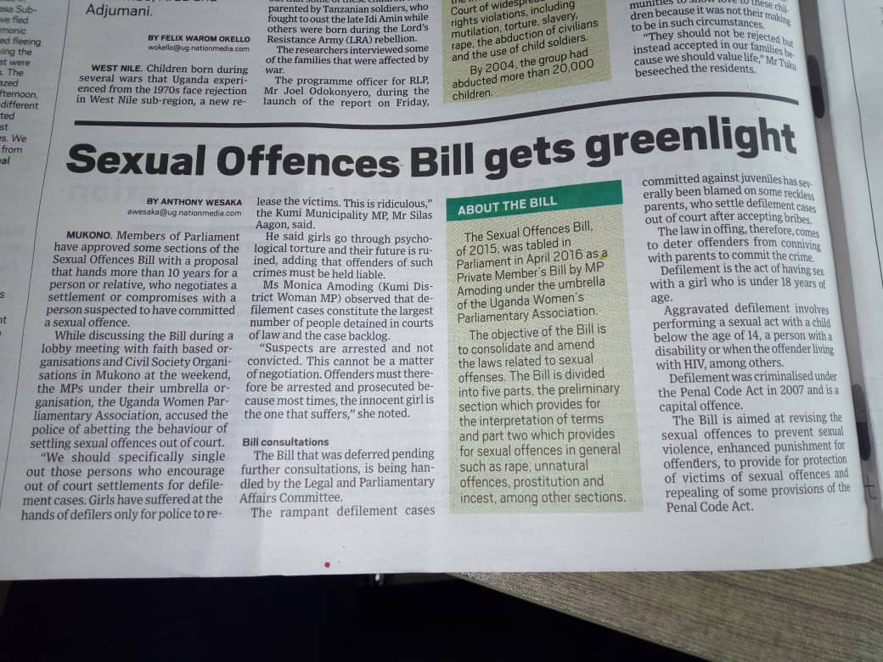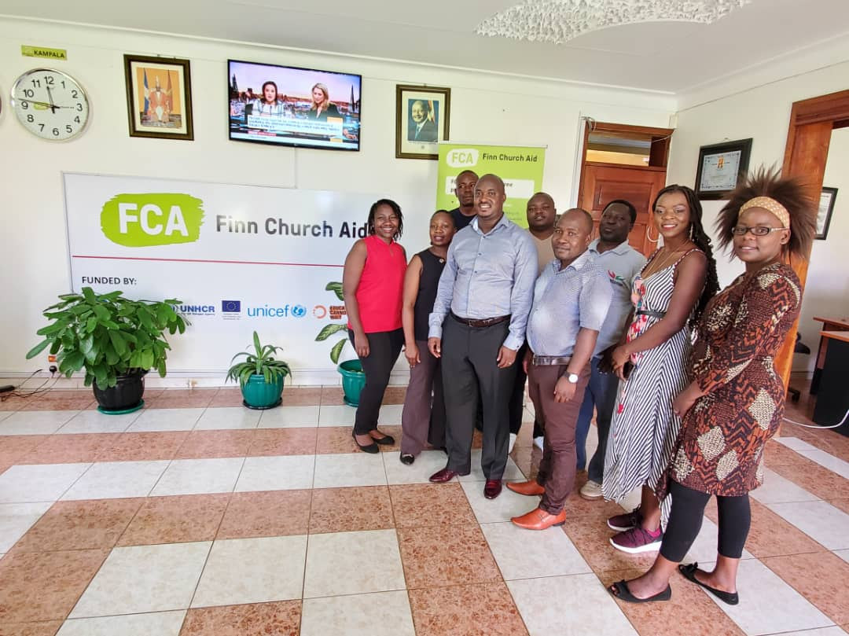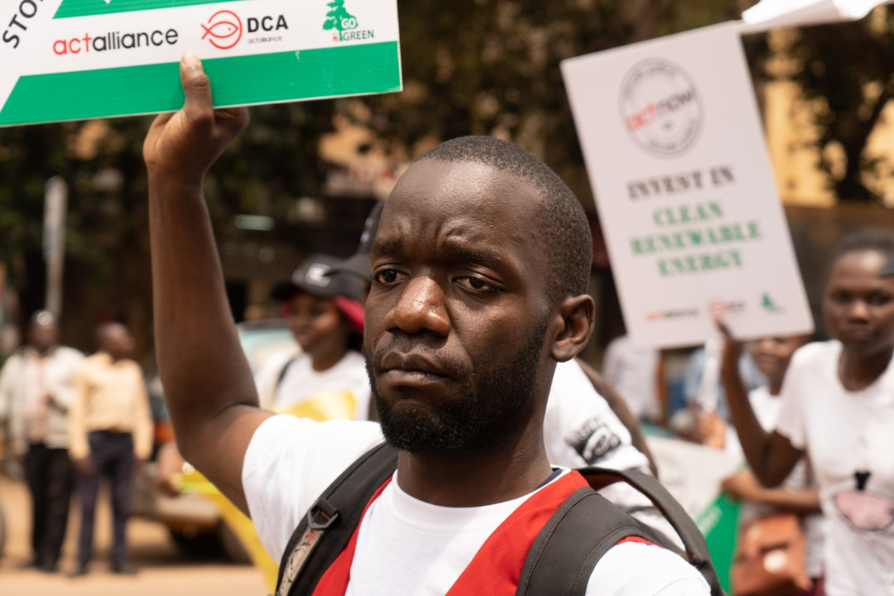

Picture: Above Left; the ACT Forum meeting in an EPRP session while on the right, the youth during the ACT Supported climate strike/march

Below: On the left, ACT Forum Malawi delegation visits ACT Uganda delegation for learning purposes , right; the sexual offences bill progress captured in the national newspaper

1. **Global ACT members** (by January 2018): Baptist World Aid (USA), ECLOF International (Switzerland), Lutheran World Federation (LWF - Switzerland), Mission 21: Protestant Mission Basel (Switzerland), The Salvation Army (UK), United Evangelical Mission (Germany), World Association for Christian Communication (WACC - Canada), World WYCA (Switzerland).
2. **Observer ACT members** (by January 2018): Anglican Alliance, Conference of European Churches (CEC), World Student Christian Federation (WSCF).
3. **National Council of Churches (NCCs) and Regional Ecumenical Organisations (REOs**), who are not ACT members, are required to be invited as permanent guests in the ACT forums.