Annexure 10

Case Stories

ACT Response

ACT Alliance Nepal Forum



Case 1

**ACT Alliance model village for earthquake relief created in Nepal**

Kathmandu, Nepal/Geneva

| 28/5/2015

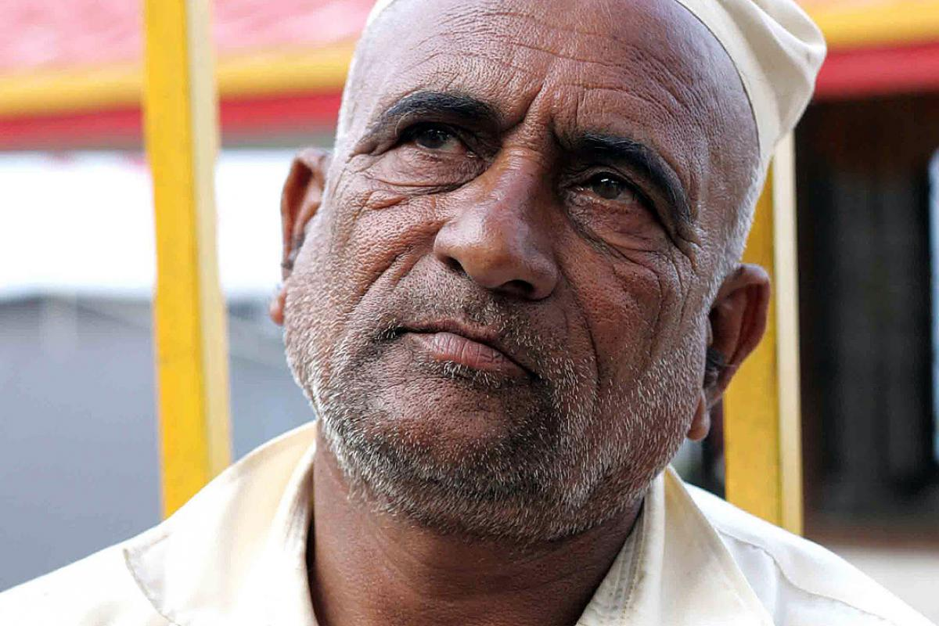

Punya Prasad Dangal lost his mother and granddaughter in the massive April 25 earthquake in Nepal. Photo: LWF Nepal

## Agencies combine earthquake response

Kathmandu, Nepal/Geneva, 21 May 2015 - Punya Prasad Dangal was in Kathmandu when the earthquake hit on April 25. He saw people falling off motorbikes and running around trying to find a safe place to shelter. Then the tremor stopped. Five minutes later the mobile phone in his pocket rang and changed his life forever.

It was a call from his son, Tara, who was with the family in Nanglebhare, a remote area in Kathmandu district. "Our house collapsed. Grandma was inside the house when it happened. My daughter Samiksha is also missing," Dangal heard his son say.

“Everything became a blur after that,” Dangal recalls. With his second son, Binod, who works as a medic, he took a motorbike to Nanglebhare. On the way there, the phone rang again: the family had found the grandmother’s body. “The dead body of my mother was taken out of the debris and placed in a corner. My granddaughter was still missing," Dangal said. Only two days later was he able to retrieve her body. She had been playing in a neighbor’s house and was buried when the house collapsed.

Nanglebhare is one of the badly affected rural areas in Kathmandu district. More than 95 per cent of the mud and brick houses in the area have been destroyed. Dangal’s family is one of many who lost loved ones, and along with them, their animals and livelihood. People now live in the open. The villages have a shortage of latrines, increasing the threat of an epidemic.

After an assessment, the LWF found that government agencies were not distributing relief materials in this area. Though it is only 20km from Kathmandu, Nanglebhare is extremely hard to reach. The road, which starts at an elevation of 1800m, is navigable only in fair weather.

To provide initial relief, the LWF- a member of ACT Alliance - distributed blankets, tarpaulins, mattresses, ready-made food, soap and hygiene material to 135 families in the village. To help in a sustainable way, though, Nanglebhare has been selected as an “ACT Model Village.” The ACT members that make up the ACT Nepal Forum will combine their expertise in different aspects of relief work – water, sanitation, food, shelter, cash grants, psychosocial support and education to assist the village in all necessary areas.

“A joint response in all the emergency sectors is not only possible but also more effective and resourceful,” the forum of ACT members states, in a report.

Food and shelter are the most immediate needs of  people, whose supplies are now covered by tons of mud and rock. "We could not take out anything from the debris and we have been surviving with the food brought in by our relatives," said Dangal. In Hindu culture, people mourn for 13 days while relatives bring in food. The family has been staying in a makeshift hut but with the monsoon coming, will need more than that.

"Rebuilding a place to live and arranging things to eat has become a tough challenge,” Dangal says. “But consoling your family after the death of loved ones is even harder.”

Case 2

[[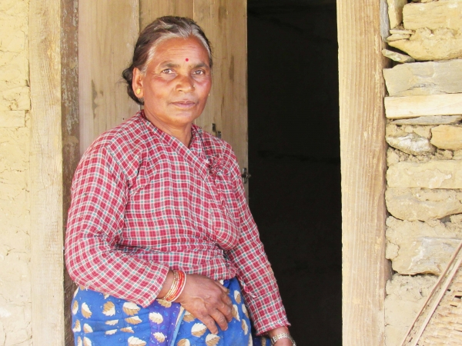](http://www.actalliancenepalforum.org.np/media/k2/items/cache/4695cb3b19cbf906e45dac0da0913068_XL.jpg)](http://www.actalliancenepalforum.org.np/media/k2/items/cache/4695cb3b19cbf906e45dac0da0913068_XL.jpg)

03 Aug 2017

Umesh Pokharel/LWF

## Reconstruction Symbolizes Dignity Featured

Radhika BK, 57, a single woman in Suri village development committee (VDC) in Dolakha district, had almost given up her hope to begin a normal life, following the April 2015 Nepal earthquake. Not only her house was collapsed, the falling wall killed her all cattle.

BK was alone in her house in Suri when the earthquake struck. She lived under tarpaulins for more than two months since the earthquake. Later on she constructed a temporary shelter with support from The Luther World Federation (LWF) Nepal and its partner Human Rights Awareness and Development Centre (HURADEC). Her children were in Kathmandu and used to visit her occasionally.

“When my children invited me to go to Kathmandu, I was in a dilemma,” she recalled a time one and half years ago. However, her intent to stay in her ancestral land outweighed her children’s wish. She decided to rebuild her house and spend her life where her forefathers lived for centuries.

**Supporting Hands**

Support from the Government of Nepal along with Evangelical Lutheran Church in America (ELCA), LWF Nepal, Dalit NGO network and their representative organization Dalit Welfare Association (DWA) have been a help to make her dream come true.

Following the earthquake, LWF Nepal with support from ACT Alliance provided her emergency shelter kit along with livelihood support package while during the recovery phase, LWF Nepal and Dalit NGO network and their representative organization DWA with support from ELCA provided them top-up shelter grant.

“With support such as tarpaulin sheets, nails and other shelter kits, I constructed a temporary shelter nearby my previous house,” she walked down the memory lane. “Later on, the top-up grant support of Rs 75,000 helped me to start reconstructing permanent shelter,” BK says.

Against such background, the Government of Nepal (GoN) announced the support of Rs 300,000 as a shelter support grant to the earthquake-affected households, the ELCA, LWF Nepal and DWA came up with the additional shelter support grant of NRs 75,000 each household. “The additional support was to fulfill the unmet fund requirement for the reconstruction, constructing a toilet and installing solar panel,” Dr Prabin Manandhar, Country Director of LWF Nepal says.

At present, Radhika has completed the construction of her house. With the construction of permanent shelter, her dream to live in her ancestral land has been fulfilled. Radhika plans to keep some goats, begin farm as usual and live peacefully in her village. “My house in my village means a lot for me, it is a symbol of dignity and happiness,” she says.

Case 3

# A safer place to stay

*17 January 2018*

*LWF/OCS*

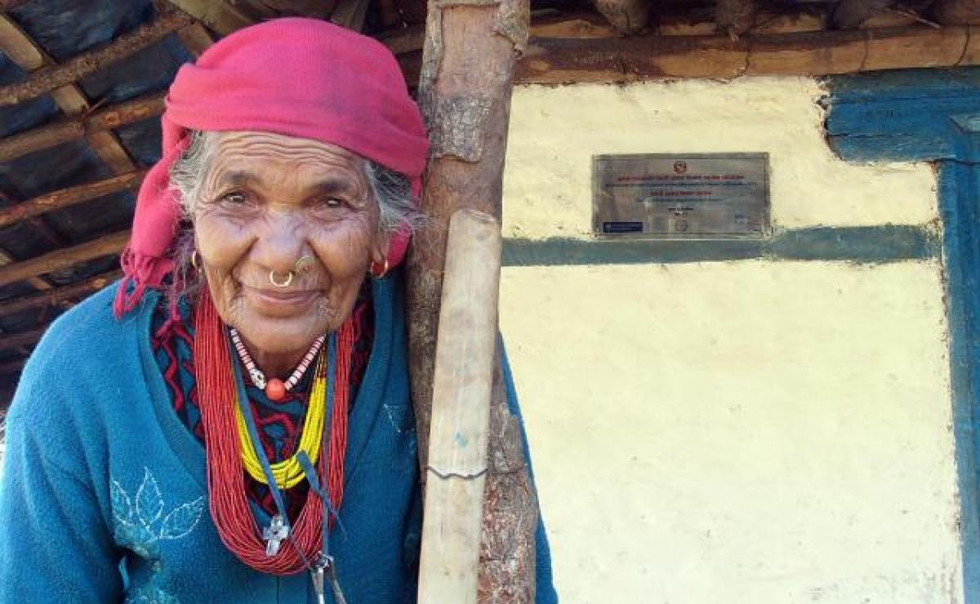

Kali Kamini, known as “grandma” to the village, in front of her new house.

## Re-building Homes and Lives after Devastating 2015 Earthquake

(LWI) - Building her own home has been a dream for Kali Kamini, known in her Nepali village as ‘Grandma’ – and her dream became reality thanks to The Lutheran World Federation (LWF) and a local women-led charity.

Bent at the waist and in her 80s, Kamini lost her home in [the devastating earthquake that hit Nepal on 25 April 2015](https://www.lutheranworld.org/content/emergency-nepal-earthquake), killing nearly 9,000 people and injuring another 22,000 in the worst natural disaster to hit the country since 1934.

### Renewed sense of hope

“ ‘Grandma’ Kamini told her story to LWF staff in the Sirangaun Village of Jugal Rural Municipality in Sindhupalchok district of Nepal, an eight-hour drive from the capital city, Kathmandu.

“Although I was assured money of Nepalese Rupees (NPR) 300,000, finding masons, managing food for them was a tough task for me. However, it has been possible due to support from Gramin Mahila Shrijanashil Pariwar (GMSP) and the LWF,” she said.

(GMSP is a female-led organization, established in 1993 by rural women from Sindhupalchok District in Nepal.)

Selecting [‘Grandma’s’ family as one of the shelter beneficiaries](https://www.lutheranworld.org/news/distributions-starting-worst-affected-districts-outside-kathmandu-valley) was not enough. She was in need of someone who could help her reconstruct the house. Therefore, LWF Nepal, [during its mason training program](https://www.lutheranworld.org/news/ninety-masons-trained-rebuild-rural-nepal), encouraged local masons to give priority to building her house.

So, Palsang Lama, 33, her neighbor and relative, offered her help reconstructing the house.  Lama coordinated the masons and the delivery of construction materials. As a result of the collaborative effort, the octogenarian has finally been able to build her house.

The house has brought a renewed sense of hope to her.  She has been able to get her life back. She wakes up in the morning, cleans her new house, prepares fodders for her goats, and fetches water at a nearby tap – then tends to her family.

“Finally my former days have been restored, I feel like going to my neighbor’s house every evening to have  a chit chat as I used to before the earthquake.” she added.

### Earthquake Shattering life and livelihood

‘Grandma’ was alone inside her house when the earthquake struck. It felt like the floor in front of her dropped. Dizzy at first, she eventually managed to leave, staying with her neighbors out in the open for nearly a week, living under a tarpaulin and dealing with frequent aftershocks.

Her house was destroyed. “It was like a bomb exploded,” she recalled.

She was hit by anxiety and her fears increased. Life looked hopeless. Her only support was her husband, Maila, who is in his 70s. Her daughter lives in another village in the district. It takes nearly five hours to walk to her home.

LWF Nepal reached ‘Grandma’s’ village with food, tarpaulins and other support immediately after the earthquake. It provided corrugated galvanized iron sheets to build temporary shelter. The elderly couple stayed under the tarpaulin for a number of months before moving to temporary shelter.

“Life under the tarpaulin and corrugated iron sheet was the worst ever in my life,” she remembered.

LWF emergency team in a Nepali village after the earthquake. Many houses in poorer regions were completely destroyed in the disaster. Photo: LWF/ C.Kästner

Within a year and a half of the earthquake, [LWF Nepal](https://www.lutheranworld.org/content/nepal) began providing technical and other services to help 142 households in her village rebuild their homes. Fortunately, ‘Grandma’ was among those chosen to receive this support.

Today, ‘Grandma’ frequently receives visits from her grandchildren from Pantang village, which gives her great pleasure.

“After the construction of my new house, they started visiting us frequently. Now, they have a safer place to stay.  The visit of my grandchildren makes me feel special, increases my hope for life and augments my confidence,” she concluded.

Story by Umesh  Pokharel. Edited by LWF Communciations

Case 4

Rebuilding homes and heritage in Nepal one year on

24 April 2016

LWF/OCS

One year ago a 7.8 magnitude earthquake devastated central and Eastern Nepal. A year later, with the help of LWF communities are being re-built. While millions of earthquake survivors will spend another monsoon season in temporary shelters, mountain communities worry about preserving their unique heritage, which draws countless tourists to Nepal. LWF Nepal and its partners help communities in the high Himalayas to build back their homes stronger, in the traditional way.

**LWF Nepal helps mountain communities reconstruct traditional houses**

(LWI) – It is early morning and the rising sun throws a beam of light into the shadowed Gatlang Valley, a Tamang community in the high Himalayas, close to the border with Tibet.

The village was hard hit by last year’s earthquake. All the traditional houses collapsed and four people died.

Once considered an example of unique mountain architecture, Gatlang, like any other village in Nepal’s worst affected districts, now is made up of rubble and shelters made from zinc sheets.

**Concerned about heritage**

In one of the temporary shelters, Pasang Tamang prepares breakfast for her family. The young mother of two has been living in a hut made from corrugated iron sheets and recycled wood from her damaged house for close to a year. Pasang tells us she is worried, not only about the delay in reconstruction, but also about the way the houses of Gatlang will be rebuilt.

“This is a cold place. Our forefathers used wood to build warm houses. Because even our roofs were made from wood, our village is known as ‘Black Village’ and used to attract many tourists. Building back in the traditional style will be good for us and for the hotels. But buying wood is very expensive, and cutting trees is seldom allowed.”

Pasang is not alone in her worries. Across Nepal people are concerned about a loss of heritage after the 2015 earthquake destroyed or damaged over 750,000 homes.

Although the relief provided by LWF Nepal and its partners and other agencies has been hailed as timely and effective, the survivors, one year after the disaster, still mostly live in temporary shelters or risk their lives by moving back into their damaged homes. Millions of people brace themselves once more for the monsoon season, which lasts for four months and unleashes heavy rains which damage shelters and lead to dangerous landslides.

**Rebuilding homes**

The delay in reconstruction was caused by a political crisis following the passing of a new constitution in September 2015, and delays in setting up a National Reconstruction Authority to oversee the distribution of government support and approves designs for earthquake-resilient houses. Although the use of stones and wood is allowed, people have to follow strict and go through a lengthy approval process.

LWF Nepal joined hands with Islamic Relief Worldwide and local partner Manekor Society Nepal to support communities in five communities of Rasuwa district. The communities will select 230 vulnerable families to rebuild their home. LWF Nepal also prepares the people for rebuilding their homes by providing training in masonry. The training is crucial to ensure the new houses have a strong structure when using locally available materials like stones, mud and wood. By now 150 community members, including many women, have been trained in masonry.

“Reconstruction is not only about rebuilding homes, but also about rebuilding heritage,” says LWF country director Dr. Prabin Manandhar. “Culture is the heart of our nation. Gatlang’s architecture, in which the joint houses were built step wise in lines, and blended in with the natural surroundings, was unique and attracted countless tourists. So rebuilding in the traditional style is also important to recover livelihoods.”

Meanwhile in Gatlang people prepare themselves for the one year commemoration of the 25 April earthquake. “We are grateful for the support we got so far, but are concerned about spending another monsoon and possibly another winter in homes that are inappropriate for this climate,” says Pasang.

While serving breakfast to her children, Pasang says: “As much as possible we want to rebuild our houses in the traditional way. But for buying wood we need money, which we don’t have. I hope we will get support in rebuilding our houses the traditional way, so that we can survive in this cold, remote place.”

While others remain asleep in the early morning, a woman heats water for tea over a fire in her family's temporary shelter in the village of Gatlang, in the Rasuwa District of Nepal near the country's border with Tibet.

The village was hard hit by last year’s earthquake. All the traditional houses collapsed and four people died. Once considered an example of unique mountain architecture, Gatlang, like many other villages in Nepal’s worst affected districts, now is made up of rubble and shelters made from zinc sheets.

A Tamang woman cuts branches to make a temporary shelter. To shield against the cold in the mountains, the entire village was built from wood. Because even the roofs were made from wood, the village is known as ‘Black Village’ and used to attract many tourists.

A woman carries a beam for her new house through the village of Gatlang. In the aftermath of the April 2015 earthquake, the Lutheran World Federation, a member of the ACT Alliance, helped people in this village with a variety of services, including shelter and livelihood assistance.

A man nails on tin roofing provided by ACT Alliance as he puts the finishing touches on a transitional shelter. Traditional split-wood roofs of the village have been replaced with tin sheets in the wake of the quake.

Pasang Bri Ghale winnows grain at her home in the Tamang village of Goljung, in the Rasuwa District of Nepal near the country's border with Tibet.

Sita Ghale, 14, uses a pestle and mortar to grind grain in the village of Goljung, in the Rasuwa District of Nepal near the country's border with Tibet. Preserving traditional lifestyle also means re-building villagers’ livelihoods.

Sita Ghale, 14, winnows chaff from grain. Her village Goljung is located in the same district and was equally affected by the earthquake one year ago.

Anaju Tamang, 67, holds reeds he is going to cut and weave into a mat in Goljung village. With the help of the LWF they plan to re-build in the traditional way.

A woman and child obtain water at a communal tap in the village of Gatlang, in the Rasuwa District of Nepal near the country's border with Tibet. LWF Nepal also prepares the people for rebuilding their homes by training them to build quake-proof. By now 150 community members, including many women, have been trained in masonry.

Contribution by LWF correspondent Lucia de Vries.

Annexure– 22

Submitted to:

DEC

By:

Christian Aid

February 2017

**ACT Alliance Nepal Forum**



**ACT Alliance Nepal Forum**

**GPO Box No: 3330, House No. 217, Chundevi Marga -4**

**Maharajung, Kathmandu, Nepal**

**Tel: +977-1-4720217,4720152**