Annexure 3

**ACT General Secretary Visit**

**7-11 March 2016**

ACT Alliance Nepal Forum

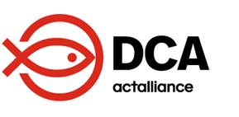

**ACT General Secretary Visits Nepal**

LWF Nepal, a member of ACT Alliance, was one of the first responders to the 2015 Nepal earthquake. Dr Prabin Manandhar, Country Director, called a meeting, at the office premises while the ground was shaking, within hours of the temblor. This was perhaps an exceptional meeting as it was called amid powerful aftershocks. The meeting decided to immediately distribute relief around the core areas of Kathmandu, the capital city.

Similarly, Dr Manandhar, called the first emergency meeting of the ACT Alliance Nepal Forum on Monday, two days after the devastating earthquake, that too amid powerful aftershocks. An everyday meeting was called for about two months to devise plan, to develop proposal and to distribute relief to the affected people.

Thanks to such a proactive and dedicated emergency work, LWF Nepal and other members of the ACT Alliance Nepal Forum were able to reach the unreached within a week. Such planning was instrumental in saving the lives of the people who had not received any support for many days, particularly those who lived in the remote areas of the badly affected districts.

The relief and recovery work of LWF Nepal was appreciated by the government agencies, the beneficiaries and covered by the mainstream national media.

Against this backdrop, Dr John Nduna, General Secretary of ACT Alliance, visited Nepal to observe the earthquake response going on in the affected communities and to take stock of the overall scenario and the policies and plans of the Government of Nepal on earthquake response.

Dr Nduna held meetings with the high-level officials of the National Reconstruction Authority (NRA), a government mechanism set up in the aftermath of the earthquake to streamline the entire response programs and activities. He also met with representatives from Association of International NGOs in Nepal and had a press meet as well.

Dr Nduna visited different affected communities in Sindhupalchok district, one of the most affected districts by the earthquake. He interacted with women, men girls and boys there.

He also paid a courtesy call on Right Honorable Prime Minister Mr. KP Sharma Oli on 9 March 2016. Dr Nduna was accompanied by Dr Manandhar, and Dave Smith, Country Director of Dan Church Aid, one of the ACT members. Dr Nduna also held meeting with Honourable Deputy Prime Minister and Minister for Women, Children and Social Welfare Mr. CP Mainali and Honourable Deputy Prime Minister and Minister for Home Affairs Mr. Kamal Thapa at the Prime Minister’s Office. Both the ministers were related with emergency response.

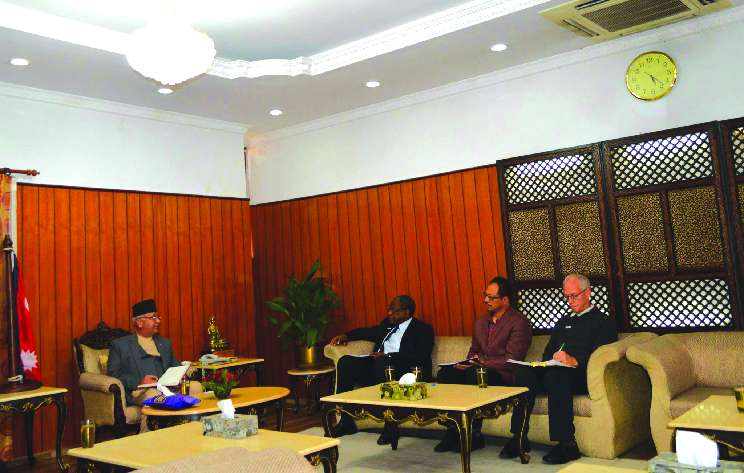

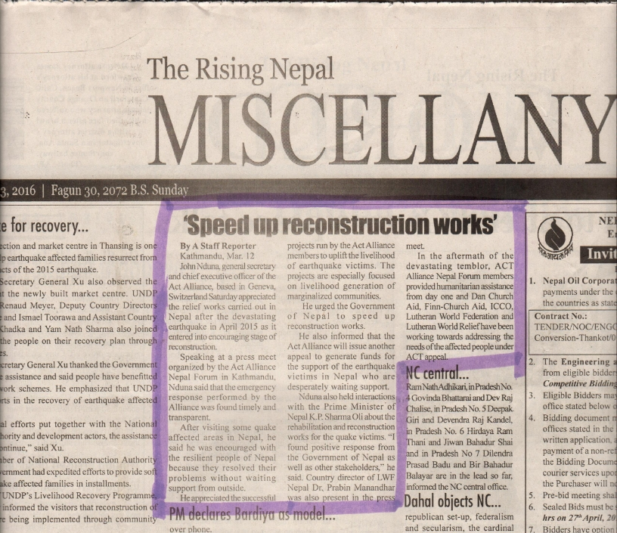

Annexure– 22

Submitted to:

DEC

By:

Christian Aid

February 2017

**ACT Alliance Nepal Forum**



**ACT Alliance Nepal Forum**

**GPO Box No: 3330, House No. 217, Chundevi Marga -4**

**Maharajung, Kathmandu, Nepal**

**Tel: +977-1-4720217,4720152**