Annexure 4

**ACT response to the Gorkha Earthquake**

**Lessons Learnt**

**ACT Alliance Nepal Forum**

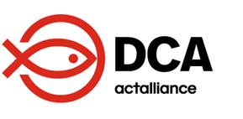

ACT Alliance Nep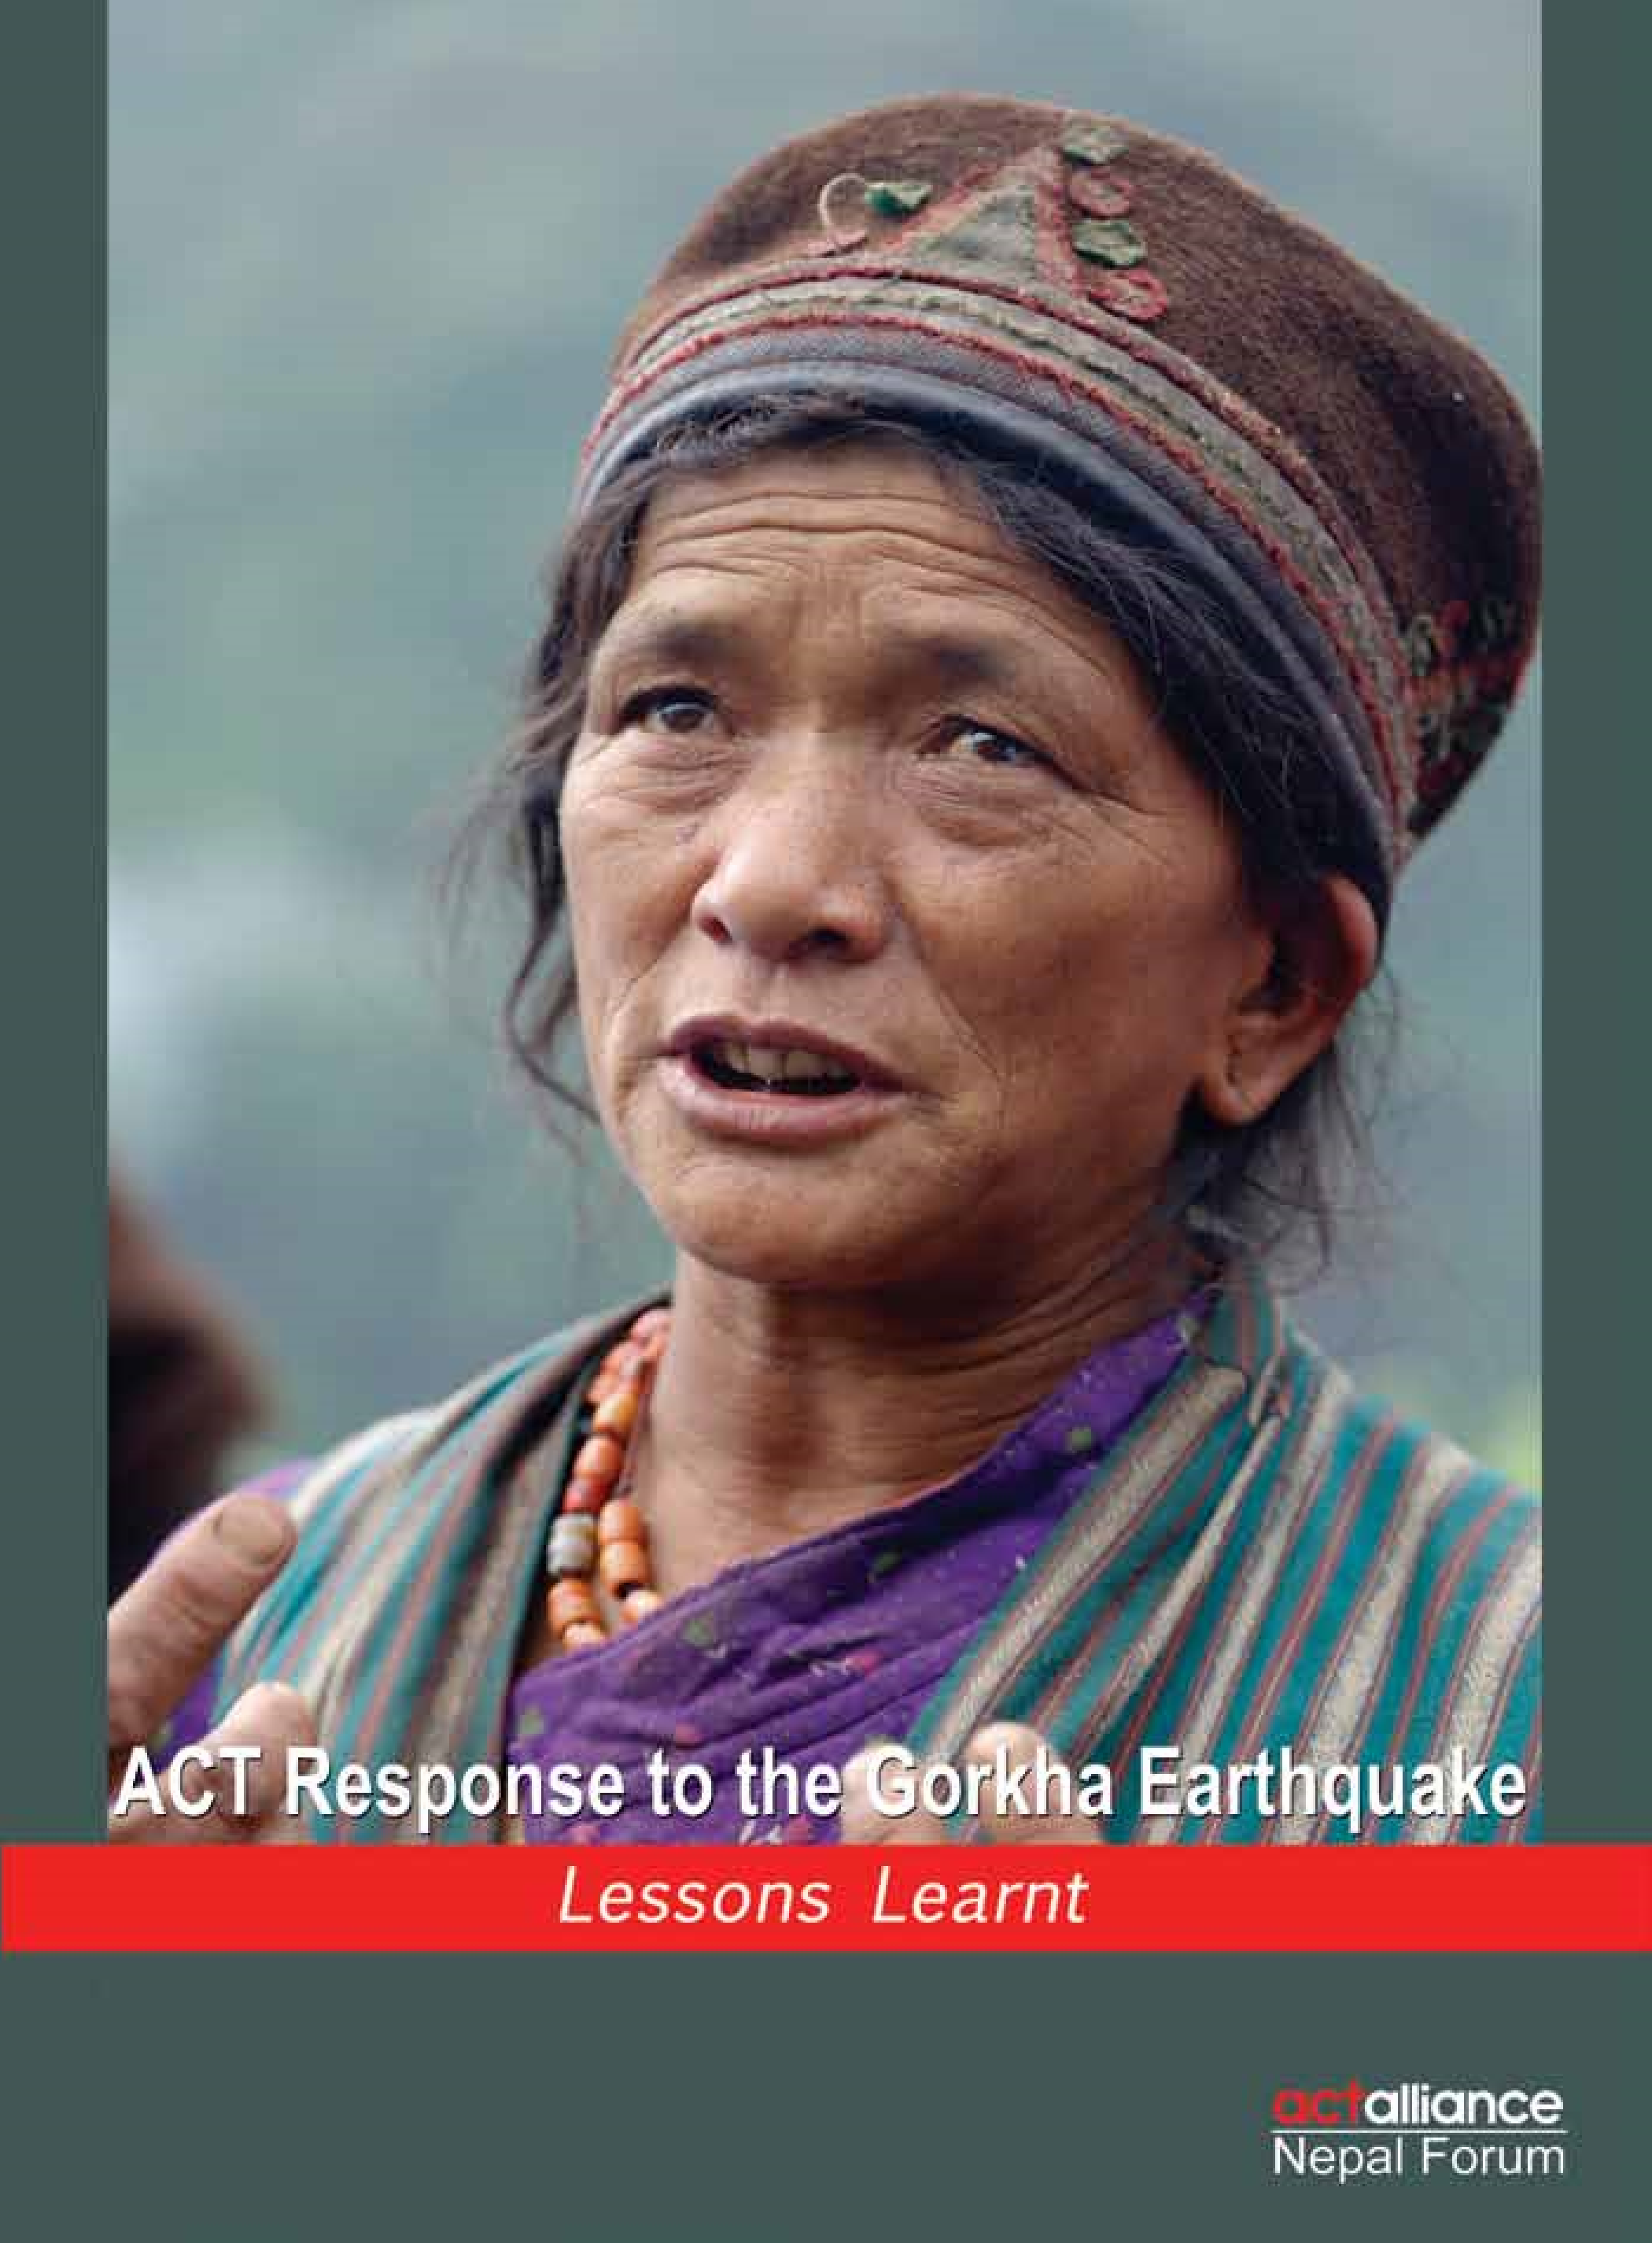

**arnt**

**ACT Response to the Gorkha Earthquake: Lessons Learnt**

©2016 ACT Alliance Nepal Forum

ACT Alliance Nepal Forum reserves all rights of ownership to the original material in this

report. No part of this document can be reproduced, stored in a retrieval system or

transmitted in any form or by any means without written permission of ACT Alliance

Nepal Forum. Readers are, however, free to make use of the material for noncommercial

purposes in course of development work. ACT Alliance Nepal Forum requests to properly

acknowledge such use.

**Disclaimer**

The material and the geographical designations in this report do not imply the expression of

any opinion whatsoever on the part of ACT Alliance Nepal Forum concerning the legal status

of the country, zones, districts, municipalities, village development committees or areas, or

concerning the delimitation of its boundaries.

**Cover photo:**

An earthquake-affected woman from Goljung, Rasuwa speaks to humanitarian

aid workers about the condition of the survivors.

*LWF Nepal*

Design and Print: Media Gallery Pvt. Ltd.

**Message from the Convenor**

Dear colleagues and well-wishers,

I am happy to share with you “ACT Response to the Gorkha Earthquake: Lessons Learnt,” a report on ACT Alliance Nepal Forum’s humanitarian support to the people affected by the Gorkha Earthquake. It encapsulates the work that the members of the Forum accomplished, the challenges faced during implementation and the lessons learnt from the emergency.

All the members focused their efforts to reach out the unreached and the most vulnerable while distributing relief materials, providing temporary and transitional shelters, livelihood support, psychosocial counselling, carrying out WASH activities.

We were among the very few humanitarian and development organizations that began relief work right from day one. Soon our members were able to reach the far-flung and inaccessible places hit hardest by the temblor.

On the one hand, there were competing needs of the earthquake-affected people form the 14 worst-hit districts. And there were dearth of relief materials in the local market, on the other hand. On top of that the months-long blockade imposed by India on the border exacerbated the problem. Despite the difficulties, we were able to reach the remoter parts of Gorkha, Lamjung, Dhading, Makawanpur, Kathmandu, Lalitpur, Bhaktapur, Rasuwa, Sindhupalchok, Dolakha, Kavrepalanchok, and Nuwakot districts.

ACT Alliance Nepal forum is the second largest network of the humanitarian and development organizations working in Nepal and particularly during the emergency. Our locally rooted partner organizations’ knowledge of the field, culture and the zeitgeist, and our international experience in responding large-scale calamities rendered us stronger and more relevant for the emergency response.

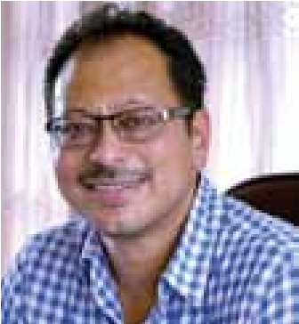Our intervention ranges from distribution of food and non-food items, shelter, education, water, sanitation and hygiene, cash support for livelihood, capacity building of local people, temporary shelter, psychosocial counselling to disbursement of cash for permanent shelter. Despite our willingness, commitment, expertise and availability of financial resources, our intervention particularly on reconstruction was marred by lack of clear and timely guidelines on permanent shelter from the government and delay in the formation of the National Reconstruction Authority. Our members provided support to the affected people of the district based on the thematic areas of intervention. This not only created synergy, but also proved relevant in terms of efficient and effective use of the scarce resources while supporting the most needy and vulnerable sections of the affected people.

Guided by our international code of conduct and best practices, our members strictly followed the Core Humanitarian Standard, Sphere Standard, the standard set by the Red Cross throughout our intervention in each geographic area.

All the activities mention in the report were carried out since April 2015 to April 2016. Building back safer was our priority. All of our members carried out the humanitarian support adopting ‘linking relief, rehabilitation and development’ approach for the sustainability of our intervention.

All ACT Alliance Nepal Forum members worked in coordination with the government agencies at the national and local levels, ensured the meaningful participation of the beneficiaries in decision-making and consulted a wide range of stakeholders during the entire intervention. We were able to reach more than 500,000 hard-toreach people during the year.

Our achievements are but the results of our collective commitment, passion, hard work and unity of members, implementing partners, beneficiaries, supporting partners, and government agencies, civil society actors, media and the colleagues.

I would like to thank all the beneficiaries, government officials, heads of organizations, thematic leaders, communication colleagues of ACT Alliance Nepal Forum members and volunteers. I also thank Mr Pranaya Shumsher JB Rana, Mr Umesh Pokharel and Mr Ram Sharan Sedhai for bringing out this publication. Happy reading!



Dr Prabin Manandhar

Convenor, ACT Alliance Nepal Forum

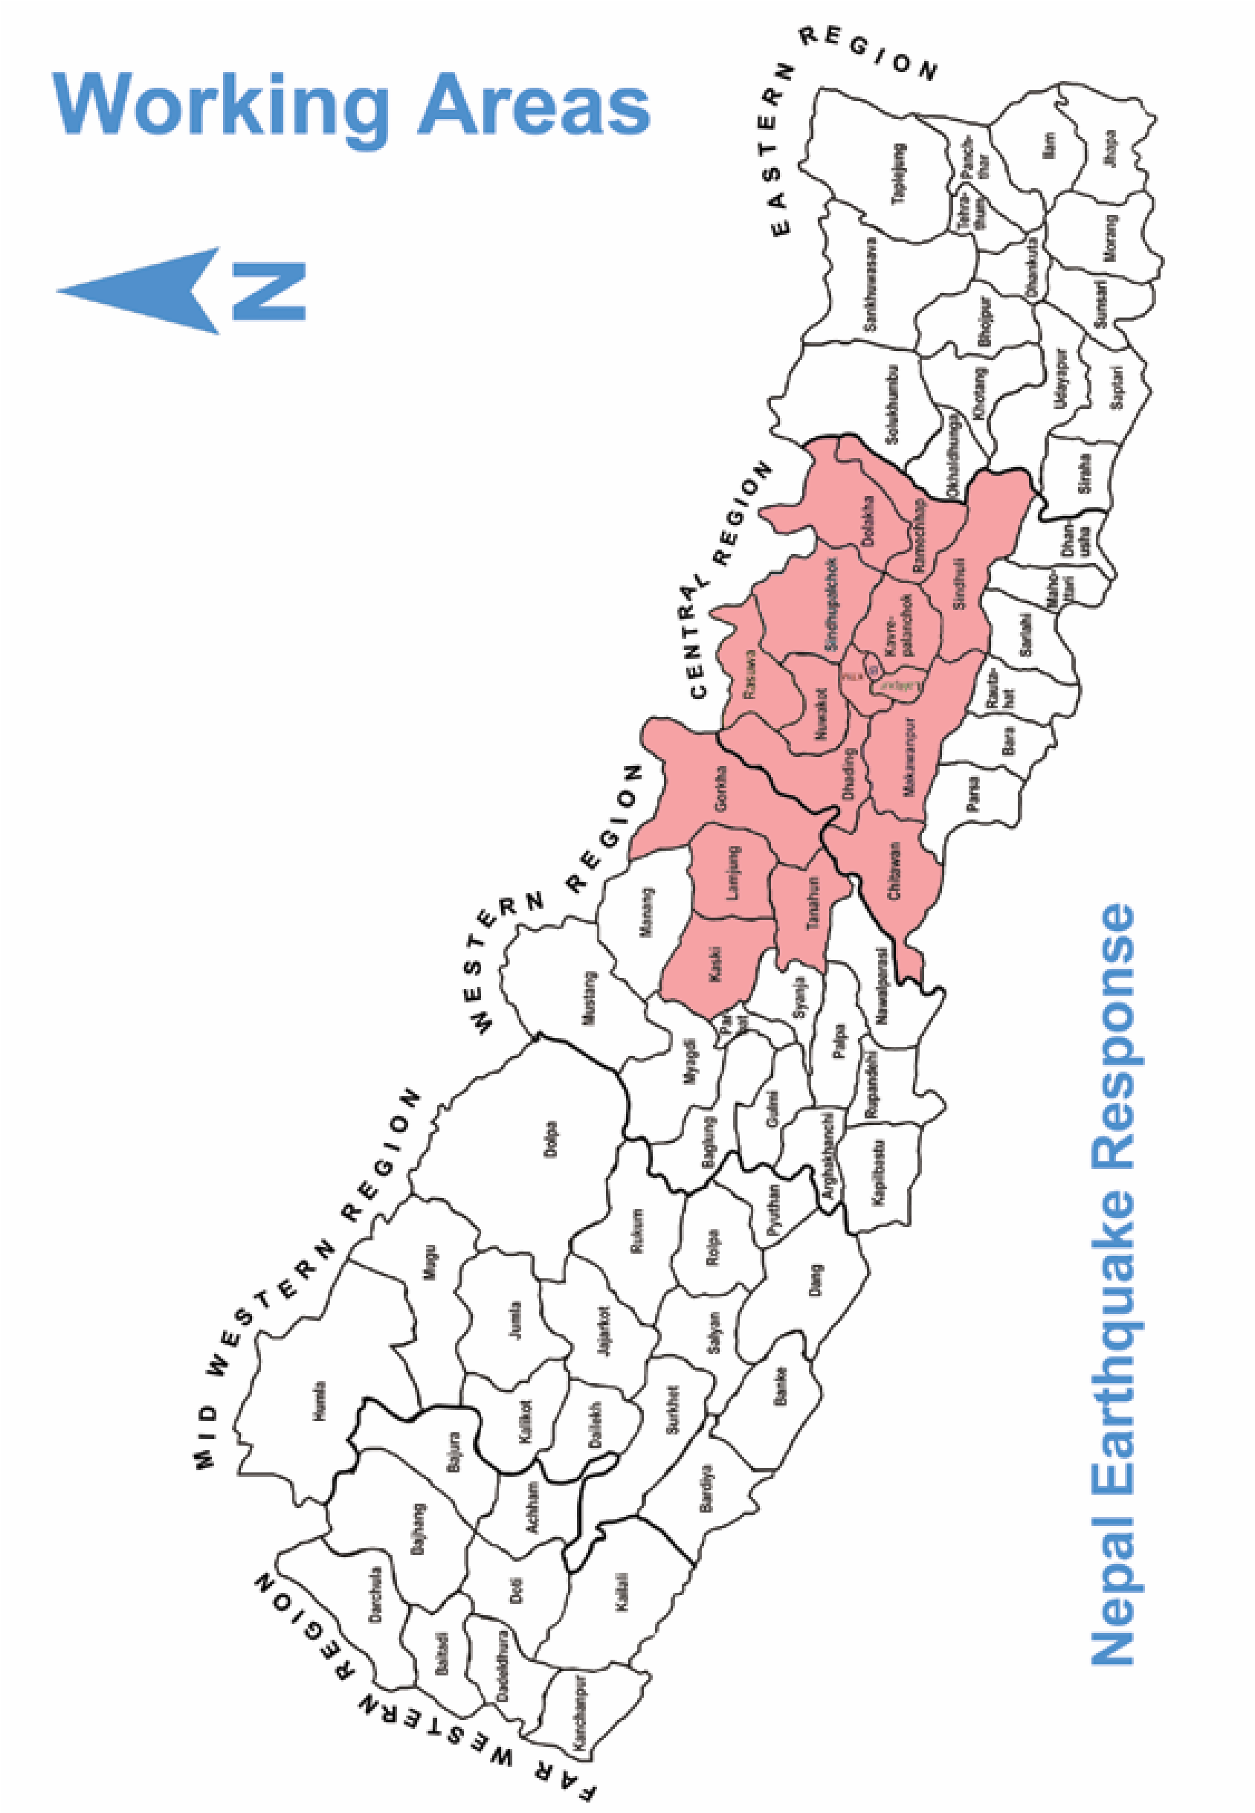

## Acronyms

ACT Action for Churches Together

CA Christian Aid

CBPSS Community-based Psychosocial Support

CBO Community-based Organization

CRM Complaint Response Mechanism

CTP Cash Transfer Programming

CWSS Community Water Supply Scheme

DCA Dan Church Aid

DDRC District Disaster Relief Committee

DKH Diakonie Katastrophenhilfe

DRR Disaster Risk Reduction

DUDBC Department of Urban Development and Building Construction

ECHO European Commission’s Humanitarian Aid and Civil Protection Department

FCA Finn Church Aid

FCHV Female Community Health Volunteer

HIV Human Immunodeficiency Virus

HURADEC Human Rights Awareness and Development Centre

INEE Inter-Agency Network for Education in Emergency

INGO International Non-governmental Organization

KUKL Kathmandu Upatyaka Khanipani Limited

LWF The Lutheran World Federation

LWR Lutheran World Relief

NCA Norwegian Church Aid

NERP Nepal Earthquake Response Program

NGO Non-govermental Organization

NRA National Reconstruction Authority

TLC Temporary Learning Centre

TWG Technical Working Groups

UK United Kingdom

UN United Nations

VDC Village Development Committee

VDMC Village Disaster Management Committee

WASH Water, Sanitation and Hygiene

WOREC Women’s Rehabilitation Centre



### Summary

Christian Aid (CA) responded to the earthquake-affected communities in Nepal from early days through local partners and deployed staff from its regional office in Delhi and headquaters in London in addition to the local staff. CA worked within the UN cluster systems and coordinated with District Disaster Relief Committee (DDRC) since the first earthquake struck. CA and local partners have worked tirelessly, reaching more than 100,000 people with vital emergency supplies across the worst-affected areas in Sindhupalchowk, Gorkha, Dhading, Dolakha, Kathmandu, Bhaktapur and Rasuwa. CA's immediate response started from Arughat, Gorkha on 26th April 2015.

CA works through local partner to enhance local capacity and build on existing strength. This is done with the aim to ensure they are better prepared to engage with and influence other actors. As an example, our partners are actively working with ward citizen forums, in each of the target wards within the Village Development Committee (VDC) in which they operate.

During an extremely stressful period, in the beginning of emergency response action, Christian Aid distributed tarpaulin (emergency shelter) to 18,351 households, hygiene kits to 10,038 households, water purification tablets to 20,043 households and food items to 11472 households. CA also installed 15 water purification units across the districts.

During the recovery phase, CA worked in four most-affected districts, Dhading, Gorkha, Sindhupalchok and Dolakha wherein individuals received support in transitional shelter, MPG, WASH and livelihood. Similarly, CA provided temporary shelter support along with masons training to 5,813 individuals, WASH support to 62,452 individuals, livelihood support to 1,413 households and MPG cash grant to 2,776 individuals.

The major learning of the CA program has been to be ready for changes. The last one year has shown us that we can initiate a large scale response program in a country with no presence and yet be successful with it. The entire action in Nepal has shown that as an organisation, CA can come together with various offices across regions providing support and surge capacities to ensure that the CA programming is leading world class.

#### Background

CA is a UK and Ireland-based development and humanitarian organization that works to support sustainable development, stop poverty, support civil society and provide disaster relief in South America, the Caribbean, the Middle East, Africa and Asia.

CA works where the need is greatest, regardless of religion, nationality or race, and has supported humanitarian and development partners globally to eradicate poverty and fight climate change for more than 65 years. CA works with over 600 local partner organizations in 50 countries around the world.

CA has been working in Nepal since 2004 through various partners and, in the aftermath of the April 2015 earthquake, established an office in Nepal. CA is a member of AIN and is registered with the Social Welfare Council. It believes in

|  |  |  |  |  |
| --- | --- | --- | --- | --- |
| **Project** | **Districts Partners** | **HHs** | **Sector** | **Donor** |
| Emergency Response | Sindhupalchok-CEN,  Sindhupalchok, Rasuwa,  Bhaktapur, Kathmandu &  Lalitpur -LWF,  Gorkha and Dhading - Practical Action | 17,000 8,000  7,500 | Emergency Shelter  Emergency WASH,  Food Distribution | CA Appeal,  DEC, Irish  Aid, Roddick  Foundation |
| Earthquake Recovery | Sindhupalchok-CEN,  Dolakha -LWF,  Gorkha and Dhading - Practical Action | 3,000  3,000  3,000 | Shelter  WASH  Livelihood | DEC |
| Nepal Earthquake Recovery Program | Sindhupalchok- CEN | 765  1,431 | Shelter  WASH  Livelihood | ECHO |
| Nepal Earthquake Recovery Program | Dhading-FOCUS, Gorkha- GORETO, Dolakha- CEEPARD  &HURADEC | 5,283 | Shelter  (Winterization  Support) | DEC |

#### Programs and Projects

providing a credible voice to the excluded and marginalized through capacity enhancement and investment in capacity building. CA responded to earthquake-affected communities in Nepal from the early days of the disaster through its local partners and deployed staff from its regional office in Delhi and its headquarters in London, in addition to local staff. CA worked within the UN cluster system and coordinated with various DDRCs.

CA and its local partners have worked tirelessly, reaching more than 100,000 people with vital emergency supplies across the most-affected areas in Sindhupalchok, Gorkha, Dhading, Dolakha, Kathmandu, Bhaktapur and Rasuwa districts. CA’s immediate response started from Arughat in Gorkha on 26 April, 2015.

### Relief Phase

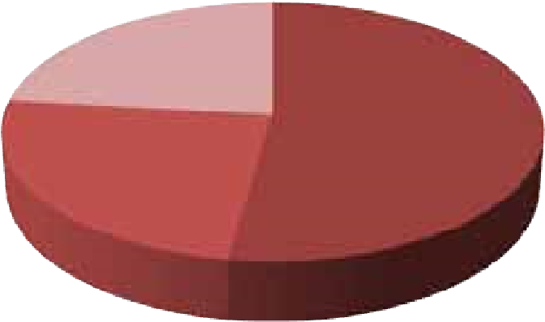

Shelter 17,000

WASH

8,000

Food Distribu

ti

on

7,500

**Emergency Response**

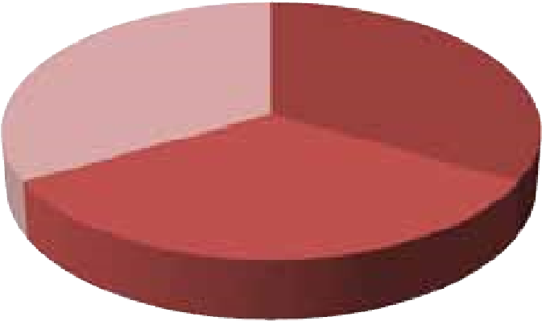

Shelter 3,000

WASH 3,000

Livelihood 3,000

**Earthquake Recovery**

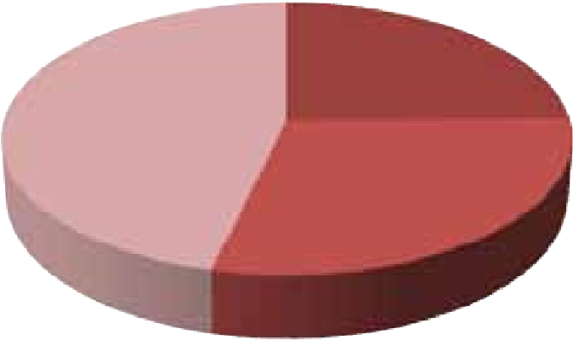

Shelter 765

WASH 896

Livelihood 1,431

**Nepal Earthquake Recovery Program**

CA responded to the disaster in seven districts (Bhaktapur, Lalitpur, Kathmandu, Gorkha, Dhading, Sindhupalchowk and

Rasuwa), in partnership with LWF, PA and CEN. CA provided emergency shelters, water and food.

* **Emergency Shelter:** Emergency shelter kits were distributed to 18,351 households across the most-affected districts within a month of the disaster.
* **Emergency Water Distribution:** 
  + CA installed 15 water purification units across the districts within one month, comprising five water filters with pumps, which provide 1,500 litres per hour, running for an average of 10 hours a day.
  + A large Ultra Membrane filter with a 10,000 litres tank was also installed, providing 4,000 litres of water per hour over a 10-hour period daily. A bladder tank (10,000 litres) was installed at Padma Higher Secondary School in Bhaktapur with a community water filter and a Honda pump, which provided safe purified drinking water to schoolchildren and communities (2,400 individuals).
  + All units were handed over to communities, with periodic maintenance being carried out by WASH engineers an needs-based support through repair materials, toolkits and training.
* **Food Distribution:** About 11,472 HHs were provided with dry food rations for a month to ensure food security.

|  |  |  |  |  |  |  |  |  |  |  |  |  |  |  |  |  |  |  |  |  |
| --- | --- | --- | --- | --- | --- | --- | --- | --- | --- | --- | --- | --- | --- | --- | --- | --- | --- | --- | --- | --- |
| **Recovery Phase** of the most-affected districts, providing  After the emergency relief phase response, transitional shelter, WASH and livelihood CA started with recovery action in four support.  2,686  1,729  416  982  20,449  22,353  17,756  1,894  1,017  0  759  1,000  0  1,431  0  0  0  5000  10000  15000  20000  25000  Dhading  Sindhupalchok  Gorkha  Dolakha  **Recovery Phase**  Trasnsi  ti  onal Shelter  WASH  MPG  Livelihood   |  |  |  |  | | --- | --- | --- | --- | | **District** | **VDC** | **Activities** | **Achievement** | | Dhading | Jyamrung, Chainpur, Aginchok, Gumdi, Jiwanpur, Salyantar | Transitional Shelter  WASH  MPG | 2,686  20,449  1017 | | Sindhupalchok | Pangretar, Thulopakhar, Attarpur, Jethal Pangretar | Transitional Shelter  WASH  Livelihood | 1,729  22,353  1,431 | | Gorkha | Borlang, Asrang | Transitional Shelter  WASH  MPG | 416  17,756  759 | | Dolakha | Suri, Marbu, Jiri | Transitional Shelter  WASH  MPG | 982  1,894  1,000 | |

#### Process Followed

Sites for implementation of programs were selected in coordination with the DDRCs and different clusters at the district level. The clusters allocated VDCs as per needs as well as through partner reports. Selection of beneficiaries was conducted based on a scorecard developed by the shelter cluster, which mostly included those who were most vulnerable to after effects of the disaster, those with low economic capacity, the marginalized and Dalits, indigenous groups, single women and the people with disabilities.

Similarly, CA ensured that both transitional shelter and prototype shelter were constructed in areas that were safe from landslides, floods and other hazards. Accessibility for the elderly, children and people with disabilities were also kept in mind while constructing shelters. Trained carpenters and masons were involved in the construction and on-the-job training was also provided.

CA followed cluster guidelines as well as government policies and guidelines for better coordination with agencies and beneficiaries. It continually participated in cluster meetings at the national and district levels for better coordination and the sharing of knowledge and experience. CA played a key role in the Shelter, Early Recovery and WASH cluster, including as a part of Technical Working Groups (TWGs). VDC/ Village Disaster Management Community (VDMC) consultations and recommendations were also considered while implementing activities.

With technical expertise from shelter advisors, CA developed IEC materials on building safe temporary shelters and suggestions for homeowners. It developed technical guidelines for safe transitional shelters, including techniques like anchorage, bracing, continuity, ductility, and Enhancement for construction. Since CA believes in need-based, culturally-appropriate and high-quality relief material, it also participated in the following clusters: Shelter, Cash, WASH and Early Recovery. It was also a key member of the Winterization TWG.

#### Challenges Faced

* A needs assessment in the rapid response phase would have helped agencies formulate a more informed response strategy.
* Targeting was a challenge, given the blanket approach adopted. As resources were limited, a targeted approach would have ensured that the needy received their relief in time.
* Devoid of any selection criteria, agencies were forced to provide all members in the community with relief and emergency material.
* It would have been very helpful if community meetings had been conducted and the criteria for selection shared with locals.
* There was also a strong need to coordinate with local leaders, women’s groups, VDC secretaries as well as CBOs.

#### Ownership and Sustainability

CA supported the rebuilding of a water supply scheme and provided toilet kits in Dhading district. With the active participation of the community, CA has been able to coordinate with the VDC and allocate funds for regular repair and maintenance of the Community Water Supply Scheme (CWSS).

Beneficiaries of shelter, toilet and water scheme support in Sindhupalchok also contributed with their salvage and labor, building a level of ownership. “Christian Aid provided us with material but my family toiled for 10 days building the shelter,” said Akkal Bahadur Mijar of Pangretar-2 in Sindhupalchok. “I feel like I can live in this house for five to seven years without fear of another big earthquake.”

#### Lessons Learnt and Way Forward

Aid agencies and authorities have responded to earthquakes and its frequent aftershocks over the past year and their collective experience has provided a number of valuable lessons for the future.

**Focus on geography and communities:**

* Agencies need to move quickly into remote areas
* Target marginalized communities
* Disaster response activities must combine structural measures, such as the constructing quake-resistant buildings and roads, with non-structural measures, such as enhancing the rights and negotiating power of vulnerable and marginalized communities
* Be aware of logistical challenges in the Kathmandu Valley and in rural and urban areas

**Preparedness:**

* Need to move into Disaster Risk Reduction (DRR) and preparedness to build resilience
* Deployment of contingency stocks across the region
* Livelihood is key to recovery. In most cases, people’s means of making a living have been destroyed. Survivors must be assisted to rebuild livelihood to help them cope with and recover from shocks and stresses

**Human capital:**

* Invest in locally capable people
* Training and capacity building should be a priority

**Recommendations:**

* Work rapidly on shelter reconstruction in active coordination with the Nepal Reconstruction Authority (NRA)

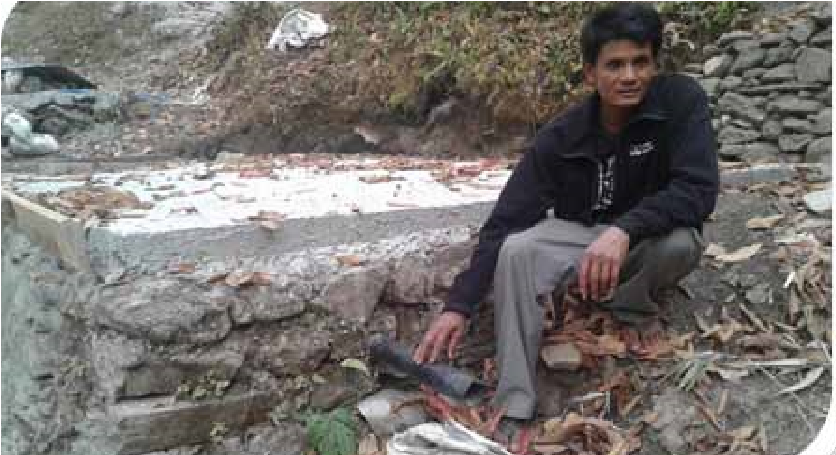**Story of Change**

* Establish a learning exchange platform for Nepal
* Focus on an amalgam of traditional shelter construction and modern seismic proofing
* Encourage the use of locally-available resources, including hardware (building materials), human resources and construction methods
* Remain apolitical
* Target vulnerable groups and mainstream response actions by

including marginalized and ‘off-grid’ communities

* Develop local advocacy groups and strong implementing partners which are better able to respond to future disasters by provisioning of contingency stocks and rapid response funds
* Prepare a detailed matrix and a clear policy on T-shelters

Thirty-six-year old Yam Bahadur Gahatraj lives with his wife and two children at Pangretar-6 in Sindhupalchok. He works in a metal workshop with his brother and although he has to earn a daily wage to provide for his family, he makes time for community work. He is very active and works with the ward representative for all kinds of development work. In order to build a drinking water supply scheme, he consulted with ward representatives and the VDC and as a result, received support from CA and CEN, along with the European Commission for Humanitarian Aid (ECHO), to bring safe drinking water to his community.

|  |
| --- |
| Hygiene promotion training provided by CA dispose of sanitary pads and also how to to Female Community Health Volunteers maintain hygiene during menstruation.”  (FCHVs) from Suri and Marbu VDCs has been  Another FCHV from Suri VDC shared, “We  very effective. “I didn’t know very much hadn’t received training like this. I am  about hygiene during menstruation,” one pleased to gain some knowledge and happy  FCHV said. “I will now impart all I’ve learned  to deliver it to the villagers”.  to others. I will show them how to use and |

An elderly man from the northern mountainous region of Samagaun in Gorkha district receives winterization support. “No one came to help us here,” he said. “We have hardly received any support from any organization.” Gorkha’s population is very widespread, with small settlements and villages scattered in between deep valleys and mountains. Accessibility to mountainous areas was already very limited before the earthquake, due to the topography and poor road conditions. Samagaun VDC lies at an altitude of 3,400 meters and was badly damaged by the earthquake, making it even more inaccessible. It takes around five to six days of hard walking from the nearest road head to reach Samagaun.



#### Background

An earthquake of magnitude 7.8 struck Nepal on 25 April 2015, followed by an aftershock of magnitude 7.3 on 12 May 2015. The quakes claimed nearly 9,000 lives and injured more than 22,000 people. Over 600,000 houses were destroyed while 290,000 were partially damaged. The lives and livelihood of hundreds of thousands of poor and vulnerable families across Nepal were affected and 14 out of 75 districts were severely hit.

#### Immediate Relief

DCA began an immediate response from the third day of the disaster and started distributing cooked meals in the affected areas. Norwegian Church Aid (NCA) and Church of Sweden, along with other ACT members, partnered with DCA from the very onset of the disaster. We immediately started the distribution of food baskets, non-food items and water trucking, as per Sphere standard, in the most-affected communities. Our operations further expanded to the building of temporary latrines, rehabilitation and repair of drinking water systems, distribution of hygiene kits, provision of psychosocial support and counseling, and distribution of cash for shelter. The recovery phase saw the building of toilets, water systems, replenishment of hygiene kits, awareness raising, livelihood support, skills training, and intermediate shelters.

DCA Nepal soon mobilized its regular development program to support immediate response operations. Particularly in the initial two months, each staff member contributed to the response until new emergency response staff were on board to take over the humanitarian response, after which the development team slowly returned to their normal duties. Thus, the DCA humanitarian response benefitted from a longer-term development perspective, linking relief to livelihood and recovery interventions.

Based on the work done by ACT Alliance members in Nepal, DCA also received support from the European Commission’s Department for Humanitarian Support

(ECHO) to lead a consortium project for

Christian Aid, ICCO Cooperation and LWF Nepal. Besides, it is also implementing longterm recovery projects, with support from ECHO and other ACT members beyond 2016.

#### Process Followed

DCA started working with regular partners for immediate relief operations while simultaneously selecting well-established national humanitarian partners for efficient response.

Based on the DCA South Asia regional strategy, it provided humanitarian support in the form of immediate shelter, Water, Sanitation and Hygiene (WASH) and

Community-based Psychosocial Support (CBPSS), among others. Initially, a blanket approach was followed to provide all kinds of support to disaster survivors based on humanitarian principles. In areas where markets were functioning and accessible, DCA provided cash support based on the community’s desires and needs.

Based on participation in the cluster meeting and inter-cluster coordination meeting, DCA decided to work in Dhading, Gorkha, Lalitpur and Bhaktapur, among the worst-hit districts These were new working districts for DCA. However, the process of mobilizing partners, resources and selecting/deciding working areas were expedited in a prompt and efficient manner.

Moving forward, our strategy is to integrate elements of our existing DRR and livelihood work into earthquake recovery and

|  |  |  |  |  |  |  |  |  |  |  |  |  |  |  |  |  |  |  |  |  |  |  |  |  |  |  |  |  |  |  |  |  |
| --- | --- | --- | --- | --- | --- | --- | --- | --- | --- | --- | --- | --- | --- | --- | --- | --- | --- | --- | --- | --- | --- | --- | --- | --- | --- | --- | --- | --- | --- | --- | --- | --- |
| **Programs and Projects**   |  |  |  |  | | --- | --- | --- | --- | | **S.N.** | **Districts** | **Implementing partners** | **Donors** | | 1 | Gorkha | ECO Nepal | ACT, ERD | | 2 | Dhading | FAYA Nepal and Pourakhi Nepal | ACT, ERD, ECHO | | 3 | Lalitpur | FSCN and WOREC | ACT | | 4 | Bhaktapur | FSCN and WOREC | ACT | | 5 | Makawanpur | ECHO consortium project in partnership with ICCO Cooperation | ECHO, ACT | | 6 | Rasuwa | ECHO consortium project in partnership with LWF Nepal | ECHO, ACT | | 7 | Sindhupalchok | ECHO consortium project in partnership with Christian Aid | ECHO, ACT | |

reconstruction, thus utilizing our learning from many years of work in developmentoriented humanitarian programming on linking relief, rehabilitation and development.

#### Achievements and Learning

##### Use of innovation and technology

1. Mobile phone-based cash transfer programming (CTP): After a successful piloting of mobile phone-based cash transfer to victims of fire in Saptari in early 2015, DCA used the same model to distribute cash to build intermediate shelters for earthquakeaffected communities. We were the first development agency in Nepal to distribute cash and that too through the use of technology. For our market survey and analysis, we used the application AKVO in partnership with ICCO Cooperation. Our learning and experience on CTP was used by many other actor.
2. District coordinators in project areas: We housed our ‘district coordinators’ in our project areas with our implementing partners. This helped us provide close support to partners and ensure the quality of work. It also bridged the gap between partners and leveraged trust and confidence.
3. Community mediators: DCA responded to the community’s demand to appoint mediators who were locally selected and trained. This helped in mediating and resolving disputes or complaints. This also helped us respond quickly to local critiques and suggestions and adjust our project interventions to suit community needs.
4. Working with the private sector: DCA mobilized the private sector in two of its major projects. We joined hands with Hello Paisa to distribute cash through mobile phones while we partnered with Kathmandu Upatyaka Khanepani Limited (KUKL) to build a 3-km pipeline to provide access to water to the people of Bungmati, Lalitpur. Both models were pioneering works in Nepal, as they were the result of a tripartite partnership between an INGO, NGO and a private company, which was later replicated by other agencies.
5. Mobilization of existing development program partners in emergency response: DCA mobilized its existing development partners in the relief and recovery phases. This proved to be an effective way to ensuring capacity. Some used their existing capacities in response (e.g. WOREC and Pourakhi in counseling and psychosocial support) while other partners, such as FSCN, FAYA, and Eco Nepal have, with DCA’s technical support and backstopping, developed considerable capacities in new sectors, such as WASH, shelter and CBPSS. This has resulted in capacity building of partners which now are well placed to implement further scaled-up relief/recovery projects in the future independently.

#### Ensuring Accountability

Accountability towards the affected people has always been a priority of all DCA interventions. A Complaint Response Mechanism (CRM) was established in all project areas, along with a complaint box, flex, and leaflets with telephone numbers of key persons. The process of CRM was well

|  |  |  |  |  |  |  |  |
| --- | --- | --- | --- | --- | --- | --- | --- |
| **Per Household Expenditure (District wise)** | | |  |  |  | |  |
| S.N. | Particular/district | Unit | Gorkha | Dhading | Lalitpur | Bhaktapur | Total |
| 1.0 | Total budget | NRs | 176,406,268.0 | 202,803,573 | 120,058,640 |  | 499,268,481 |
| 2.0 | Total maximum HHs covered | HHs | 10,026 | 8,279 | 5,361 | 2,905 | 26,571 |
| 3.0 | Per HH average expenditure in NRs. | NRs | 17,595 | 24,496 | 14,524 | 14,524.39 | 18,790 |
|  | Per HH average expenditure in US$ | US$ | 175.95 | 244.96 | 145.24 | 145.24 | 187.90 |
| 4.0 | Implementing partners |  | ECO Nepal | FAYA/Paurakhi | FSCN/WOREC | |  |

##### Relief and Recovery Phase

communicated to local communities and stakeholders. In many areas, it was posted in the VDC offices as well.

Use of communication and visibility board in each DCA intervention area helped locals to understand the kind of support activities, beneficiary HHs, project location and duration. We also approached the media and were interviewed time and again to illustrate our response process and achievements along with questions and concerns.

Additionally, mediators, who were local residents selected by their communities, were also trained to channel cases to DCA or the government for appropriate responses to resolve possible complaints and irregularities. The project will continue during the recovery phase, allowing feedback from participants to DCA and its partners to make quick and accurate adjustments in the type, level, and quality of support being provided.

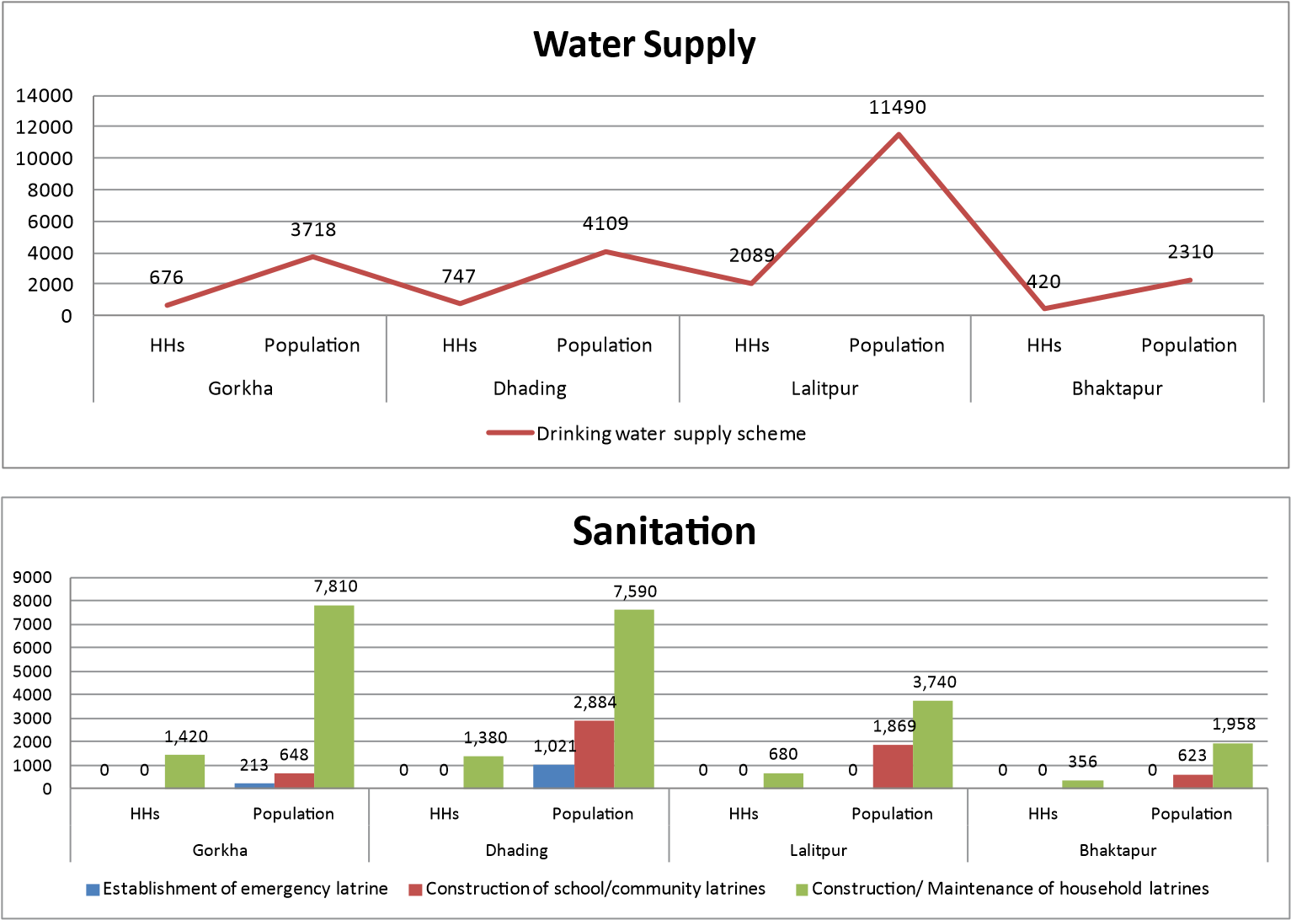

|  |  |  |  |  |  |  |  |  |  |  |  |  |  |  |  |  |  |  |  |  |  |  |  |  |  |  |  |  |  |  |  |  |  |  |  |  |  |  |  |  |  |  |  |  |  |  |  |  |  |  |  |  |  |  |  |  |  |  |  |  |  |  |  |  |  |  |  |  |  |  |  |  |  |  |  |  |  |  |  |  |  |  |  |  |  |  |  |  |  |  |  |  |  |  |  |  |
| --- | --- | --- | --- | --- | --- | --- | --- | --- | --- | --- | --- | --- | --- | --- | --- | --- | --- | --- | --- | --- | --- | --- | --- | --- | --- | --- | --- | --- | --- | --- | --- | --- | --- | --- | --- | --- | --- | --- | --- | --- | --- | --- | --- | --- | --- | --- | --- | --- | --- | --- | --- | --- | --- | --- | --- | --- | --- | --- | --- | --- | --- | --- | --- | --- | --- | --- | --- | --- | --- | --- | --- | --- | --- | --- | --- | --- | --- | --- | --- | --- | --- | --- | --- | --- | --- | --- | --- | --- | --- | --- | --- | --- | --- | --- | --- | --- |
| **Hygiene**   |  |  |  |  |  |  |  |  |  |  |  |  | | --- | --- | --- | --- | --- | --- | --- | --- | --- | --- | --- | --- | |  | | | | 2  6  , | | 2 | |  | |  | | | 9  6  9  7  9 | | | |  | |  | |  | |  | | | 1  6  ,  3  1  6  , | | | |  | |  | |  | |  | | |  | |  | |  | | 3  3 | | 7 | |  | | | ,  9  8  1  ,  0  8  7 | | 8  ,  3  6  4 | | 5  ,  0  7  9  5  ,  0  7  9 | | 7  ,  1 | | 4  ,  7  6  3  3  5  ,  7  3 | | 4  ,  5  7  1  4  ,  0  4  3  7  2  5 | | | 2 | 3  0  0  0 | 5  8  1  ,  3  7 | 3 |  | 0  0  0 | 8  8 | 8  1  0 | 8  6  6  1  ,  0  4  0  0  0 | 4  0  5  7  2  2  2  5 | 8  3  1  7  3  5  0  0  0 | 3  0  2  ,  2  7  0 | | HHs Population | | | | HHs Population | | | | HHs Population | | HHs Population | | | Gorkha | | | | Dhading | | | | Lalitpur | | Bhaktapur | |   30000  4  6  2  7  ,  9  3  5  25000  20000  15000  10000  5000  0  Hygiene kits distribution Hygiene kits replenishment Hygiene promoters trained Hygiene promoters activities (community level) Hygiene promotion activities in school |

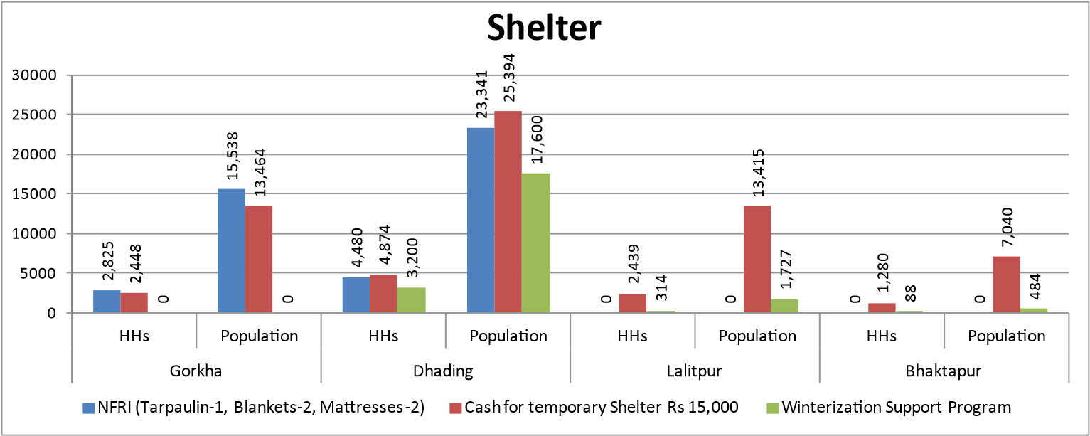

#### Sustainability

DCA and its partners were quite concerned about the sustainability of its response activities. On shelter-related activities, we worked closely with the shelter cluster, both at the district and the national levels. For all WASH-related activities, we jointly worked with the DWSDO offices. Since WASH activities were quite heavy in DCA operations, we the invited government and local stakeholders to visit/monitor our ongoing/completed activities. We managed to established DCA as a strong WASH partner at the national level through our learning, sharing and support of cluster activities.

On CBPSS, our psychosocial coordinator and partner staff worked closely with the protection cluster and adapted its tools and template for the community level. We also provided all necessary information, as requested by the cluster or the government. Our approach focused on building community capacity, changing their behavior and the formation of local user committees to sustain activities.

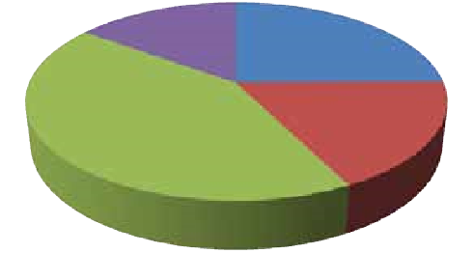

Bhaktapur, 8863

Gorkha, 6

Dhading, 15

Lalitpur, 5

Bhaktapur

Gorkha

Dhading

Lal

tpur



Bhaktapur 8,863

Gorkha 6,297

Dhading 15,136

Lalitpur 5,362

Bhaktapur

Gorkha

Dhading

Lalitpur

1

7

6

,

4

0

6

,

2

6

8

2

0

2

,

8

0

3

,

5

7

3

1

2

0

,

0

5

8

,

6

4

0

0

10,026

8,279

5,361

2,905

0

2000

4000

6000

8000

10000

12000

0

50000000

100000000

150000000

200000000

250000000

Gorkha

Dhading

Lalitpur

Bhaktapur

**B**

**u**

**d**

**g**

**e**

**t**

**Per Household Expenditure (District-wise)**

Total Budget

HHs Covered

**H**

**H**

**c**

**o**

**v**

**e**

**r**

**a**

**g**

**e**

We encouraged the community to seeking support and services from the local government and relevant stakeholders in respective areas. We kept stakeholders and the community informed about our activities throughout the entire planning, implementation and monitoring processes. Community awareness and communication with the affected community helped us raise awareness and ownership, which will help in the sustainability of our humanitarian interventions.

## Story of Change

Bhagwati Tamang was busy making mortar and working with stone when we first arrived in Majimtar in Dhading, a central district located approximately 50 kilometres northwest of the Nepalese capital, Kathmandu. It was amongst the areas worst hit by the earthquake.

Tamang is the only female mason in a group of bricklayers working tirelessly to rebuild the community’s decimated properties. Despite working in a male-dominated field, she is proud of the essential role she plays in improving her neighbours’ lives.

When Tamang first decided to become a mason, many questioned her ability, but she ignored.

“If women can fly airplanes in the sky, I can also do this masonry work as I have the skills and determination”, says Tamang. She proved those who criticised her wrong and became a skilled mason.

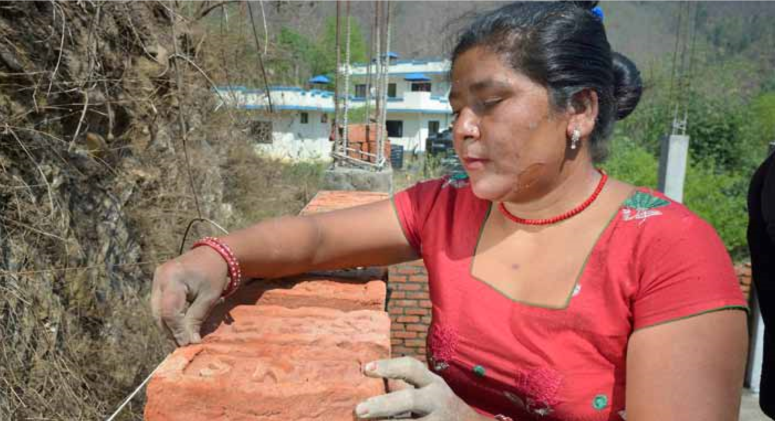After the earthquake, the 34-year-old and her skillset became an invaluable asset to the village. Thanks to her expertise, she could construct temporary shelters for many of the neighbours whose houses were flattened by the strong tremor. Although Tamang could have earned a good income, she refused to collect any fees from the villagers who had already borne the brunt of the earthquake.

To further enhance her skills, she attended the training in masonry and carpentry launched as part of an EU-funded project, implemented by a DCA-led consortium of humanitarian organisations. The course aimed to equip local masons and carpenters with earthquakeresilient construction techniques, such as ABCDE (Anchorage, Bracing, Continuity, Ductility and Enhancement). The objective was to provide the participants with knowledge on how to repair shelters or construct houses that are able to cope with recurring earthquakes. Both theoretical and practical lessons were given to trainees.

Tamang had been working as a mason for more than 12 years, said that the course had been invaluable in improving her construction skills.

“If we incorporate these new techniques in the traditional construction methods, our houses will be strong enough to resist future earthquakes.” She said that she would also be teaching the new techniques to other masons in her hometown. Besides Bhagwati Tamang and her fellow stonemasons in Majimtar village, training was also provided to almost 100 other bricklayers and carpenters in four highly-affected districts, namely Dhading, Makawanpur, Rasuwa and Sindhupalchok.



### Summary

Diakonie Katastrophenhilfe initiated its immediate humanitarian response to the 2015 earthquake in Nepal in May. Having assessed and identified immediate humanitarian needs on the ground with its partners, Diakonie Katastrophenhilfe supported four immediate emergency response projects, directly implemented by its partners in northern and southern Dhading, northern Gorkha and mostaffected areas in Kaski during the emergency phase. The primary support included provision of CGI sheets, tarpaulins, blankets, construction tool kits, hygiene kits, kitchen sets, food rations, water tanks and variety of seeds.

During the provision of humanitarian support, the issue of accessibility was one of the major challenges, as some of the target areas of Diakonie Katastrophenhilfe were only accessible by helicopters and porters. Diakonie Katastrophenhilfe and its partners, however, managed to reach thousands of earthquake-affected households living in inaccessible and hard- to-reach areas during the emergency phase. With close coordination among partners, the ACT Alliance Nepal Forum, relevant clusters and networks, the emergency response operation was successfully completed.

Diakonie Katastrophenhilfe continues to support efforts towards earthquake recovery and rehabilitation in Nepal by focusing on housing reconstruction, water, sanitation and hygiene, livelihood and disaster risk reduction in Dhading, Kavrepalanchok, Sindhupalchowk, Dolakha and Lalitpur districts. Furthermore, Diakonie Katastrophenhilfe is one of the major financial contributors to the ACT Appeal 151.

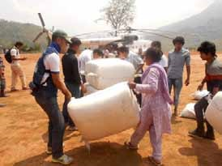

Photo: UMN

#### Background

Diakonie Katastrophenhilfe, a German nongovernmental organisation headquartered in Berlin, has been supporting disaster response efforts in Nepal since the devastating earthquakes of April-May 2015 by extending its financial and technical support to local partners implementing disaster response projects in the earthquake-affected areas.

Diakonie Katastrophenhilfe provides worldwide humanitarian aid along the primary strategic objectives of focusing on regions where actual and potential impacts of disasters are most acute, establishing strategic partnerships with local partner organizations and enhancing implementing partners’ ability to respond. **Relief and Early Recovery Phase**

With support from Diakonie Katastrophenhilfe, partner organizations in Nepal reached over 30,000 families through emergency relief and early recovery activities implemented in Gorkha, Dhading, Sindhupalchok, Dolakha and Kaski districts outside the appeal. Emergency shelter support was provided for approximately 16,500 families (tarpaulins and NFIs) and temporary shelter support for 6,760 families (CGI sheets, construction toolkits and basic fitting materials); food security and livelihood support was provided for approximately 25,000 families through different activities including immediate food

|  |  |  |  |
| --- | --- | --- | --- |
|  | **Emergency Phase and Early Recovery** | | |
| District | VDC |  | Sector |
| Gorkha | Kashigaun, Siridibas, Keraunja, Uhiya, Chhekampar, Manbu, Arugat, Takukot | ·  · | Emergency and Temporary Shelter WASH |
|  |  | · | NFIs |
|  |  | · | Food security |
| Dhading | Ri, Lapa, Jarlang, Pida, Madavestan | · | Emergency Shelter |
|  |  | · | WASH |
|  |  | · | NFIs |
|  |  | · | Food security |
| Sindhupalchowk | Thautali, Manka, Chokati | · | Temporary Shelter |
| Atarpur, Dhuskun, Jethal, Pangretar,  Petaku, Piskar, Sunakhani, Tauthal,  Tekanpur, Thulo Dhading | · | Food Security and Livelihoods |
| Dolakha | Bulung Chankhu Jhyaku Kharee Laduk Lamidanda, Lapilang, Marbu, Orang, Suri | · | Food Security and Livelihoods |
| Kaski | 30 affected settlements in various VDCs of Kaski districts | ·  · | Emergency and temporary Shelter WASH |
|  |  | · | NFIs |
|  |  | · | Food security |

assistance, variety of seeds, agricultural tools and seed storage grain bags; sanitation and hygiene support has been provided for approximately 16,500 families (mainly hygiene kits and water tanks).

4896

5993

7170

7500

615

4896

11000

615

4890

11000

615

4896

1250

615

0

2000

4000

6000

8000

10000

12000

Gorkha

Sindupalchowk

Dolakha

Dhading

Kaski

**Emergency Response and Early Recovery**

Food Security and Livelihoods

WASH Support

Emergency Shelter and NFI

Temporary Shelter

### Recovery Phase

Diakonie Katastrophenhilfe has been supporting the recovery and rehabilitation projects of its partners in Sindhupalchok, Dolakha, Kavre, Dhading and Lalitpur districts. A recovery project focusing on food security, livelihood and DRR is being implemented in 20 VDCs of Sindhupalchok and Dolakha districts, targeting approximately 13,000 households through seeds and tools provision, relevant trainings and DRR activities.

A WASH recovery project, focusing on recovery of water supply schemes and hygiene promotion is targeting an area covering approximately 15,000 HHs in six VDCs of Sindhupalchok district.

A Community Infrastructure Recovery Project aimed at recovery of water supply schemes, reconstruction of latrines in schools and health centers and repair of local tracks, footbridges and electricity infrastructure has been implemented in five VDCs of Dhading district with an approximate target of 7,000 HHs.

Recently launched recovery project in Lalitpur District will focus on housing reconstruction support, WASH and DRR in the most affected communities.

|  |  |  |  |
| --- | --- | --- | --- |
|  | **Rehabilitation and Recovery** | | |
| **District** | **VDC** |  | **Sector** |
| Sindhupalchowk | Baramchi, Fulpingkot, Hagam, Jalbire, Pangtang,  Selang | · | WASH |
| Atarpur, Dhuskun, Jethal, Pangretar, Petaku, Piskar,  Sunakhani, Tauthal, Tekanpur, Thulo Dhading | · | Livelihoods Recovery and DRR |
| Dolakha | Bulung Chankhu Jhyaku Kharee Laduk Lamidanda,  Lapilang, Marbu, Orang, Suri | · | Livelihoods Recovery and DRR |
| Kavrepalancowk | Mahadevsthan, Baluwapati Deupur, Chandeni  Mandan, Gairibisaunaa Deupur, Jaisithok Mandan,  Jyamdi Mandan, Naya Gaun Depur | ·  ·  · | Housing reconstruction support  Livelihoods recovery  WASH support |
| Dhading | Ri, Lapa, Jarlang, Pida, Madavestan | · | Community Infrastructure recovery and WASH |
| Lalitpur | Bajra Barahi Municipality | ·  ·  · | Housing reconstruction support  WASH support  DRR |

All the projects have been developed and being implemented in close coordination with local authorities, local communities and all other relevant local stakeholders.

15000

3500

500

300

250

7000

500

6000

1030

7100

240

500

230

0

2000

4000

6000

8000

10000

12000

14000

16000

Sindhupalchowk

Dhading

Kavrepalanchok

Lalitpur

Dolakha

**Recovery and Rehabilita**

**ti**

**on**

WASH (HHs)

Housing (HHs)

Community infrastructure (HHs)

Livelihoods (HHs)

DRR (HHs)

#### Process Followed

Local partners and Diakonie Katastrophenhilfe jointly developed vulnerability criteria for the selection of geographical locations and project beneficiaries. During the emergency phase, a blanket approach was adopted for the most-affected districts for the provision of relief items, whereas a more targeted approach was used for moderately affected areas. Target communities and all the other local stakeholders were involved in the selection process for all projects.

#### Ownership and Sustainability

Diakonie Katastrophenhilfe and its partners make significant efforts to ensure high-level community participation throughout the project development, implementation, monitoring and evaluation phases of all projects.

Furthermore, capacity building was one of the key components of all recovery and rehabilitation projects, as strengthening the capacities of communities and all other local stakeholders was given special emphasis within all Diakonie Katastrophenhilfe supported projects. At both phases, projects supported by Diakonie Katastrophenhilfe were aimed at ensuring that local communities feel ownership over the projects that would ensure the sustainability of all the actions.

### Story of Change

My name is Arjun Karki. I was born in Mankha village of Sindhupalchok district. I am 70 years old and I had never experienced a horrific incident like this one ever before. I remember that day. I was grazing cow in the field. All of a sudden the ground started shaking. I was confused for a moment, as I was not sure what was going on. When I realized that it was a big earthquake, I was very worried about my wife and children at home. I have three daughters and two sons.

My second daughter is mentally disabled.

The earthquake had destroyed our home.

We were left without a roof over our heads.

When the big jolts subsided, I left for home. I met my wife on the way, who had also come to look for me. She looked terrified. She told me that our house and our daughter’s had been destroyed. When we came back to our village, it was havoc. People were searching for their family members. My 18-year-old niece was missing. Someone had last seen her going to the toilet in my daughter’s house minutes before the earthquake. We learned that she was buried in the rubble, but we were unable to rescue her. We had no tools or equipment. Her dead body was removed from the rubble three days later.

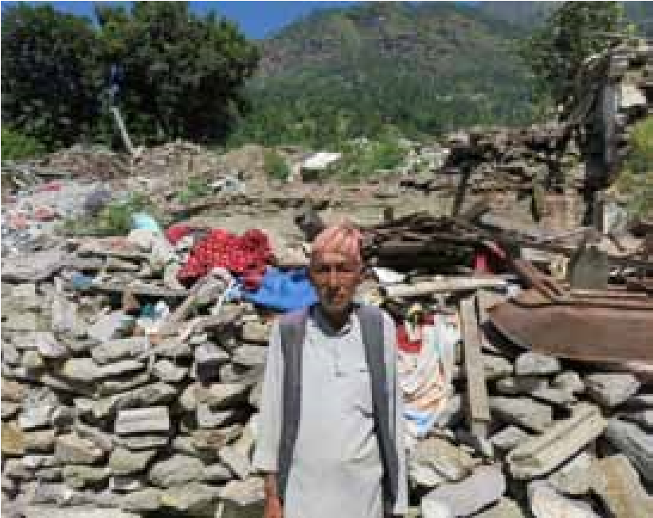

We had lost our loved ones, our homes and our belongings. All of us in the village became homeless. But people came to help us and their helping hands eased us our shock and helped us gradually recover. The government provided Rs 15,000 to each household in the VDC. Many individuals and organizations came to help us wholeheartedly by providing relief materials such as food, tarpaulins and blankets. PHASE NEPAL, with the support of Diakonie Katastrophenhilfe, distributed CGI sheets and supported the building of temporary shelters. We are very thankful to all of them, as everything could have been much more difficult without this support.

Lastly, we should never forget that we are farmers and laborers, so we have to rise up to re-establish our own livelihood and build safer homes.

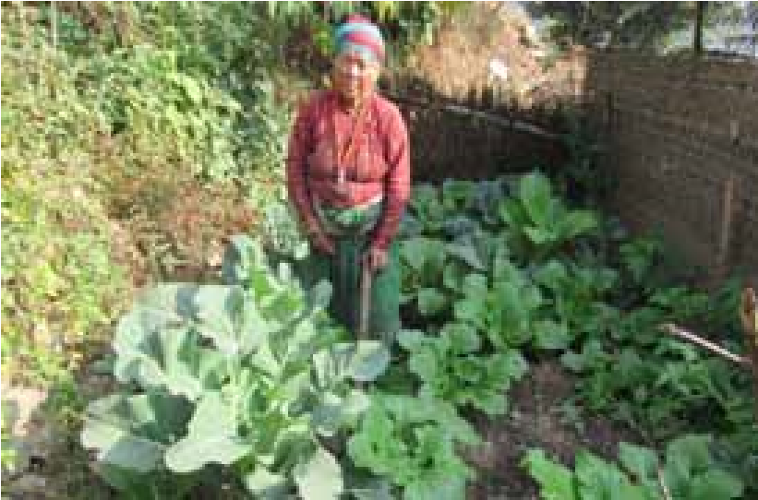

Poornima is a resident of Lamidanda in Dolakha district. Her home was completely destroyed during the earthquake and all her belongings, including grains and seeds, were buried under the rubble. Poornima’s family quickly managed to build a makeshift shelter but they were having problems getting together enough food. The nearest village where Poornima could procure seeds was 30 km away from Lamidanda. Furthermore, her family did not have the savings needed to buy seeds to restart their agricultural production.

Seeds provided by LI-BIRD/ Diakonie Katastrophenhilfe have helped them to recover their vegetable production. “I am now able to grow my own vegetables again,” said Poornima. “We are very thankful to all the helping hands that supported us.”

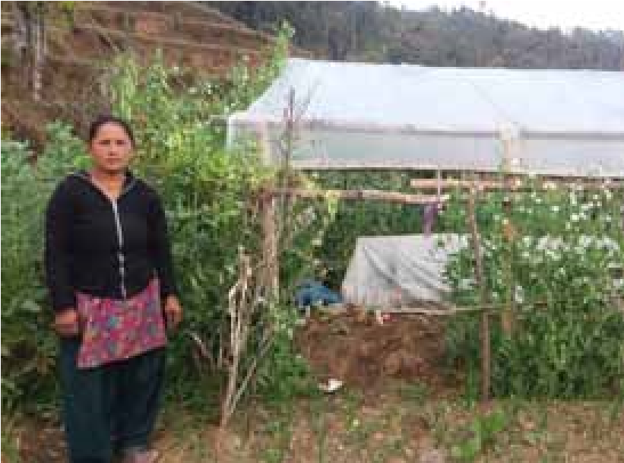

Farming Project of LI-BIRD supported by Diakonie Katastrophenhilfe. She has lost her house and all her belongings during the devastating earthquake on 25 April. The first few months following the earthquake were the most difficult times of her life, she said. Her family was without food and shelter, struggling to meet even their most basic needs.

Sukumaya was one of the beneficiaries, who were provided with agricultural inputs in the form of a composite packet of 10 different varieties of vegetable seeds from LI-BIRD. The vegetables cultivated are now supporting the family’s food consumption. Furthermore, she has even been selling the surplus vegetables to a cooperative in Sildhunga.

Sukumaya has decided to become a commercial farmer, building a shelter for vegetable cultivation. “I want to cultivate vegetables in a few plastic tunnels and further enhance the family income,” she said. Some of the seeds provided in the composite packet were new to her but she managed to grow radish, beans, peas and fava beans well and has also saved some. Besides this vegetable composite packet, she was also provided with

Sukumaya Shrestha, 24 from Attarpur VDC Sindhupalchok district, is one of the beneficiaries of the Rebuilding Family

wheat, mustard, lentil and maize seeds. Sukumaya added, “I am thankful for the agricultural inputs and the technical support, and very grateful that you have supported my dreams.”

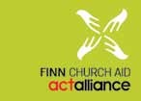

#### Summary

Nepal earthquake 2015 made a significant impact on the access of children quality education destroying 35,986 classrooms keeping 1.2 million children out of school. Education, even in emergencies, is a human right. Children cannot wait months or years to resume education, while government and other humanitarian actors are prepared for managing required funds and start reconstruction works. Providing temporary classrooms immediately aftermath of the earthquake was the only way to soon resume a level of normalcy for children, while ensuring their access to quality education.

Finn Church Aid (FCA) understands education as a right in itself and as an enabling factor in realizing other human rights. In this background, FCA immediately responded educational needs of the earthquake-affected children in three districts; Kathmandu, Lalitpur and Bhaktapur. To meet the immediate classroom needs of 20,000 students, 170 safe and secure learning spaces have been built, locally called Temporary Learning Centres (TLCs). The TLCs were made up of light construction materials such as bamboo, corrugated galvanized iron sheets. The TLCs were built on the national government standards aligned to globallyagreed standards laid out in the InterAgency Network for Education in Emergency

(INEE) guidelines. FCA has also constructed 178 semi-permanent latrines, separate for boys and girls, along with proper hand washing and drinking water facilities to promote WASH facilities in the TLCs.

The TLCs are not the permanent solution - designed for short period. However, the pupils, who have lost their permanent schools, will most likely have to spend another monsoon and winter in the TLCs. After extended use, the walls are already showing signs of wear and tear, but the structures still serve their purpose, if maintained properly.

Besides TLCs construction, FCA has distributed over 1,400 educational and recreational kits to the affected children in the target schools. The educational and recreational materials have helped children to reduce stress and come back to normalcy from the trauma. Moreover, FCA support to strengthen the capacity of above 1,500 teachers through training has contributed to improve the quality of teaching and learning, including proper handling of children’s psychosocial issues.

FCA achievements are more than what is expressed in numbers above. FCA is now, known for a trusted development and humanitarian partner particularly because of timely delivery of quality services. FCA is a core member of Nepal Education Cluster. FCA participated in and contributed to prepare Emergency Preparedness and Response Plan (EPRP) of UNOCHA Education

Cluster. FCA, in collaboration with Nepal Education Cluster, Department of Education has produced teachers training curricula. We also developed WASH facility installation manual and shared among WASH partners through WASH cluster. FCA, in collaboration with Nepal Education Cluster and National Centre for Education Development, jointly published a training manual on use of education supplies.

FCA work was full of challenges; particularly because of absence of locally elected government. Local NGOs were prepared only for regular development program with limited understanding of humanitarian works. Other external factors such as adverse political conditions leading to various strikes, demonstrations, southern border blockade, ill-functioned market, unavailability of reliable suppliers and lack of adequate amount of quality goods and services posed a threat to the timely accomplishment of the our works.

The world rushed in to help. Government, international organisations and individuals donated millions to assist earthquake survivors. Thanks to the supports of the national and local government authorities, ACT supporting members, local partners and UN clusters were to able achieve results and to fulfil our commitments in time.

Evidence says every dollar spent on disaster preparedness saves seven dollars in response. Therefore, it is high time for the government, civil society organizations and communities joined hands to rebuild Nepal in a safer way and to strengthen community resilience.

FCA continues to build 663 semipermanent classrooms in four districts; Lalitpur, Makawanpur, Sindhuli and Gorkha, providing access to over 24,000 pupils.

|  |  |  |  |  |  |  |
| --- | --- | --- | --- | --- | --- | --- |
| **Project Budget Beneficiaries Partners** | | | | **District Sector Donor** | | |
| Rapid Response Fund | € 600,000 | 3,560 households | Under Privileged Children’s  Education Programme, Salve,  LWF ( through NPL-151) | Lalitpur, Kavre,  Kathmandu | Emergency  Shelter, Food and  Non Food Items | MFA Finland |
| NPL -151/ACT Appeal | $1,148,000 | 20,462 children and 2,009 adults | Under Privileged Children’s Education Programme, Loo  Niva Child Concern Group,  Center for Mental Health and  Counseling and World Vision  Advocacy Forum | Lalitpur (Malta,  Pyutar, Asrang,Gimdi,  Thuladurlung,  Chandanpur, Kaleshwar)  Kathmandu, Bhaktapur (Changunarayan  municipality, Madhyapur  Thimi municipality) | Education in  Emergencies (including WASH and Psycho-  Social Support in  Schools) | ACT Alliance |

##### Programs and Projects

Over 1,500 teachers will be trained, 378 school latrines will be built. The new classrooms will withstand an earthquake of the same magnitude.

##### Background

FCA has been funding projects for local partners in Nepal since 2003. It opened up a local office in 2013 and registered with the Social Welfare Council in January 2015, just months before the devastating earthquakes that struck Nepal.

An FCA humanitarian team arrived in Nepal immediately after the first quake to support the country manager with distribution of immediate relief and planning of mediumterm interventions. Now, 12 months after the earthquake, FCA staff amounts to 40 development and humanitarian professionals. FCA’s focus areas are Right to Education, Right to Livelihood, and Right to Peace. In Nepal, livelihood is the most important sector for FCA’s development projects, while access to quality education is the focus of FCA’s humanitarian response. FCA’s humanitarian implementation modality relies on close partnership with local organizations, where the local partner is responsible for implementation and FCA offers technical support and capacity building.

#### Relief Phase

In the first few months after the earthquake,

FCA distributed emergency shelter materials (tarpaulins and CGI sheets), non-food items and basic food packages (flour, split, lentils, oil, rice, salt and sugar) through a blanket approach. The targeting was done in coordination with the VDC where FCA had pre-existing partners. The response phase concluded in December 2015.

During the rapid response phase, FCA also established five child-friendly spaces in Bhaktapur and Kathmandu for six months. On average, 180 children took part in daily sessions for spaces that were located close to IDP settlements and schools.

FCA’s relief phase response reached 3,560 households and approximately 180 individual children.

1

,

4

5

0

5

0

0

2

5

0

2

,

8

1

0

5

0

0

2

5

0

0

500

1000

1500

2000

2500

3000

Lalitpur

Kavre

Bhaktapur

**H**

**o**

**u**

**s**

**e**

**h**

**o**

**l**

**d**

**s**

**Food, NFIs and Emergency Shelter**

Food Item

NFI & Emergency shelter

#### Recovery Phase

FCA’s Quality Education Response 2015-

reached a total of 20,462 students,

2016

,206 teachers and Department of

1

Education staff members, and 803 parents.

1,477

1,609

752

458

344

404

172

238

393

0

500

1000

1500

2000

1

2

3

**I**

**n**

**d**

**i**

**v**

**i**

**d**

**u**

**a**

**l**

**s**

**Psychosocial Support in Schools**

Student

Teacher

Parents

The components of the response, which

3

.

FCA distributed 850 educational and

lasted until the end of April 2016, included: recreational kits to 73 schools.

1. 170 temporary learning structures made 4. 61 head teachers and DoE staff received of bamboo with a total of 330 classrooms training in education during emergencies were built for 73 schools. and 456 teachers received a two-day

teacher training.

1. 178 semi-permanent latrines and 89
   1. 69 head teachers and resource persons handwashing facilities were completed

and 620 teachers received training in

for 58 schools. psychosocial support.

* 1. A total of 3,786 students took part in received counseling. classroom-based psychosocial support
  2. A total of 791 parents participated in

activities. Nearly 244 students received

awareness-raising events on psychosocial

individualized support from teachers

while 32 students and 12 parents

support after a disaster.

12770

3300

4392

7693

3086

4301

161

172

184

145

150

155

160

165

170

175

180

185

190

0

2000

4000

6000

8000

10000

12000

14000

Kathmandu

Bhaktapur

Lalitpur

**I**

**n**

**d**

**i**

**v**

**i**

**d**

**u**

**a**

**l**

**s**

**Quality Educa**

**ti**

**on**

Quality Educa

ti

on (TIC+UNICEF

kits orienta

ti

on)

Wash

Teachers Training

##### Process Followed

The direst need in the education sector, as articulated by the government and based on rapid needs assessment by the cluster, was the construction of temporary learning centers. FCA complemented construction with the distribution of educational materials provided by UNICEF, training for teachers in post-disaster challenges for schools and a psychosocial support component that focused on teachers’ capacities to provide support to students. The implementing partners were chosen from amongst FCA’s existing partners that were already working in the affected areas. The division of labor was quite clear -- partners were responsible for community mobilization and coordination of implementation, including management of cash for work, while FCA was responsible for technical design, quality assurance, procurement and response compliance with government guidelines. Target schools within the selected VDCs were allocated for FCA and its partners in the National Education Cluster.

With the monsoon approaching, FCA started construction in rural and logistically challenging areas in Lalitpur. Other actors started work in the schools assigned for FCA in urban areas, so FCA and its partners had to retarget Kathmandu and Bhaktapur and finally decided on total of 170 bamboo TLCs. While bamboo TLCs were good short-term solutions, the structures were not robust enough to bridge the huge gap to permanent reconstruction. FCA worked on winterization of selected TLCs in the Kathmandu Valley as well.

In WASH sector, FCA provided semipermanent solution from the beginning. The decision was good, as most latrines and hand-washing facilities remain in good condition 12 months after the disaster.

The TLC and WASH facility construction was done through Cash-for-Work arrangements. As a by-product of the infrastructure component, around 1,900 individuals from the VDCs had a chance to earn a basic living for five to seven days.

The capacity building and teacher training component of the response was implemented in close cooperation with partners. FCA supported partners in the development of content and materials and coordinated curriculum compliance with the National Education Cluster and National Center for Education Development. FCA staff was heavily involved in the Education in Emergency training of trainers phase of the process, but partner staff and DEO resource persons eventually assumed leading roles. For psychosocial support component, FCA worked with a highly professional partner organization. The partner was fully responsible for the content of the response.

##### Ownership and Sustainability

As FCA works mostly in supporting the government in provisioning public infrastructure and services, the primary local coordination partners are the Department of Education and District Education Offices. FCA has been actively involved in the development of consistent education response as a member of the National Education Cluster.

When discussing the functionality of TLCs immediately after the disaster and not comparing it to a permanent concrete building, communities largely see TLCs as an appropriate first response. The priority was to get children back to school and provide them with a routine as quickly as possible. The lifespan of the bamboo TLCs is directly dependent on the school management committee’s ownership. Some TLCs are totally functional while others have been dismantled or destroyed. In rural areas, TLCs are generally in better shape that in the urban areas. Latrines remain in good condition.

Besides the orientation for the school material kits, rest of the capacity building component was organized within the existing government structure and planned and implemented in close cooperation with District Education Offices and resource centers in the target areas.

The biggest success has been the teacher training in psychosocial support. Anecdotal evidence suggests that teachers felt out of their depth in the first weeks and months after the earthquakes. The training provided basic skills and appropriate tools to respond to the psychosocial needs of students.

The teacher training and psychosocial support components are likely to have longterm impact, as a national curriculum for teacher training related to post-disaster challenges is being developed, based on lessons learned from the first year’s activities.

##### Lessons Learnt and Way Forward

While planning an education response, there is always a dilemma of whether to provide a short-term solution for many or a medium-term solution for a smaller number of students. In the first months of the response, a bamboo temporary learning structure was absolutely the right answer. Many schools recovered, with students having a safe and functional learning space. However, a year after the response, many of these schools and children have outgrown these structures without having anything more permanent to replace them. Many schools are back to square one.

The quick provision of the TLCs did not only provide the infrastructure, but also a muchneeded routine for the students, which helped with their psychosocial well-being. However, the humanitarian community, FCA included, needs to stay one step ahead. No one is surprised that the reconstruction of permanent schools has been delayed, so it would have made sense to proceed with the first response and medium-term planning simultaneously. In 2016-2017, FCA will be providing transitional and semi-permanent infrastructure for schools. The biggest challenge with the capacity building component has been that the training required teachers to be absent from schools. As a consequence, children were released from school as well. As learning had already been impacted by the disaster, the further days off created problems for students, disrupting their fragile routine.

FCA has taken a very labor-intensive route to address this problem in its interventions in 2016-17. The teacher training will be organized in schools and there will be complimentary activities for students during these days and even joint sessions, where students, teachers and parents will all work and learn together. However, this sort of capacity building needs more planning than the basic teacher training combination, so the most of the content will need to be readily available and the context very familiar for the responder. The most important lesson learned is to invest in community mobilization, communication and guidance for schools. According to an internal monitoring exercise, UNICEF school materials were more versatile for use in those schools where a half-day orientation had been conducted, compared to schools where the materials had simply been distributed with an accompanying user guide.

There is also a direct link between the cleanliness of the latrines and the amount of time and effort put into the orientation to maintenance and hygiene promotion. A few moments of discussion between the FCA/partner staff, the teachers and children go a long way compared to hygiene promotion posters.

With the sustainability of the TLCs there were more factors in play, but ownership of the community remained the most important guarantee for the functionality of the TLCs.

#### Story of Change

Twelve-year-old Yuna Shrestha has a broad smile on her face. She is one of 80 pupils studying at the temporary learning spaces built by FCA at Padmodaya Higher Secondary School.

“I liked my old school a lot, but I feel much safer in this bamboo classroom,” she says, clad in a neat school uniform and with her braided hair decorated with beautiful red flowers.

The earthquake is already a distant memory for the bright, math enthusiast. She prefers to look ahead. “I want to become a doctor,” she says.

(Picture: One year after the earthquakes, Yuna Shrestha’s bamboo classroom remains

in full use.)

The 70-year-old main building of the school collapsed in the earthquake. Fortunately, it was a Saturday, a holiday. Had the earthquake struck on a weekday, Nepal would have lost many more teachers and children. The school grounds now house five temporary structures made of bamboo. The sheet-metal-roofed bamboo structures are light, but sounds travel from classroom to classroom through the thin walls. After extended use, the walls are already showing signs of wear and tear, but the structures still serve their purpose, according to teacher Sudha Pathak. “We are doing just fine,” says Sudha. “Besides, this is all we have.”

Sudha explains that teachers don’t know when a new, permanent school building will be constructed. “It is probably going to take at least one more year,” she opines. She says that the lives of the school and the pupils have returned to normal, a sentiment shared by Lalita Khadki, who has brought her two daughters to school, even though she still fears that an earthquake will strike again.

“We still think about the earthquake. We are constantly on our toes. My daughters want to sleep in their clothes so that they can quickly run outside in case an earthquake hits,” says Lalita. “We have suffered a lot. But we must go on with our lives.”

**Background**

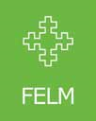

Finnish Evangelical Lutheran Mission (FELM) has worked in Nepal since 1977 in the development cooperation sector, focusing on the sectors of health,

|  |  |  |  |  |
| --- | --- | --- | --- | --- |
|  | **Implementing**  **FELM-funded Regular Project**  **Partner** | | **Beneficiaries** | **Districts** |
| 1 | Child Mental Health | CMC Nepal | 17,500 people | Salyan, Kailali, Gorkha, Rasuwa |
| 2 | Community Mental Health and Psychosocial Programme | CMC Nepal | 3,000 people | Achham, Kailali, Banke, Bardiya, Salyan, Morang |
| 3 | Disabled Empowerment Program | Forward Looking | PWDs | Banke, Dhading, Gorkha, Kaski,  Kailali, Lalitpur, Palpa |
| 4 | Scholarship Program | Forward Looking | 1,000 Students with disability | Baglung, Banke, Dhading, Gorkha, Sunsari, Palpa |
| 5 | Community Empowerment for  Food and Livelihood Security  (CEFALS) Project | SAHAS Nepal | 3,000+4,800  HHs | Bajura, Kalikot, Mugu |
| 6 | Enhancing Livelihood through  Local Efforts Project (ELLEP) | SAHAS Nepal | 2,536+2,120  HHs | Dhading, Gorkha, Tanahun, |
| 7 | Local Initiative for Grassroots Peace Building | Sanjal | 17,175 people | Achham, Banke, Kailali |
| 8 | Education for HIV/AIDS and Safe Migration | Sanjal |  | Achham, Kailali |
| 9 | Community Health Education  Project | Shanti Nepal | 365,860 people | Dhading |
| 10 | Uplift Program | SUS | 11,667 HHs | Chitwan, Sarlahi, Morang |
| 11 | Community Health Program | Tansen Mission Hospital | 20,649 people | Palpa |

##### Programs and Projects

education, livelihood, peace building, and the empowerment of Dalits, people with disabilities (PwDs) and people living with HIV (PlwHIV), women and children. FELM-Nepal currently has 11 development cooperation projects with seven local partner organizations. In response to the Gorkha earthquake, FELM channelled its emergency, relief and recovery funds through ACT Alliance and also through FELM-Nepal’s local partner organizations.

##### Relief Phase

Besides ACT Appeal, FELM-Nepal participated in the relief phase process through its local partner organizations, reaching at least 40,000 people. Besides providing temporary shelters, CGI sheets, food and non-food times (such as seeds and tools), through FELM’s support the partner organizations provided psychosocial support, baby kits and special support to PwDs.

|  |  |  |  |  |  |
| --- | --- | --- | --- | --- | --- |
| **Partner Organisation** | **District** | **Total #**  **Cluster**  **Reached** | | **Unit: Beneficiaries / Households / Trainings etc.** | **Brief Activity Details** |
| SAHAS | Dhading,  Gorkha and  Tanahun | Shelter,  Food and  NFI | 3,653  18,265 | HHs people | food, vegetable seeds, farming utensils, temporary shelters, blankets |
| Shanti Nepal | Dhading | WASH | 1,467 | HHs | toilets, drinking water |
| CMC | Dhading,  Gorkha and  Dolakha | PSS | 1,751 | people | psychosocial support |
| Forward looking | Dhading Gorkha | Shelter,  Food and  NFI | 144 | HHs | food, vegetable seeds, farming utensils, temporary shelters, blankets for people with disabilities |
| Sansthagat Bikash Sanjal | Dhading,  Gorkha,  Dolakha,  Ramechhap and Chitwan | WASH,  Food and  NFI | 4,750 | HHs | food, vegetable seeds, farming utensils, temporary shelters, blankets, baby kits, |
| Samari  Utthan Sewa | Chitwan | Shelter and  Food | 1,520 | people | food, vegetable seeds, farming utensils, temporary shelters, blankets |
| CCDN | Makawanpur | Shelter and  Food | 1,629  8,145 | HHs people | food, vegetable seeds, farming utensils, temporary shelters, blankets |

##### Recovery Phase

In the recovery phase, FELM-Nepal’s partners have focused on repairing water systems, toilets and livestock shelters in the project area communities, as well as supporting communities to cultivate vegetables when possible. Felm-Nepal’s partner CMC has supported communities, teachers and schools with psychosocial support in earthquake-affected districts. Recovery phase activities have focused on supporting the existing project area communities and have been part of normal project activities.

###### Process Followed

The geographical areas were selected according to where Felm-Nepal’s partner organizations were already working with development cooperation projects. FelmNepal’s partner organizations collaborated and coordinated all relief and recovery work closely with district level line agencies to select which beneficiaries and communities would benefit from relief and recovery phase activities. Existing strong and good relations with government offices were key to successfully implementing the activities. The challenges in selecting beneficiaries were resolved by negotiating and collaborating with district offices and other NGOs working in the area.

###### Ownership and Sustainability

Since Felm-Nepal’s partners implemented relief and recovery activities in those communities where they have already worked in development cooperation projects, the beneficiary communities were already familiar with the work Felm’s partner organizations do and with the partner organizations. This was one of the success factors in implementing the activities and in supporting the sustainability of the work. Also, using existing VDCand district-level stakeholder contacts and relations were important in creating ownership and sustainability in the process.

###### Lessons Learned and Way Forward

What Felm has learned from this process is that it is essential to have networks and connections, especially since Felm is a development cooperation organization. One of the biggest success factors was that Felm channeled all of its relief and recovery aid either through ACT Alliance or its local partner organizations. By channeling the aid through local partner organizations in those districts and areas where the partners had been already implementing development cooperation projects, Felm and its partners were able to use existing contacts and networks at the VDC and district levels. Another success factor was that the community was familiar with Felm’s local partners and recovery phase activities were linked with existing projects and activities. In the future, close collaboration and coordination with the line agencies of the

**Story of Change**

Juth Bahadur Nepali’s home in Mulchowk,

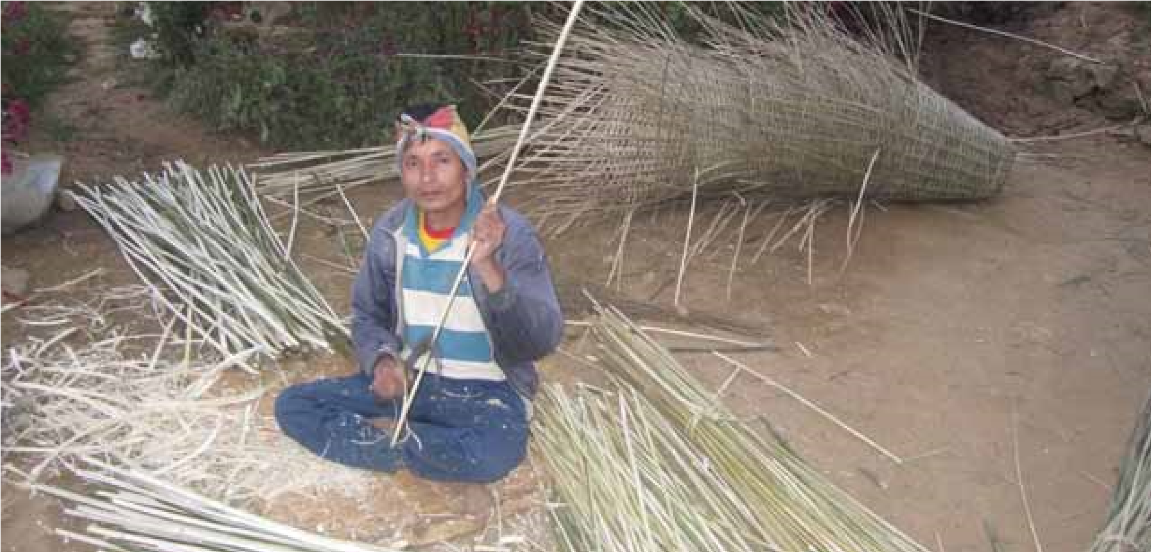Gorkha was completely destroyed in the April 25 earthquake. For Juth Bahadur, this was a catastrophe. Juth Bahadur, 32, suffered a debilitating injury when he fell from a tree at the age of five, leaving him unable to walk properly. He walks around on crutches as a wheelchair is not suitable in the hilly area of his home.

Juth Bahadur’s only caretaker was his mother, who died in the aftermath of the earthquake. He was once married but his wife refused to live with him owing to his disability. Now, he lives with his younger brother’s family but claims that they do not look after him very well.

Juth Bahadur received some help from

FELM-Nepal, through its local partner Forward Looking. He received materials to construct a temporary shelter, a mosquito net and blanket, kitchen utensils and rice. He also received a zinc box to keep safe his academic records, disability documents and other valuables.

As a disabled member of the Dalit community, Juth Bahadur ran the risk of being doubly marginalized, had it not been for the help that he received from Forward Looking and FELM-Nepal.

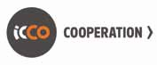

Summary

ICCO Cooperation joined hands with ACT Alliance Nepal Forum in humanitarian response to the earthquake from April 28, 2015 onwards. During the emergency relief phase (April- July, 2015), ICCO Cooperation reached 25,000 households with hygiene kits, cash, non-food items, and food packages in Sindhupalchok, Dolakha, Dhading, Rasuwa, Makawanpur, Kavrepalanchok and Nuwakot districts.

ICCO’s use of mobile-based assessment tool AKVO, was crucial in the initial needs assessment to establish the most urgent needs of the earthquake-affected communities. The beneficiary selection process resultant from this needs assessment not only ensured inclusion but also prioritized people with disabilities to ensure that the most vulnerable people in the community are reached first. Furthermore, ICCO Cooperation’s Global Office in Netherlands drove public fundraising through various media campaigns to raise funds for Nepal.

ICCO started its early recovery and response program in July, 2015 which focused on securing livelihood of the earthquakeaffected communities through the restoration of socio-economic infrastructure in Makawanpur, Dhading and Sindhupalchok districts. The key interventions of this targeted approach were provision of access to inputs, reconstruction of roads and bridges, irrigations schemes, cardamom dryers, store houses, bee hives, collection centres, etc. ICCO’s multi-stakeholder approach in its program design also allowed people to truly claim ownership of the projects with local communities coming together to contribute funds and labour support to the restoration schemes, design management plans and forming working communities. Additionally, ICCO also ran a winterization campaign to ensure that warm woollens, blankets and other winter essentials were made available to the affected communities to withstand the harsh winter.

ICCO’s long-standing partners United

Mission to Nepal (UMN), Center for

Community Development (CCDN), Nepal

Trust (NT) and Integrated Self-help Association for Rural Development (ISARD) have been crucial in overcoming the huge challenges posed by the scale of the devastation and the fuel crisis following the Terai unrest. By the end of April 2016, ICCO interventions have successfully restored the livelihood of 18,846 HHs.

Background

The Nepal Earthquake Response Program

(NERP) is ICCO’s response towards a massive 7.8 magnitude earthquake that struck Nepal on 25th April, 2015. This project started from July 1, 2015 and ended in April 2016. It is part of a larger program under ACT Appeal where, together with ICCO, other ACT Nepal members like LWF, DCA, LWR and FCA, are implementing projects in the three mostaffected districts for early recovery and rehabilitation with their local partners.

ICCO is co-implementing this project with

ISARD and Nepal Trust in Sindhupalchok,

UMN in Dhading and CCDN in Makawanpur

District. The overall goal of this project is to recover and improve the livelihood of 46,067 households that are most affected and have the least resilience capacity in an inclusive and sustainable manner. Gender balance and inclusion of the disabled and marginalized groups are major cross-cutting issues for this project.

The interventions for this project were designed on the basis of detailed needs assessments carried out by ICCO, together with its partners, to stimulate the livelihood recovery of the affected people. ICCO and its partners identified two specific areas of intervention. First and foremost,

Programs and Projects

|  |  |  |  |  |  |  |  |  |  |  |  |  |  |  |  |  |  |  |  |  |  |  |  |  |  |  |  |  |  |  |  |  |  |  |  |  |  |  |  |  |  |  |  |  |  |  |  |  |  |  |  |  |  |  |  |  |  |  |  |  |
| --- | --- | --- | --- | --- | --- | --- | --- | --- | --- | --- | --- | --- | --- | --- | --- | --- | --- | --- | --- | --- | --- | --- | --- | --- | --- | --- | --- | --- | --- | --- | --- | --- | --- | --- | --- | --- | --- | --- | --- | --- | --- | --- | --- | --- | --- | --- | --- | --- | --- | --- | --- | --- | --- | --- | --- | --- | --- | --- | --- | --- |
| |  |  | | --- | --- | | **Name of project** | **Nepal Earthquake Response Program** | | **District partners** | Sindhupalchok (ISARD & Nepal Trust) | | Dhading (UMN) | | Makawanpur (CCDN) | | Targeted Households | 10,004 | | Sector | Livelihood | | Donor | ACT Alliance, Geneva |   **Recovery Phase**   |  |  |  |  |  |  |  |  | | --- | --- | --- | --- | --- | --- | --- | --- | | **ICCO Partner** | **Sector Target**  **Geographical location (Districts/VDCs)**  **Response HHs** | | | **Target population** | **Male Female PwD** | | | | CCDN | Early recovery | Makawanpur – 7 VDCs  (Chattiwan, Naamtar, Thaha,  Faakhel, Chitlang, Kankada and  Harnamadi) | 1,000 | 5500 | 2,585 | 2,640 | 275 | | ISARD | Early recovery | Sindhupalchok – 6 VDCs  (Piskar, Dhuskun, Ghorthali,  Chokati, Karthali and Tauthlai) | 730 | 3285 | 1,544 | 1,577 | 164 | | Nepal  Trust | Early recovery | Sindhupalchok – 5 VDCs  (Sipapokhare, Nawalpur,  Kunchok, Syaule and Helambu) | 1,993 | 8,607 | 4,045 | 4,131 | 431 | | UMN | Early recovery | Dhadling – 5 VDCs  (Pinda, Mahadevstan, Lapa,  Jharlang and Ri) | 6,281 | 31,405 | 14,760 | 15,074 | 1,571 | | Total | 3 districts with  23 VDCs |  | 10,004 | 48,797 | 22,934 | 23,422 | 2,441 | |

re-engaging vulnerable people in incomegenerating activities, both on the farm and off-farm. Second, assisting the revival of a functioning market and re-establishing access of quake-affected producers and service providers.

Working Areas

* Makawanpur – 7 VDCs (Chattiwan, Naamtar, Thaha, Faakhel, Chitlang,

Kankada and Harnamadi) – CCDN

* Sindhupalchok – 6 VDCs (Piskar, Dhuskun, Ghorthali, Chokati, Karthali and Tauthlai) – ISARD
* Sindhupalchok – 5 VDCs (Sipapokhare,

Nawalpur, Kunchok, Syaule and

Helambu) – Nepal Trust

* Dhadling – 5 VDCs (Pinda, Mahadevstan, Lapa, Jharlang and Ri) – UMN

**Results Achieved:**

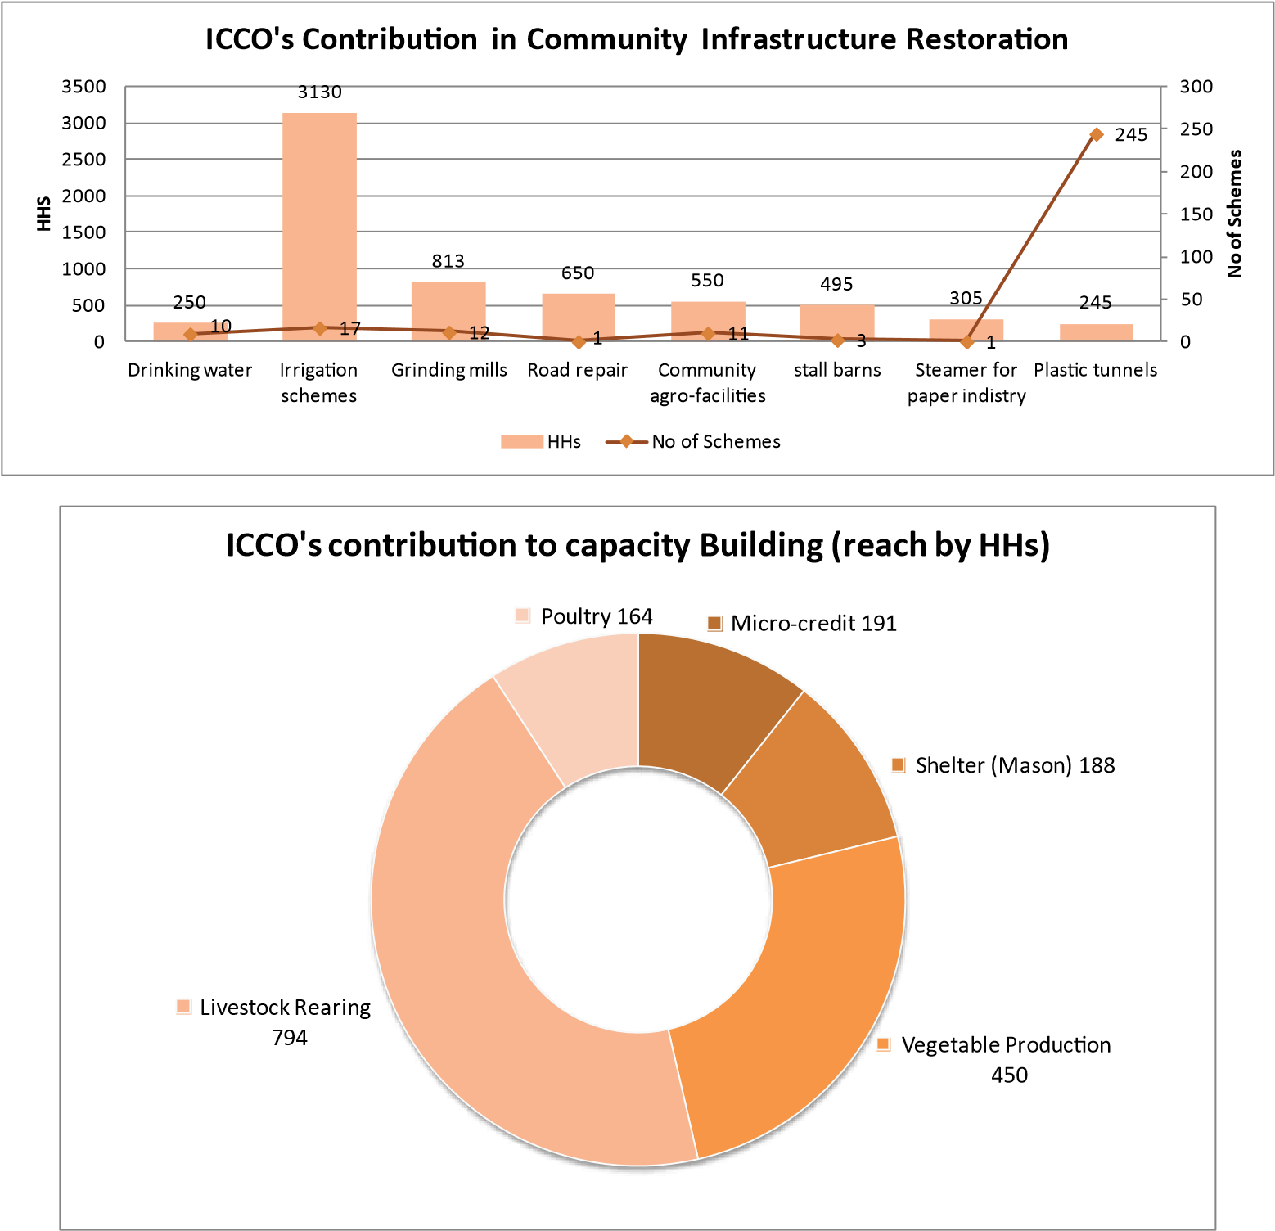

Provision of Agriculture inputs

Beehives

Poultry

Seed, micronutrients, fertilizer...

106

HHs

3

,251 HHs

17

HHs

**Fact Sheet**

**Nepal Earthquake Response Program (NPL 151)**

Community Infrastructures Restoration

* 27 irrigation schemes developed
* 9 Agriculture roads constructed/opened
* 2 collection centers & 3 rustic centers restored
* 3 bridges built
* 1 drinking water scheme developed
* 2 Haat Bazaars restored
* 1 Electricity supply restored
* 14 grinding mills restored
* 6 Cardamom dryers restored
* 1 paper steamer restored
* 20 saving groups received micro credit

##### Provision of Agriculture inputs

* Bee hives
* Poultry
* Seed, micro-nutrients, fertilizer
* Tools & materials

##### Capacity building

* Mason Training (Shelter)
* Vegetable Production
* Poultry
* Livestock rearing

##### Progress

**Start**

**Finish**

**88,576**

**(Number of beneficiaries reached)**

**18,846 HHs**

**(Number of households reached)**

##### 626,686

**Total budget**

###### Working Districts

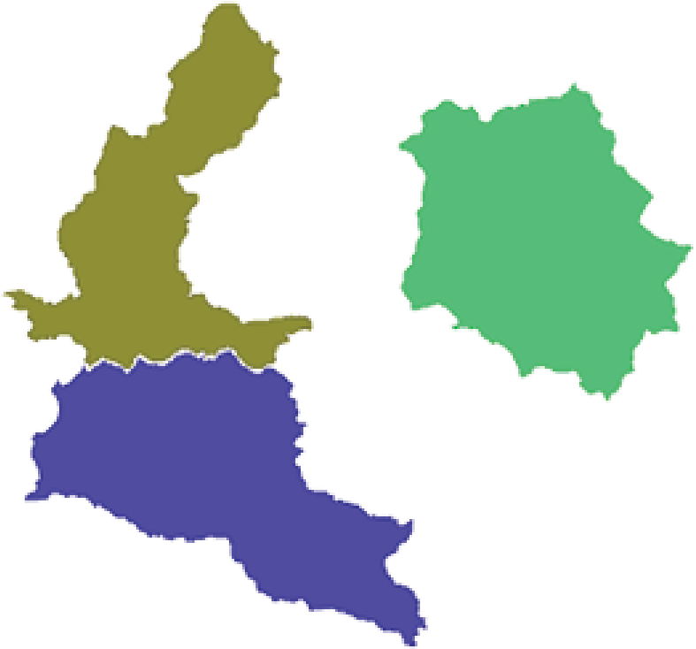

 Dhading  Sindhupalchok  Makawanpur

Process Followed

The area of intervention was based on the scale of destruction in the VDCs/ municipalities. The list of HHs that suffered complete destruction was obtained from the VDCs/municipalities and the number of beneficiaries per VDC/municipality was decided based on that data. The process of selection included orientation to the program and area of intervention with the DDRC and district-level stakeholders. VDC representatives, LDMC members, including all ward citizen forum coordinators, local political leaders, social leaders, and related stakeholders working in the VDCs/ municipality were thereafter oriented to the program, support and selection criteria.

In general, marginalized communities that had lost their homes and assets and had a minimal capacity to revert to normal on their own were prioritized under the selection process. More in-depth selection processes were conducted, depending on specific interventions. ICCO’s interventions primarily started at the early recovery stages, where HHs with lower socioeconomic conditions were assessed -- people who might not have received a red card but were living in poverty. HHs with disabled family members or sufferers from chronic diseases, older people (aged more than 65) and children aged below five were prioritized next. The list of beneficiaries prepared was then endorsed by the LDMC and VDC secretary.

Ownership and Sustainability

One major factor that will ensure sustainability is the approach that ICCO used in its interventions. We strongly believe in what we call a ‘systems approach’, whereby we work and promote working with established system actors on the ground, such as government service delivery organizations, private sector agencies like suppliers and buyers of commodities, and relevant technical institutions. We also believe that change is only possible if all agencies work together for a common purpose, and ICCO and our partners play a strategic linking role. In this sense, the consolidation of relations between these system actors will ensure sustainability of the results produced by this project.

Moreover, our district partners are wellrooted with the communities that they work in. They were working in these districts before the earthquake and will continue to be present in these districts for many more years. In addition, in all our intervention areas, we preferred to work with established community institutions, like farmers’ groups, mothers’ groups and micro-credit/cooperatives. This will also ensure and promote ownership among community members.

In a lot of our activities, especially related with the restoration of community infrastructure, we have chosen to restore facilities that users groups or community groups had already started rebuilding. In other words, our support was demand based. In a few cases, like the restoration of irrigation schemes in Chitlang of

Makawanpur, the community contributed around 35 percent of the cost in cash. In most cases, users contributed in kind through their labor. Owing to our careful selection of cases at the beginning of the program, we directly supported initiatives that were raised by the communities themselves. We strongly believe that this will ensure both ownership and sustainability of these initiatives.

Lessons Learnt and Way Forward

During our interventions, we learnt that our project team and social mobilizers need to actively and consistently engage with the communities in order to understand their real needs as these needs change quite rapidly during natural disaster. We needed to remain very alert to these changes and adapted our strategies and actions accordingly.

Another important lesson for us was the way in which we selected our beneficiaries. In a situation where the local government was very fragile and decisions from authorities depended on a variety of factors, we needed to cross-check the information gathered from different sources before beginning any activities. Otherwise, there were high chances of vulnerable sections of the population getting overlooked by our information systems.

Therefore, we needed a very strong and objective information management system in place at the inception of our projects, with provisions for adaptation in changing situations. This provided a strong basis for informed decision-making and in turn, enabled us to reach out to those who needed our support the most.

##### Story of Change

Thuli Maya Tamang, a resident of Phakel, Makawanur district, is a subsistence farmer and a daily-wage laborer. A mother of five, Thuli Maya works half the year on her farm, where she grows maize and vegetables, and the other half as a hired hand on other people’s farms.

“Sometimes I go, other times, I send my kids. The wage going rate is Rs 250 for a day’s work. Some months, especially around the planting and harvesting seasons, there is regular work but then again, those are the times when you have to work on your own field too,” says the 50-year-old.

Thuli Maya’s children dropped out of school before turning 16, except the youngest, who is 13 and still in school. Her sons work odd jobs in Kathmandu and her daughters help out on the fields.

“It was not easy raising five young kids on my own but at least we had a roof over our head,” says Thuli Maya. “Sadly, the quake rendered my house uninhabitable. It took away my sole consolation.”

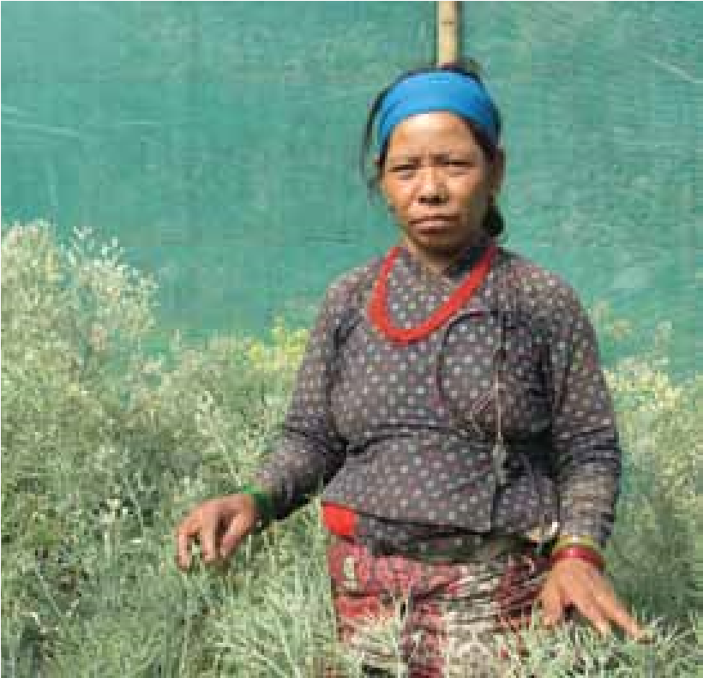

Since 2015, with support from ACT Alliance,

ICCO has been working in wards 1 and 4 of Phakhel to restore livelihood of earthquakeaffected farmers like Thuli Maya through its local implementing partner, CCDN. Thuli Maya has benefitted from a lucrative cauliflower seed production program for vulnerable farmers. She received a financial support to construct a plastic tunnel, free seeds for her nursery and her daughter, 20-year-old Chandra Kumari Tamang, received technical training in hybrid seed production.

A single tunnel can hold around 200 seedlings, with each fully-grown plant producing between 15-20 gms of seed. Each tunnel can then in turn produce over 2.5 kgs of seed, with a kilo of grade a cauliflower seeds fetching up to Rs 18,000 in the local market.

“My daughter has benefitted greatly from the technical training. She earned around Rs 30,000 within the last eight months alone,” says Thuli Maya. “She now wants to save up and construct more tunnels to begin commercial vegetable and seed production.”

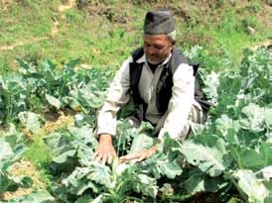

Laxman Gopali is a 62-year-old farmer from Chitlang-6, Makawanpur district. The past year has been tough on him and his family, not only because of the earthquake but also due to an ongoing drought that is posing a serious threat to his livelihood.

Laxman, who relies on 0.2 hectare of farmland to provide for his family, is worried that if the monsoon rains don’t come soon, his income will take a major hit. Things were much harder in the initial days, right after the earthquake, though.

“We relied on a small stream for irrigation. However, after the earthquake, water sources dried up,” says Laxman. “I lost

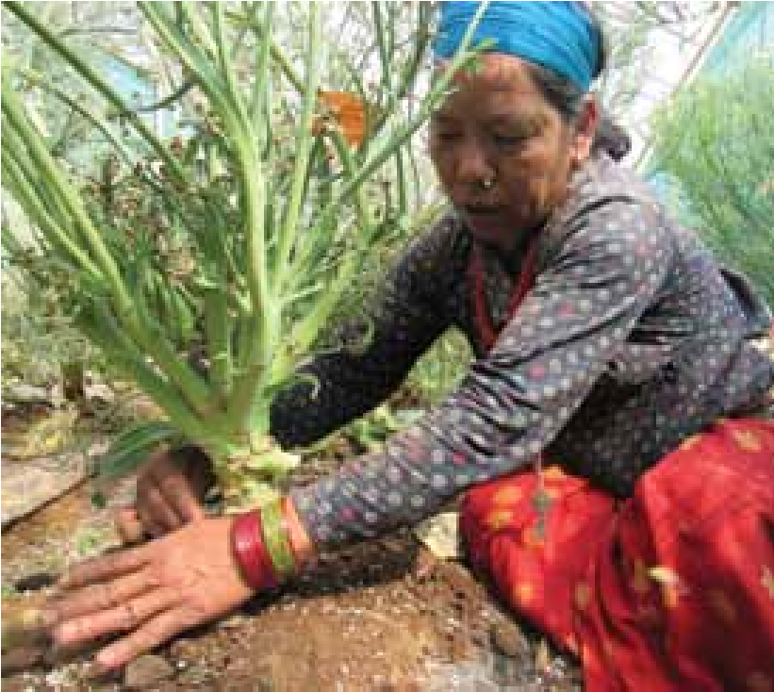

around 8 to 10 quintals of cauliflower due to the chaos following the quake as the buyers did not come down to our village. I lost around Rs 50,000. I cannot afford to take another hit like that.”

Around 30 hectares of farmland was at a risk of going fallow without the restoration of irrigation channels, affecting 200 HHs like Laxman’s.

ICCO Cooperation, along with CCDN, its local implementing partner, decided to restore irrigation channels (multiusers scheme) based on the immediate needs of the community to secure their livelihood. ICCO’s financial support of Rs

200,000, combined with the community’s investment of Rs 75,000, laid the groundwork for the reconstruction of the irrigation channels.

“With the restoration of the channels, I was able to farm cauliflowers again this season. I hope to see a yield of around 25-30 quintals and expect to make around Rs 100,000 at current market rates. Since we haven’t had any rain for the past five months, the irrigation channel has saved us,” says Laxman.

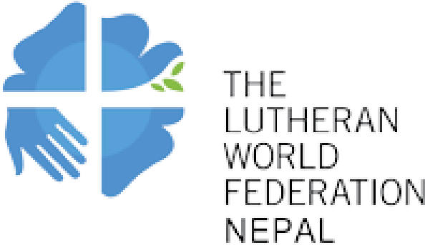

###### Summary

Lutheran World Federation Nepal (LWF) initiated its humanitarian response to the Gorkha earthquake from the very first day. Despite an unfavorable environment, during the relief phase (April-July 2015) LWF Nepal distributed tarpaulin (emergency shelter) to 17,363 households, hygiene kits to 10,592, non-food items to 18,043, ready-toeat food to 5,122 and basic food to 6,353 households in Sindhupalchok, Dolakha, Rasuwa, Makawanpur, Kavrepalanchok and Nuwakot districts.

LWF took initiation to set up Earthquake

Emergency Operation Centres for the ACT Alliance Nepal Forum. As a member of the Forum, LWF Nepal stayed in communication with other ACT Forum members and convened regular meetings. Particularly, it provided leadership in joint assessment and planning of the ACT Forum emergency response.

Similarly, during the recovery phase LWF provided temporary shelter support to 7,201 households, pit latrine support to 5,957 and livelihood support (cash) to 7,266 households. LWF also provided more than 20,000 people with psychosocial support. Additionally, 123 community water systems were repaired and rehabilitated.

We have noted early signs of hope, renewed vitality, optimism, self-confidence to the earthquake survivors. The key players behind the LWF success to respond to earthquake-affected people are its partners namely Manekor Society Nepal, Rasuwa; Gramin Mahila Srijanshil

Pariwar (GMSP) Sindhupalchok; Human

Rights Awareness and Development Center

(HURADEC), Dolakha; Integrated Community

Development Organization (ICDO), Lalitpur, Society of Local Volunteers Efforts (SOLVE), Lalitpur; Transformations Nepal, Bhaktapur.

Reaching to earthquake affected people with its quality humanitarian support was possible only because of the trust and effective collaboration between stakeholder. Collaboration and effective coordination among ACT Alliance Nepal Forum members from the very beginning of its emergency relief activity, coordination with DDRC , VDC, Ward Citizen Forum and local political leaders helped LWF Nepal to implement its response activities. LWF Nepal’s coordination and engagement with Association of NGOs in Nepal (AIN), Department of Urban Development and

Building Construction (DUDBC), National

Reconstruction Authority (NRA), Social Welfare Council (SWC) and I/NGOs working in humanitarian sector were instrumental for national level policy advocacy, joint planning and compliance with the standard norms and criteria.

LWF Nepal faced a number of challenges, including issues related to partner capacity, a lack of coordination among agencies, issues related to procurement, lack of government guidelines on construction of shelters and problems in transporting materials due to a blockade on the NepalIndia border and landslides.

**Background**

The two devastating earthquakes of magnitude 7.8 and 7.3 in April and May 2015 caused 8,891 casualties and 22,302 injuries. Similarly, 608,155 residential buildings were completely destroyed while 298,998 were partially damaged. Furthermore, 2,687 government buildings (including schools and health posts) were destroyed completely while 3,776 were partially damaged. Further, 743 historical and archaeologically significant heritage sites and monuments were damaged, with 133 fully collapsing, 95 partially collapsed and 515 partly damaged**1**. Out of 35 district affected by the earthquake, 14 were severely affected.

|  |  |  |  |  |  |  |  |  |  |  |  |  |  |  |  |  |  |  |  |  |  |  |  |  |  |  |  |  |  |  |  |  |  |  |  |  |  |  |  |  |  |  |  |  |  |  |  |  |  |  |  |  |  |  |  |  |  |  |  |  |  |  |  |  |  |
| --- | --- | --- | --- | --- | --- | --- | --- | --- | --- | --- | --- | --- | --- | --- | --- | --- | --- | --- | --- | --- | --- | --- | --- | --- | --- | --- | --- | --- | --- | --- | --- | --- | --- | --- | --- | --- | --- | --- | --- | --- | --- | --- | --- | --- | --- | --- | --- | --- | --- | --- | --- | --- | --- | --- | --- | --- | --- | --- | --- | --- | --- | --- | --- | --- | --- |
| **Table 1: Information on LWF Nepal’s Emergency Response, Recovery and Rehabilitation Projects**   |  |  |  |  |  | | --- | --- | --- | --- | --- | | **Targeted**  **No District**  **HHs** | | | **Sector Donor** | | | 1 | Kathmandu, Lalitpur,  Rasuwa, Dolakha  Sindhupalchok | 15,000  HHs | Shelter, WASH  Psychosocial Support  Food security/Livelihood | ACT Alliance, Switzerland | | 2 | Rasuwa | 2,042 HHs | Transitional Shelter | Islamic Relief Worldwide (IRW) | | 3 | Dolakha | 1,000 HHs | Transitional Shelter/Livelihood | Christian Aid, UK | | 4 | Sindhupalchok | 1,084 HHs | Emergency and Transitional Shelter | Canadian Lutheran World Relief | | 5 | Sindhupalchok | 510 | Permanent Shelter | Canadian Lutheran World Relief | | 6 | Lalitpur | 2,400 HHs | Transitional Shelter including Toilet and NFIs | Disaster Relief Fund, HKSAR, P.R. China through Amity Foundation | | 7 | Bhaktapur | 150 HHs | Transitional Shelter | World Dikonie/Korean Dikonie | | 8 | Dolakha | 50 HHs | Transitional Shelter/DWS | Malakar (Indian Orthodox Church) and ICON Charities Inc. | | 9 | Rasuwa | 2,100 HHs | Transitional Shelter/DWS Winterization | European Commission’s Humanitarian Aid and Civil Protection (ECHO) | | 10 | Rasuwa (Langtang  Village) | 116 HHs | Transitional Shelter | Nepalese Canadian Community  Services and Primate World Relief  Development Fund | | 11 | Kavrepalanchok | 1,030 HHs | Shelter/Livelihood | Diakonie-katastrophenhilfe, Germany | | 12 | Rasuwa | 290 HHs | Shelter/Livelihood | Islamic Relief Worldwide | |

The Lutheran World Federation (LWF) Nepal began a humanitarian response to the earthquake from the very first day. During the first three months (AprilJuly 2015), LWF Nepal focused on relief activities. Since then, it has been involved in recovery. LWF Nepal’s response reached eight districts, namely Kathmandu, Bhaktapur, Lalitpur, Rasuwa, Dolakha, Sindhupalchok, Nuwakot, Makawanpur and Kavrepalanchok, a total of 31,000 households. LWF Nepal also completed the implementation of four donorfunded responses to the earthquake by mid-2016. Two projects, from Diakoniekatastrophenhilfe Germany and IRW respectively, go beyond 2016.

###### Relief Phase

At the beginning of the relief phase, LWF Nepal distributed lifesaving relief materials like tarpaulin sheets and ready-to-eat food (water, noodles, biscuits, beaten rice, etc.) in Kathmandu, Lalitpur and Bhaktapur districts.

________________

1. http://www.nra.gov.np/pages/details/about

It expanded its outreach to remote and hard-hit areas of Sindhupalchok, Dolakha, Rasuwa, Makawanpur, Kavrepalanchok and Nuwakot districts a week after the earthquake. Further, LWF Nepal diversified relief packages based on the ground needs and cluster recommendations. Data shows that LWF reached 23,000 households during the relief period.

Another important highlight of the phase was the establishment of Earthquake Emergency Operation Centres by the ACT

Alliance Nepal Forum. As a member of the

Forum, LWF Nepal stayed in communication with other ACT Forum members and convened regular meetings. Particularly, it provided leadership in joint assessment and planning of the ACT Forum emergency response. Also, it provided leadership in partnering with local media and promoting joint visibility of the ACT Alliance Nepal

Forum members.

**Chart 1: Households Reached during Relief Phase**



,

17

**3**

63

10,592

5,122

18,043

6,353

**LWF Progress During Emergency Phase HHs**

Emergency Shelter

Hygiene Kit

Non-Food Items

Ready-to-Eat Food

Basic Food

**Recovery Phase** (July – December), LWF reached to more

than 8,000 households through different The ‘Recovery Phase’ of the earthquake projects (please refer to table 1.1) that response program began from the period were implemented in partnership with starting from July 2015. During this period Community-Based Organizations (CBOs).

**Graph 3- Recovery Phase**

|  |  |  |  |  |  |  |  |  |  |  |  |  |  |  |  |  |  |  |  |  |  |  |  |  |  |
| --- | --- | --- | --- | --- | --- | --- | --- | --- | --- | --- | --- | --- | --- | --- | --- | --- | --- | --- | --- | --- | --- | --- | --- | --- | --- |
| **LWF Nepal’s overall Progress during Recovery Phase**   |  |  |  |  |  | | --- | --- | --- | --- | --- | |  |  | 20911 |  |  | |  |  |  |  |  | |  |  |  |  |  | | 7201 | 5957 |  |  | 7266 | |  |  | 133 | 284 |  |   25000  20000  15000  10000  5000  0  Transitional Shelter Emr. Toilet (HH) Repair/Rehab Drinking Psychosocial Activities Carpertry Training Food Security/  (HH) Water system (sheme) (Persons) (Persons) Livelihood Support (HH) |

**District-wise Progress**

**Graph 4: Recovery Phase - Dolakha**

1,100

12

3,469

68

1,700

0

500

1000

1500

2000

2500

3000

3500

4000

Transi

ti

onal Shelter

(

HHs

)

Repair/Rehab Drinking

Water System/

Scheme

Psychosocial Ac

ti

vi

ti

es

(

People

)

Carpertry Training

(

People

)

Food Security/

Livelihood Support

(

HHs

)

**Dolakha**

**Graph 5 : Recovery Phase Sindhupalchok**

778

46

7030

36

1820

0

1000

2000

3000

4000

5000

6000

7000

8000

Transi

ti

onal Shelter

HH

(

)

Repair/Rehab Drinking

Water system

(

Scheme

)

Psychosocial Ac

ti

vi

ti

es

(

Persons

)

Carpertry Training

(

Personss

)

Food Security/

Livelihood Support

(

HH

)

**Sindhupalchok**

**Graph 6 : Recovery Phase Lalitpur**

2,744

55

6,201

98

2,016

0

1000

2000

3000

4000

5000

6000

7000

Transi

ti

onal Shelter

(

HH

)

Repair/Rehab Drinking

Water system (Scheme)

Psychosocial Ac

ti

vi

ti

es

)

(

Persons

Carpertry Training

(

Personss

)

Food Security/

Livelihood Support (HH)

**Lalitpur**

###### Lessons Learnt

* It is realized that a comprehensive orientation to the partners and its staffs at the beginning of project is a key to accelerate the project activities.
* Engineers are found focused on design, BOQ preparation and implementation. But their actual support to motivate community people to complete the project was seen inadequate.
* Program progress to be reviewed in periodic basis.
* Construction of T-shelter with direct participation of community was a good practice and it is recommended to continue the practice in future.
* As women are more vulnerable to psycho social problem, mobilization of female psychosocial officers is found very effective to deal with psychosocial issues. Therefore, continuing mobilization of female psycho social officer is one of the recommended strategies for future program implementation
* There should be the proper orientation regarding the Government shelter construction policy. That will help to avoid the confusion among the beneficiaries.
* Organizations need to train staffs on accountability before the project implementation. Also, partner’s capacity building is crucial.

**Graph 7: Recovery Phase Rasuwa**

2429

20

4093

82

1700

0

500

1000

1500

2000

2500

3000

3500

4000

4500

Transi

ti

onal Shelter (HH)

Repair/Rehab Drinking

Water system (Scheme)

Psychosocial Ac

ti

vi

ti

es

(

Persons

)

Carpertry Training

Personss

)

(

Food Security/

Livelihood Support (HH)

**Rasuwa**

* Involvement of district authorities on some key decision about project implementation would be very fruitful.
* Complain handling mechanism is one of strengths of LWF Nepal. It is high time to strengthen feedback mechanism.
* Involvement of local population on crucial decision making such as selection of beneficiaries, material distribution and monitoring lessens the error and increases the transparency

###### Story of Change

With support from ACT Alliance, LWF Nepal has repaired pipelines and installed water tanks and taps in four water-insecure VDCs in Sindhupalchok district, helping more than 2,500 households access clean water for drinking and sanitation.

The twin earthquakes of April and May not only caused massive damage to life and property but also severely affected water sources. Sindhupalchowk, one of the worsthit districts, faced an immediate water crisis following the tremors.

As the water systems in remote areas were damaged and sources dried up, risks of diarrhea and typhoid fever spreading also increased. In immediate response, LWF Nepal, in collaboration with ACT Alliance, initiated a Drinking Water Reconstruction and Repair Project in four Sindhupalchowk VDCs -- Baramchi, Selang, Gumba and Pantang -- to restore damaged water systems and improve health conditions by reducing risks associated with unsafe drinking water.

In Sindhupalchok, the main source of water for many VDCs is spring water, often located far from settlements. The earthquake and subsequent landslides damaged water pipelines and also changed the output of many water sources. While water sources located uphill diminished, sources at the foothills showed an increased discharge.

“Our main water supply from Jugey, almost two kilometers from our village, got damaged after the earthquake,” says Nir Bahadur Paudel, a 75-year-old resident of Chanaute, Baramchi-9. Forty-five households were without water for two months after the earthquake, forcing people to walk for almost two hours to fetch water from the nearby Balefi river.

But this was before LWF Nepal initiated its drinking water project in Baramchi. With support from ACT Alliance, LWF repaired The disruption in the supply of water also affected women disproportionately. Washing, bathing and going to the toilet became difficult chores since women were now forced to look for private spaces in the open.

“We were compelled to use another water source, located some 40 to 45 minutes away from our village, and we had no safe, private spaces to bathe,” says 32-year-old Anshu Shrestha of Pangtang-2.

LWF and ACT Alliance installed water taps and bathroom shelters in 10 locations across Pangtang, to the relief of 622 households. This made things much easier for women since they no longer had to travel far to fetch water and with the new bathroom shelters, they no longer had to worry about their privacy. Almost a year after the earthquake, the water taps and shelters teem with people every morning, serving as a communal social space for the entire community.

|  |
| --- |
| pipelines to affected villages and installed water tanks and taps for the community to use.  “We repaired nine water systems in Baramchi and installed water taps for the convenience of locals. This solved the water problem for almost 866 households,” says Rabindra Ghimire, Secretary of the Baramchi Drinking Water Consumers’ Committee. |

The Drinking Water Reconstruction and Repair Project was started with the aim of providing sustainable access to safe drinking water for the people of Sindhupalchowk after the earthquake. It’s been a major success so far. LWF has now helped more than 2,500 households in Sindhupalchowk

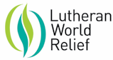

Summary

Lutheran World Relief (LWR) has worked in Nepal since 2009 and had existing development programs in Lamjung district, close to the epicenter of the April 25, 2015 earthquake. Because of our established presence on the ground, LWR was wellpoised to mobilize our emergency response to the 7.8 magnitude earthquake within the first 24 hours of the disaster. Under our Nepal Earthquake Response Program (NERP), LWR has thus far committed close to $2.5 million for a year and a half to meet the immediate relief and long-term recovery needs of five earthquake-affected VDCs in Lamjung and one in Gorkha, reaching more than 23,000 people in total. LWR collaborated closely with the DDRCs of

Lamjung and Gorkha to determine in which VDCs it would work. In the immediate relief phase of NERP, LWR supported Bhalakharka, Bichaur, Chakratirtha, Dudhpokhari and Kolki VDCs in Lamjung and Jaubari VDC in Gorkha. In the recovery phase, LWR continues to support Bichaur, Dudhpokhari, Kolki, and Jaubari. LWR prioritized coordination with communitybased organizations (CBOs) and local authorities in all of these VDCs to ensure its activities were needed, sustainable, and ultimately owned by the community.

Between April-July 2015, NERP’s relief phase, LWR distributed food packs and seeds to promote food security to 2,085 households in Lamjung and 829 households in Gorkha. LWR also distributed non-food items/material resources, such as quilts, personal care kits, and water filtration units, to 2,061 households in Lamjung and 839 households in Gorkha. For shelter support, LWR locally purchased and distributed tarpaulins and corrugated galvanized iron (CGI) sheets or provided cash to those who preferred this means to 1,458 households in Lamjung and 827 households in Gorkha.

Since July 2015, NERP’s recovery phase, LWR has been implementing it early recovery and livelihood activities, including cash-for-work (CFW), seed and livestock distributions, and improved agriculture and livestock as well as earthquake resistant masonry skills training, reaching 1,458 households in Lamjung and 1,505 households in Gorkha. Now that the government has finalized its reconstruction plans, LWR is working with the NRA to begin its permanent shelter programming. In the months ahead, LWR will continue its programming to improve rural livelihoods as well as market and financial access since development progress in these areas is essential to ensuring Nepal’s full recovery and future resiliency.

Background

LWR began working in Nepal in 2009 to improve food security for indigenous, Dalit and marginalized communities. Despite recent declines in poverty, Nepal remains one of the poorest countries in the world. Rural communities often struggle with household food security and are extremely vulnerable to frequent natural hazards, including flash floods, landslides and earthquakes. Poverty affords these communities few resources to prepare for or mitigate the effects of these hazards and even fewer resources to recover, which can destroy development gains. LWR’s presence in Nepal allows it to immediately respond to such emergencies and provide essential

|  |  |
| --- | --- |
| **Project Name** | Nepal Earthquake Response Program (NERP) |
| **Districts** | Lamjung; Gorkha; Kathmandu Valley |
| **Partners** | COPPADES; SSICDC |
| **Targeted Households** | 3,816 |
| **Sectors** | Food security; non-food items (NFIs) and material resources (MR); shelter; early recovery and livelihood; and quality and accountability (Q&A) |
| **Donors** | Bill & Melinda Gates Foundation; ACT Alliance; Evangelical  Lutheran Church in America; Lutheran Church- Missouri Synod;  Thrivent Financial; Annie E. Cassey Foundation; Henry Schein Cares Foundation; US Lutherans |

Programs and Projects

food, shelter materials, personal items, and cash to disaster-affected communities. Additionally, LWR promotes resilience and long-term development by better preparing communities for natural hazards and helping families realize food security and savings. In Nepal, LWR works on agriculture, food security, climate change adaptation, disaster risk reduction and emergency response programs, incorporating a capacity building approach for local partners and the communities. LWR has previously worked in Kailali, Bardiya, Jhapa, Kathmandu and Lalitpur districts and currently has projects in Nepal’s Western Region, specifically in Nawalparasai, Tanahun, Lamjung, and Gorkha districts.

Under the Nepal Earthquake Response Program (NERP), LWR has thus far committed close to $2.5 million for a year and a half to meet the immediate relief and long-term recovery needs of five earthquake-affected VDCs in Lamjung and one in Gorkha, reaching more than 23,000 people in total. In the immediate relief phase of NERP, LWR supported Bhalakharka, Bichaur, Chakratirtha, Dudhpokhari and Kolki VDCs in Lamjung and Jaubari VDC in Gorkha. In the recovery phase, LWR continues to support Bichaur, Dudhpokhari, Kolki, and Jaubari.

|  |
| --- |
| recovery and livelihood, and quality and humanitarian actors, and input from local accountability (Q&A). We are informed by partners, local government officials and the needs assessments, coordination with other affected people themselves.  **Relief Phase**  2085  2061  1458  829  839  827  0  500  1000  1500  2000  2500  Food Security  NFI/ MR  Shelter  Lamjung District  Gorkha District  **NERP Relief Phase** |

Since the April 25 earthquake, LWR has been implementing projects to address food security, non-food items (NFIs) and material resources (MR), shelter, early Immediately after the April 25 earthquake, the government of Nepal declared a state of emergency and requested international humanitarian aid for the affected areas. LWR was already working in Nepal with existing development programs close to the epicenter, and we mobilized our emergency response within the first 24 hours after the first earthquake hit. LWR Nepal staff, in cooperation with our local partner COPPADES, began by assessing the needs of the people affected by the earthquake and attending response coordination meetings with the Government of Nepal, the United Nations and other international and local humanitarian organizations, such as the Nepal Red Cross Society.

In NERP’s relief phase, LWR supported

Bhalakharka, Bichaur, Chakratirtha, Dudhpokhari and Kolki VDCs in Lamjung and Jaubari VDC in Gorkha. As shown in the graph, from May to July, LWR distributed food packs and seeds to promote food security in 2,085 households in Lamjung and 829 households in Gorkha. LWR also distributed non-food items/material resources, such as quilts, personal care kits, and water filtration units to 2,061 households in Lamjung and 839 households in Gorkha. For shelter support, LWR locally purchased and distributed tarpaulins and CGI sheets or provided cash to those who preferred this means to 1,458 households in Lamjung and 827 households in Gorkha.

Focusing our recovery phase programming in the remote mountain VDCs of Bichaur, Dudhpokhari, Kolki, and Jaubari throughout the monsoon season, LWR began implementing our early recovery and livelihood activities, including cash-for-work (CFW), seed and livestock distributions, and improved agriculture and livestock skills trainings, reaching 1,458 households in Lamjung and 1,505 household in Gorkha as depicted in the graph above.

**Recovery Phase**

,085

2

1458

,458

1

829

827

1505

-

500

1

,000

1

,500

2

,000

2

,500

Food Security

Shelter

Livelihood Recovery

Lamjung District

Gorkha District

**NERP Recovery Phase**

While waiting, along with other INGOs, for the formalization of reconstruction guidelines and the authorization to begin providing permanent shelter support from the Government of Nepal, LWR has been providing training in safe building practices for local masons and community members to construct earthquake-resistant homes using local and appropriate materials. Now that the government has finalized its reconstruction plans, LWR is in the process of submitting its permanent shelter proposal to the NRA.

Process Followed

LWR collaborated closely with the DDRCs of

Lamjung and Gorkha to determine in which VDCs we would work. It was jointly decided that LWR would implement its projects in Kolki, Bichaur and Duhdhpokhari VDCs in Lamjung and Jaubari VDC in Gorkha. LWR and our local partners then conducted a series of rapid need assessments in these areas and triangulated our findings with the DDRCs’ initial needs assessments. It should be noted that at the time of LWR’s assessment, 98 households did not respond. LWR continues to collect and update its assessment information as the project progresses.

From this needs assessment analysis, which took gender equality and social inclusion (GESI) issues into account, LWR targeted 1,458 households in Lamjung and 800 HHs in Gorkha. In total, 3,816 HHs in Lamjung and Gorkha have so far received various kinds of support throughout the project.

Ownership and Sustainability

Gorkha’s DDRC recognized LWR’s work in Jaubari with a letter of appreciation in November.

From day one, LWR has prioritized coordination with community-based organizations (CBOs) and local authorities to ensure our activities are needed, sustainable, and ultimately owned by the community. In fact, one of LWR’s fundamental activities is to train CBOs, such as farmers’ groups and mothers’ groups, in improved agriculture practices, group management, collective product marketing, and disaster risk reduction, etc. Trained members of these CBOs further disseminate their knowledge in the community and are able to lead their communities in continuing project activities after LWR has left.

Lessons Learnt and Way Forward

Poverty is the greatest hindrance to full recovery for many Nepalese. Rural communities in Nepal often lack the basic infrastructure, such as passable roads and irrigation, necessary for their development and income generation. Without the means to improve their livelihood and increase their income, most rural Nepalese will be unable to earn enough money make up the difference between the cheapest earthquake-resistant house model approved by the government and any reconstruction grants they may receive. This will result in rural Nepalese improvising non-earthquakeresistant permanent shelters, which will leave them vulnerable to the next major disaster. Improvements in rural livelihood as well as in market and financial access will be essential to ensuring Nepal’s full recovery and future resiliency.

###### Story of Change

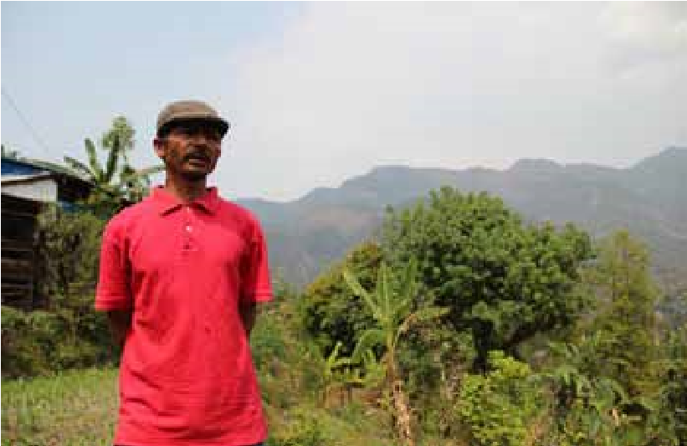

Krishna Panta owns a small farm deep in the steep hills of Jaubari VDC in Gorkha. He had lost his home and much of his food and livestock in the earthquake, but Krishna, who hails from generations of farmers, knew his best means to recovery was through his land. When LWR began offering training to help earthquake-affected farmers recover their livelihood, he jumped at the chance to participate in and learn about improved agriculture practices, which he could use to increase the productivity and marketability of his farm.

Krishna says the training gave him a better understanding of the importance of testing his soil as well as using organic fertilizer. The training also gave him the idea to further diversify his crop with avocadoes, which are not a traditional crop of Nepal but can grow well in its climate. After the training, Krishna was inspired to think of his farming and that of his community more like an agribusiness. He is now encouraging his farmers’ group to build a crop storage facility and to market their produce collectively to get better prices and to cut down on their transportation costs.

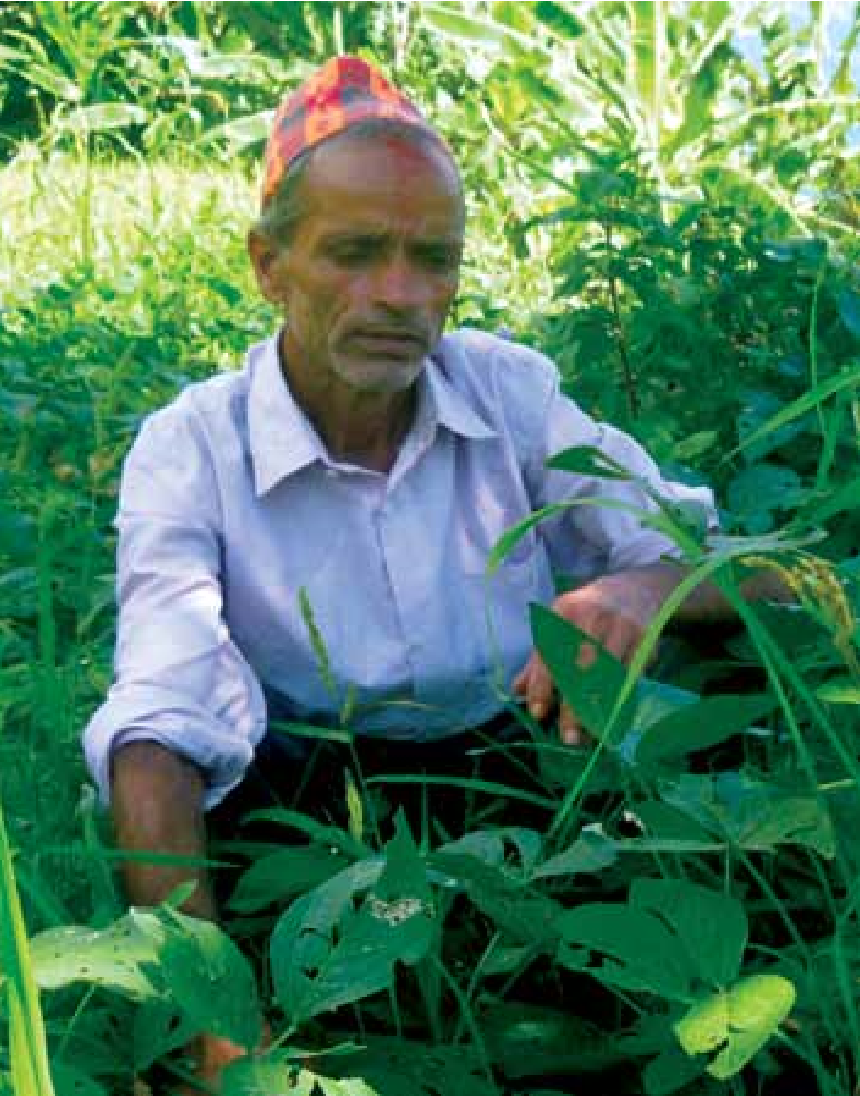Ram Chandra Dawadi is a 54-year-old father of five who lives in Bichaur VDC3 in Lamjung district. In the April 25 earthquake, the Dawadis’ home was completely destroyed, along with their food supply, much of their livestock and their peace of mind. The disaster placed a heavy financial and psychological burden on Ram Chandra’s family, which was already struggling to send one of their daughters, who is disabled, to school. They were afraid that they would continue to be homeless and hungry throughout the monsoon season, but LWR ensured that this would not be the case for them, nor for many others in Bichaur.

The Dawadis received a 15-day food pack and a large LWR quilt to ward off the hunger and cold. They were also given tarpaulin and corrugated galvanized iron (CGI) sheets to shelter themselves from the monsoon rains. Furthermore, the Dawadis participated in LWR’s soybean seed distribution and Cash-for-Work programs, improving their food security. Ram Chandra hopes to rebuild his home and recover his livelihood by raising goats with LWR’s continued support over the next year.

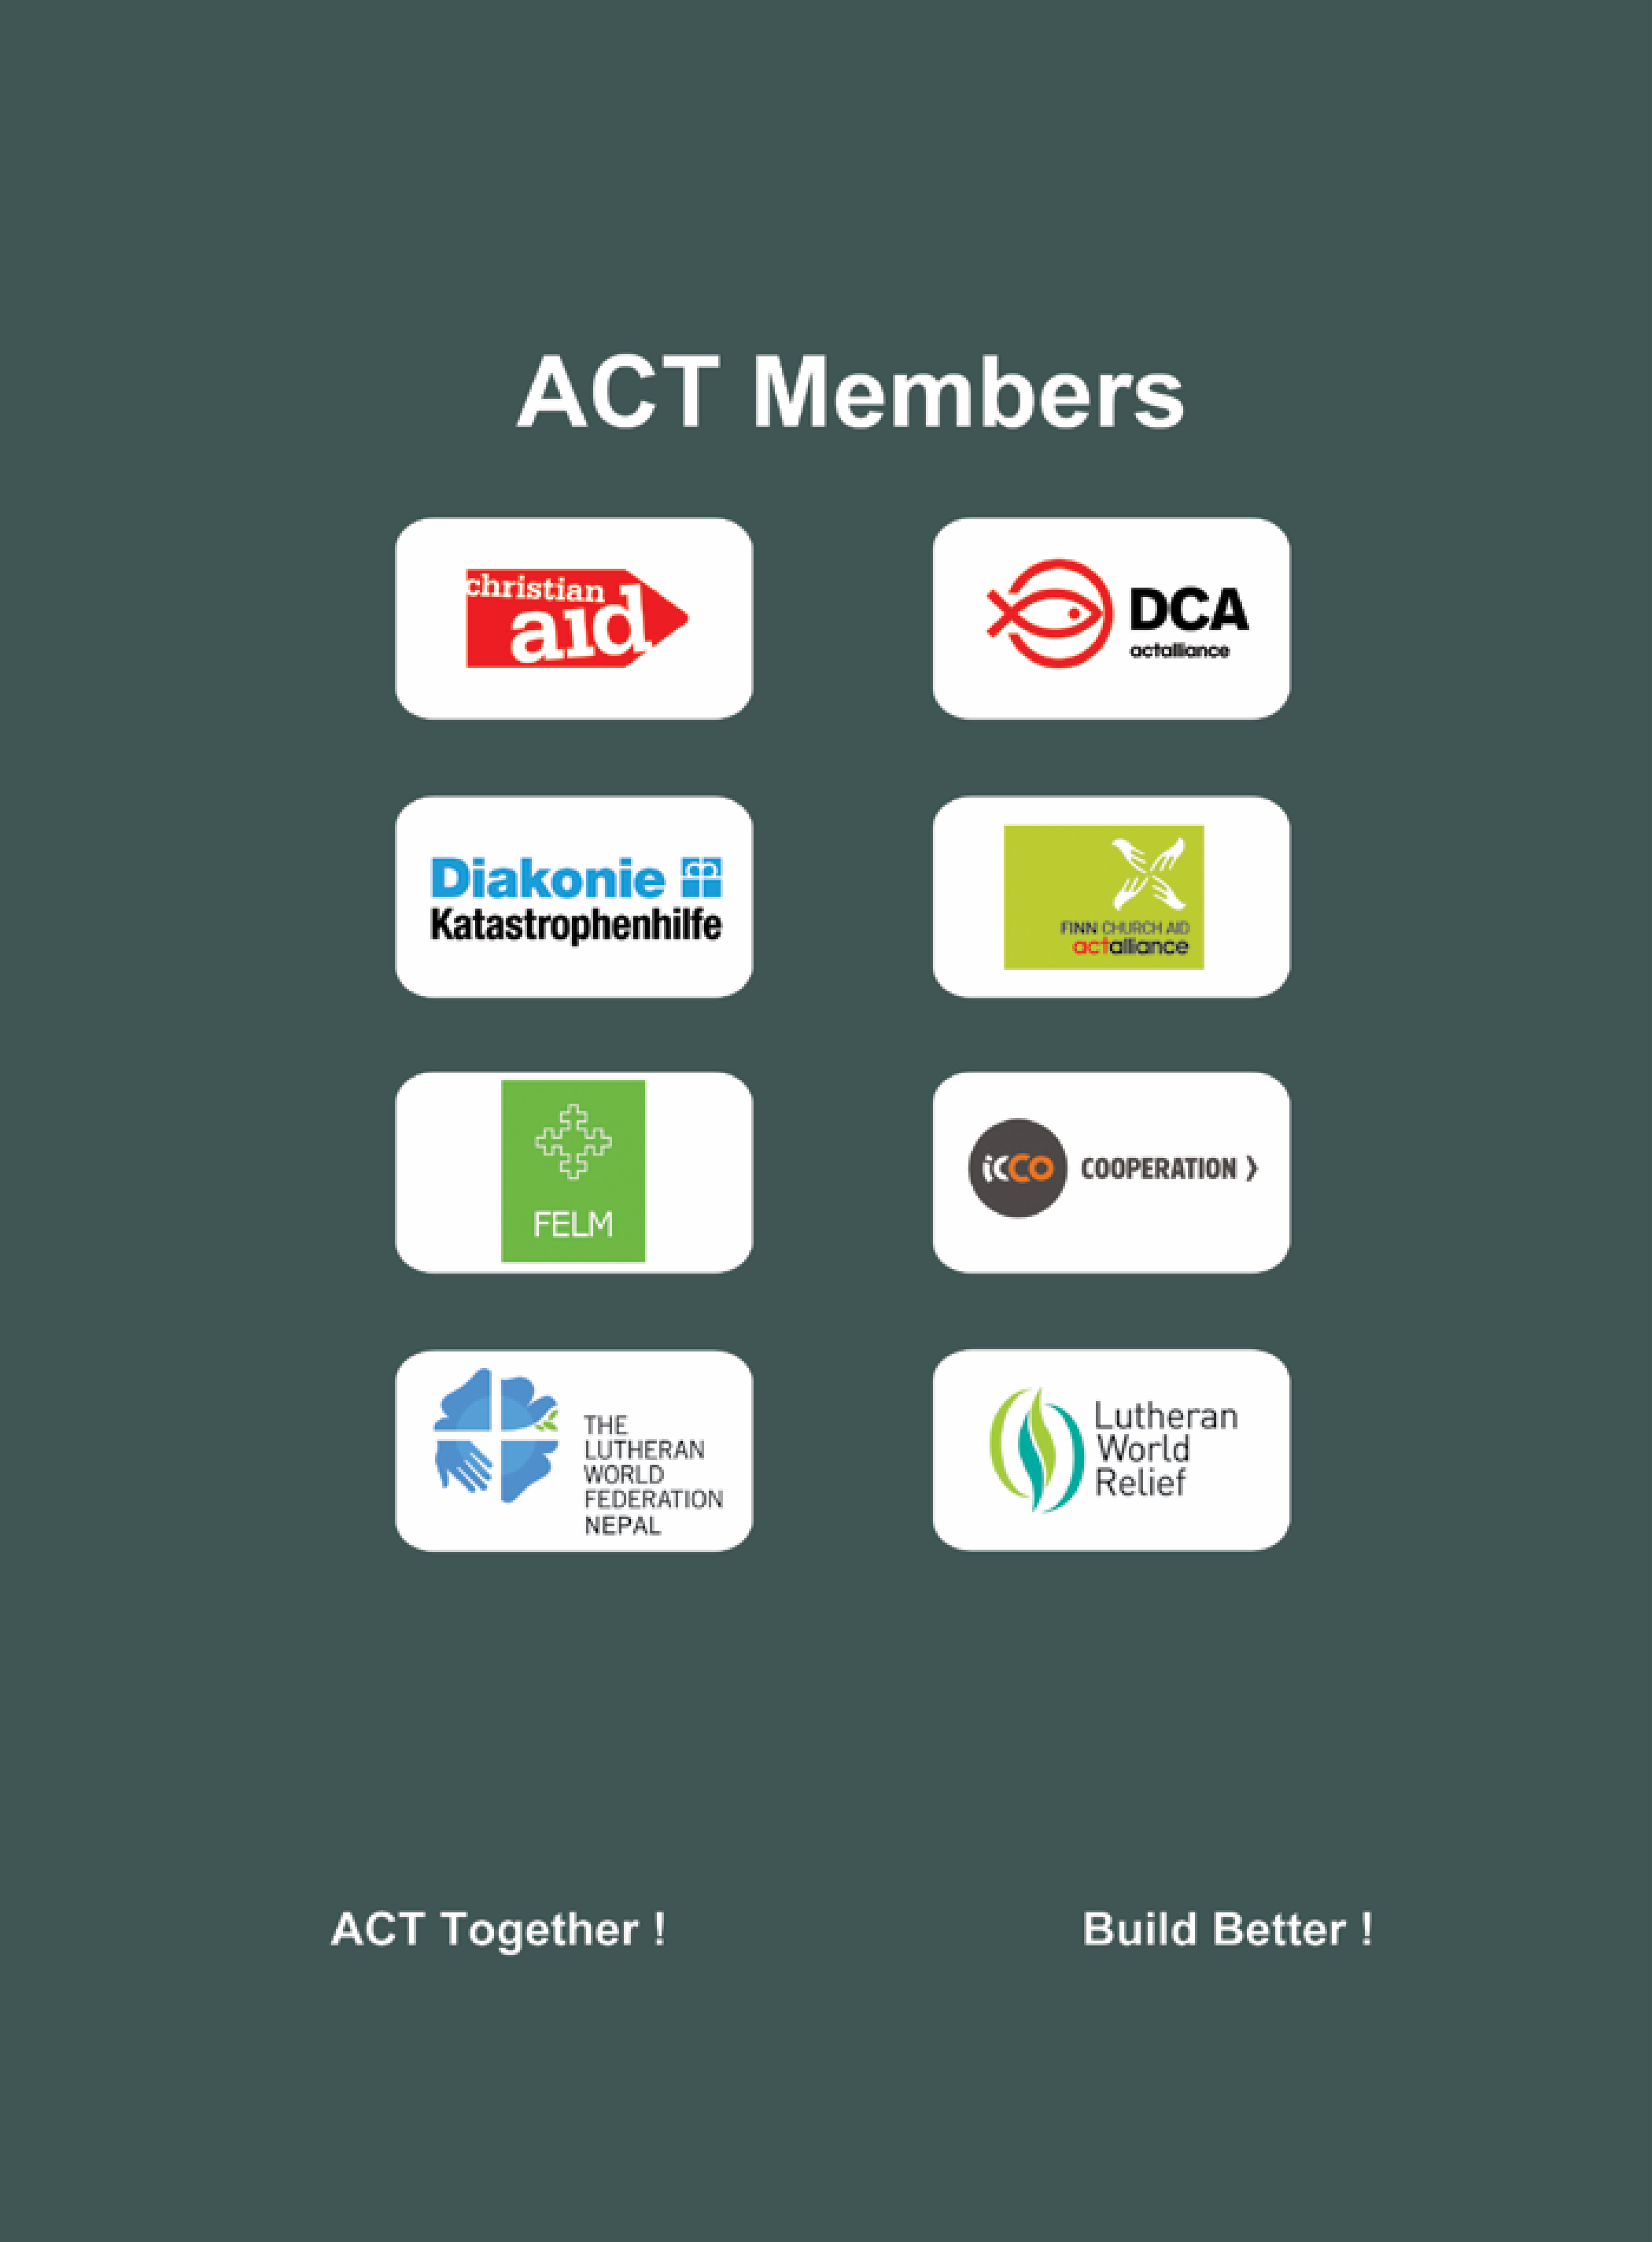 Lessons Learnt 47

**ACT Alliance Nepal Forum**



**ACT Alliance Nepal Forum**

**GPO Box No: 3330, House No. 217, Chundevi Marga -4**

**Maharajung, Kathmandu, Nepal**

**Tel: +977-1-4720217,4720152**