Guidance Note: No Cost Extension template

Purpose
The guidelines provide a clear framework for modifying existing humanitarian projects, ensuring that changes enhance humanitarian objective viability and align with the original intention of the project goals. Requesting members need to apply for a no cost extension when the project targets have not been achieved and there is a significant amount of unspent funds. Often this is caused by delays caused by issuance of government permits, goods and service provider procurement. NCEs can also happen when planned activities are no longer viable or applicable due to changing humanitarian situation, requiring the project to adapt to new circumstances to have greater humanitarian impact.

The No Cost Extension is submitted to the secretariat, through the humanitarian programme officer for review and forwarded to funding members for approval three months prior to the end of appeal project or one month prior to the end of an RRF response.

This guideline is to be used to complete the associated Project Modification template to outline the need for modification, implement changes effectively, and communication revision to stakeholders. The goal is to foster a collaborative approach that maintains the integrity of the original vision while ensuring the proposal meets evolving requirements and furthers humanitarian impact.

This guideline is read in conjunction with the No Cost Extension template.

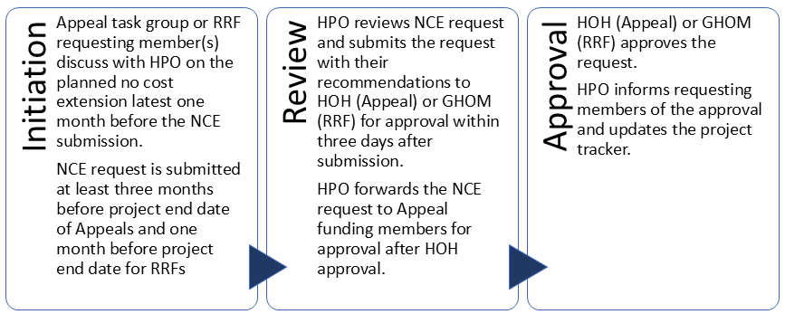

Section: Key Project Information
Fields in this section are taken from the project proposal and the requesting member completes this section. ACT Secretariat Humanitarian Program Officer can support the requesting member to confirm the details.

Section: Brief Description and Justification of Modification
- Part A: Requesting member outlines, with up to 200 words, the justification for why this modification is needed. Include any pertinent information about changes to the political and environmental situation, evolution of the crisis, changes to the needs of the affected population, and other external factors such as implementation delays.

- Part B: Clearly detail the workplan during the extension period. List each activity, its corresponding output, and the updated timeline. Include any important remarks to provide context. This clarity ensures stakeholders understand the adjustments and how they will impact project delivery.

Section: Technical Approach
Focus on the technical approach only if it is changing existing objectives, outcomes, outputs, or activities. Start by clearly stating what changes you’re proposing and why they matter. Justify each modification with a brief explanation of its expected impact. Ensure the changes are realistic and align with your project’s resources and timeline. Finally, update any relevant performance indicators and document everything clearly for easy stakeholder review.

Section: Participants
If the proposal modification involves changes to the number or type of participants, provide clear details. Specify how many participants will be impacted and who they are. Include information on the criteria used for their selection to ensure transparency. This section is important to help stakeholders understand the implications of the modifications and the intended benefits for those served. Clear communication about the changes fosters trust and accountability in the project.

Section: Implementation Area
If the proposal modification changes the project’s geographic implementation area, clearly outline the new location. Specify why this area was chosen and how it aligns with project goals. Providing this information helps stakeholders understand the rationale behind the change and its potential impact on project outcomes.

Section: Monitoring and Evaluation Plan
If the proposal modification requires updates to the Monitoring and Evaluation Plan, specify any changes needed for the log frame. Clearly outline new or modified activities, along with corresponding indicators and targets. This ensures that everyone understands how progress will be tracked and evaluated considering the changes.

Section: Quality and Accountability
When modifying the proposal, it is important to outline how any new or adjusted activities will adhere to quality and accountability standards, such as Sphere standards. Specify the measures by which the project will be implemented to ensure compliance, such as staff training, regular assessments, and beneficiary feedback mechanisms. This information helps stakeholders understand how the project will maintain high standards and accountability throughout the implementation, fostering trust and ensuring that all activities effectively meet the needs of beneficiaries while promoting their well-being and dignity.

Section: Cost Proposal
The cost proposal summarises the details in the budget modification template and should reflect the current balance and burn rate. Clearly outline the reasons for these changes and attach the modified budget for review. This ensures transparency and helps stakeholders understand the financial implications, allowing for informed decisions while maintaining the project’s integrity and goals. Always aim to justify adjustments to promote accountability and trust in the budgeting process.

