Alert note
Philippines, Severe Impacts of Typhoon Bualoi, 30 September 2025

The alert note is intended to alert all ACT Alliance members to an emerging emergency situation. It provides basic information to inform decision making within the Alliance regarding possible response options and it also forms the ‘immediate assessment’ of the situation and needs in the affected areas. An alert note should be completed as soon as it becomes obvious there is a humanitarian emergency.

The information in the alert note should be kept short and concise. Where you do not have information to address a question identified below simply state that the information is not currently available. You will not be expected to have all the information detailed below in the early stages of an emergency.

The alert note should be completed by the forum and sent to the Regional Humanitarian Programme Officer for review and circulation, with a copy to the Regional Representative.

Completed by: National Council of Churches in the Philippines
Date completed: 28.09.2025
Forum: ASIA-PACIFIC

Type of emergency: Typhoons and Monsoon Rains
Date of emergency (if rapid onset): 26.09.25

- The nature of the emergency
From September 25 to 26, 2025, Severe Tropical Storm Bualoi (locally known as Typhoon Opong) made multiple landfalls across the central regions of the Philippines. The storm made landfall first in the province of Eastern Samar (Region VIII), then twice in the province of Masbate (Region V), twice in the province of Romblon, and finally once in Mindoro Oriental—both Romblon and Mindoro Oriental are part of MIMAROPA region (Region IV-B). With maximum winds of up to 110 kilometers per hour (68 mph), the storm devastated the provinces, causing electricity poles to collapse, trees to be uprooted, and damage to infrastructure and households, along with destruction of agricultural livelihoods due to floods.

STS Bualoi (Typhoon Opong) is the 15th tropical cyclone that entered the Philippine Area of Responsibility (PAR) and the fifth one for September 2025, following Super Typhoon Ragasa (Nando) just three days after, which had a wind force of 115 to 143 miles per hour (185 to 230 kilometers per hour) that made landfall in the northern portion of Luzon, and Tropical Depression Mitag (Mirasol), which also made landfall in the eastern part of Central Luzon, specifically in Region III.

Prior to these typhoons, the Philippines was already experiencing unrelenting rains and floods caused by the southwest monsoon.

Sources:
National Disaster Risk Reduction and Management Council (Philippines)
National Disaster Risk Reduction and Management Council

- The impact and scale of the emergency (please include your source of information with links if possible)

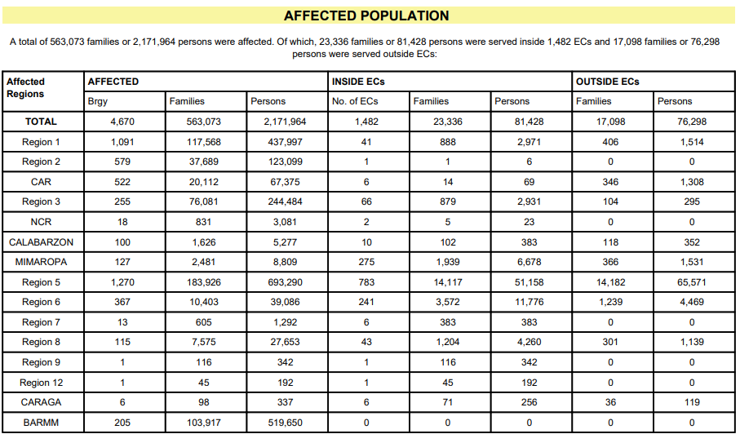
The NCCP considers the situation in the small-scale category. As of 27 September 2025, the National Disaster Risk Reduction and Management Council (NDRRMC) reported a total of 563,073 families or 2,171,964 persons were affected in 4,670 villages spanning 15 regions in the country. The combination of the intensified Southwest Monsoon, Super Typhoon Ragasa, and Severe Tropical Storm Bualoi led to these widespread disruptions. Among those affected, 81,428 individuals were pre-emptively relocated to government-designated evacuation centers for safety.

Infrastructure suffered notable damage, with roads and bridges reported impaired throughout the affected regions. Additionally, 5,282 homes sustained various levels of destruction in Ilocos, Cagayan Valley, Cordillera Administrative Region, Central Luzon, CALABARZON, MIMAROPA, Bicol, Western Visayas, Zamboanga Peninsula, and Bangsamoro Autonomous Region in Muslim Mindanao (BARMM).

The disaster’s toll on livelihoods is also significant. Agricultural losses include damage to 31,128.13 hectares of crops, impacting 31,424 farmers and fisherfolk. The estimated cost of these losses has reached PhP 914,875,615.50, though local reporting continues and these figures may rise.

Initial assessments highlight the hardest-hit areas as Cagayan Valley, MIMAROPA (including Mindoro Occidental & Oriental, and Romblon), the Bicol Region (particularly Masbate province), and Eastern Visayas (notably Northern Samar). These regions, home to many farming and fishing communities, now face acute food insecurity. Residents in island barangays of Cagayan, such as Babuyan Claro, are urgently requesting food assistance after Typhoon Ragasa destroyed their food stocks and rough seas hamper supply deliveries from the mainland. Local church networks, the Bicol Regional Ecumenical Council, Eastern Visayas Regional Ecumenical Council, and the United Church of Christ in the Philippines (a NCCP member church) continue to monitor the situation, conducting a rapid needs assessment, after ensuring communication in the heavily affected areas in Bicol region (Masbate province), Eastern Visasyas (provinces of Northern Samar and Biliran), and Mimaropa (Oriental Mindoro).

Within a span of two weeks, two typhoons swept through the country, with the intensified southwest monsoon compounding the devastation in disaster-prone regions that already contend with regular calamities. In response, the Provinces of Cagayan (Region II) and Masbate have both declared a State of Calamity.

Sources:
National Disaster Risk Reduction and Management Council (Philippines)
https://monitoring-dashboard.ndrrmc.gov.ph/assets/uploads/situations/SitRep_No__22_for_the_Combined_Effects_of_SWM_TCs_MIRASOL_NANDO_and_OPONG_2025.pdf

Cagayan Provincial Information Office
https://www.facebook.com/cagayanPIOnow/posts/pfbid02hPYESBF1h9bmcEHkUfKja2ifhtvRyj54Y2cuCg5SQ3ypnc1dKKAX3woUbeEiTyzkl?rdid=e9jX6gFcc75Cq5yE#

Masbate Provincial Information Office
https://www.facebook.com/masbatepio
- Local and national capacity
Some of the local coping strategies observed were: setting up of protection for farm crops prior the landfall of the two typhoons; early selling of un-milled rice (locally called palay) at a lower price point to avoid wastage and more severe income losses; mass evacuation of families led by local government units to evacuation sites or relative’s homes; and suspension of classes and offices in areas affected by the typhoons and heavy rains. There were also spontaneous efforts launched by churches and community organizations to raise support for disaster-affected communities.
While the national government initiated an emergency response, initial support fell short of the communities’ urgent needs. The initial assessment indicated the relief goods will only last for up to 3 days, while there still is an urgent need for hygiene materials and shelter repair. As of September 27, the Department of Social Welfare and Development – Disaster Response Management reports that a total of PhP 142 million in humanitarian aid has been distributed to thousands of affected families in the regions. Additionally, the DSWD and the Office of Civil Defense (OCD) have prepared PhP 2.9 billion in standby funds and prepositioned relief goods for rapid deployment.
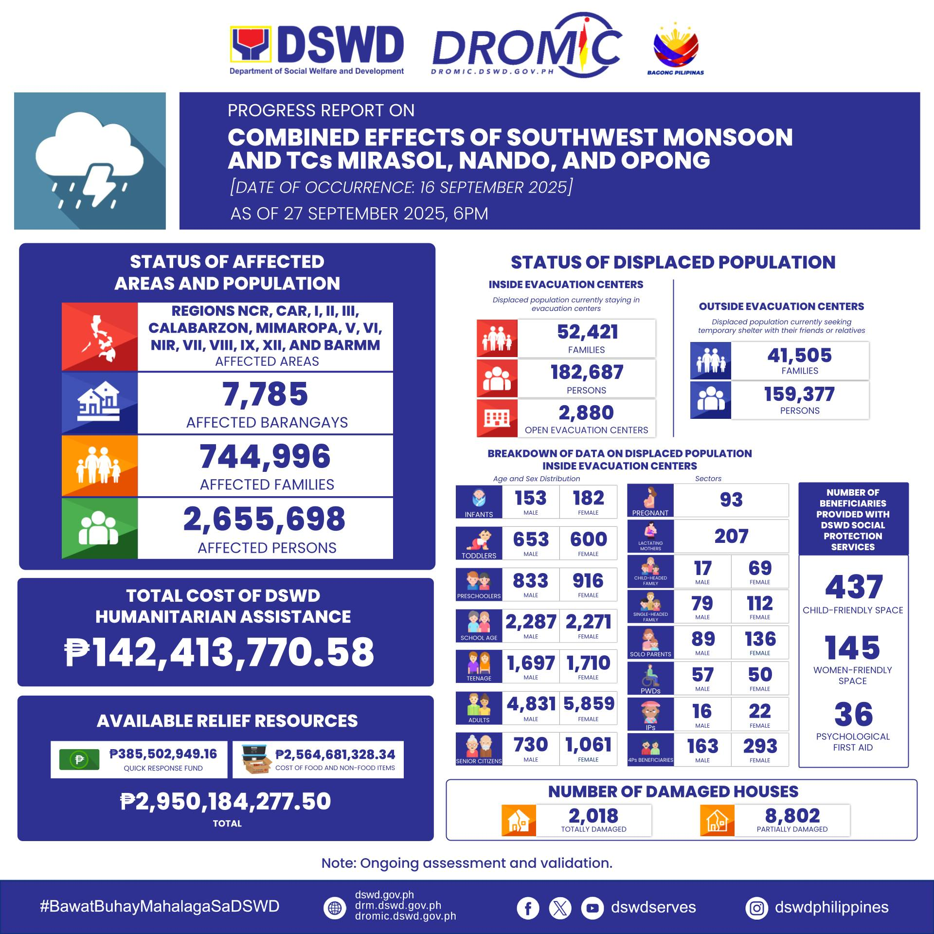
The NDRRMC leads national disaster management coordination, bringing together government agencies, non-government organizations, and the private sector for a unified response. Situation reports are released twice daily to ensure timely information sharing and effective coordination.
The NCCP is the aggrupation of 10 mainline Protestant and non-Roman Catholic churches. Its member churches in local regions and provinces are organized into local ecumenical formations and bodies. The local ecumenical formations present in the affected regions are: Cagayan Valley Regional Ecumenical Assembly (CAVREA) in Cagayan Valley (Region II), Romblon and Mindoro Ecumenical Council (ROMINEC) in MIMAROPA (Region IV-B) and Bicol Regional Ecumenical Council (BREC) in Bicol (Region V). These ecumenical formations have gained DRRM capacities through capability-building activities and on-the-ground experiences from recent emergencies. As of this writing, the NCCP Secretariat has an ongoing coordination with them to gather assessments and on-ground information, to determine priority targets and their immediate needs.
Sources:
Department of Social Welfare and Development – Disaster Response Management
https://www.facebook.com/dswddrm
- Key needs and gaps
Based on initial assessment findings from local ecumenical formations, it was identified that
priority clusters include food, potable water, temporary shelters and shelter repair kits, food security and agriculture, livelihood, psychosocial support and protection services.
Affected families and evacuated individuals expressed the necessity of food, to augment with their food and income losses, and cash for their various urgent needs such as food, medicines, shelter repair, and livelihood-related expenses.

The stark immediate needs are:
- Food packs for affected families
- Multi-purpose cash assistance to address immediate basic needs, as they face severe income losses and destruction

Please indicate whether you are considering:

 | Indicate your intention with an X below
Rapid Response Fund (intended for small and medium scale emergencies) | X
Appeal (intended for large scale emergencies)

- Forum Capacity and members intention to respond
ACT Member | Geographical focus | Sectors of expertise and experience
National Council  of Churches in  the Philippines | MIMAROPA, constituted by provinces of Mindoro, Marinduque, Romblon and Palawan (Region IV-B)  Bicol Region  (Region V)  Western Visayas Region (Region VI)  Eastern Visayas Region (Region VIII) | With Regional  Ecumenical Councils  Equipped with Emergency Response procedures.  Rapid  Assessment/Logistics/  Community  Mobilization/Relief  distribution  (volunteers)

- Potential responses
The NCCP will directly implement the humanitarian response program. At the rapid needs assessment stage, the NCCP mobilized its local ecumenical formations and local stakeholders. This ensures a participatory approach from the very start of the project management process.
Coming from the initial assessments from local partners, the NCCP plans to respond to the immediate needs of the communities through emergency food relief and multi-purpose cash assistance, through the Ecumenical Disaster Response and Management Committees of the local ecumenical formations and local church members. This will be implemented as early as possible. The response will target approximately 1,100 households, prioritising farmers, fishers and indigenous people in the affected communities.
Coordination with local government units, local stakeholders, responding faith-based organizations and other humanitarian actors will be done to achieve program complementation. This will be done through existing ecumenical platforms and networks.
A request for Rapid Response Fund is being formulated as of this writing. The ACT Alliance may support the member’s response through provision of sufficient funds, communications and continuous coordination.

